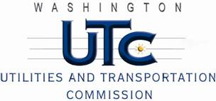

Memorandum
June 7, 2011

To: TR-110228 - File

From: Kathy Hunter, Deputy Assistant Director Transportation Safety

Subject: TR-110228 City of Moxee
Grade Crossing Protective Fund (GCPF) Project at the Intersection of
Beaudry Road and Central Washington Railroad’s Tracks in the City of Moxee

On March 2, 2011, the Washington Utilities and Transportation Commission (Commission) awarded a GCPF grant totaling $20,000 to install cantilever mounted lights and gates on both approaches to the crossing and an LED “No Right Turn” blank-out sign on State Route 24(SR-24) for westbound vehicle traffic turning right onto Beaudry Road. The City of Moxee also proposes to inter-tie the new railroad warning signals with the nearby traffic signal on SR-24, with an advance preemption of 42 seconds. The train detection to be installed is constant warning. The USDOT number assigned to this crossing is 098481T.

On May 16, 2011, the applicant, the City of Moxee submitted a request for reimbursement pursuant to Commission Order. On May 13 and June 6, 2011, Commission staff conducted site visits and verified that the project is completed according to the specifications outlined in the order approving the grant.

Please close this docket.

