OPERATIONAL FLEXIBILITY
Contents
H-2. OVERVIEW
H-3. SYSTEM BALANCING
- The PSE Balancing Authority
- Impact of Variability and
Uncertainty on System Volatility
- Managing Volatility
H-11. FLEXIBILITY SUPPLY
AND DEMAND
- Flexibility Supply
- Flexibility Demand
- Procuring and Deploying
Balancing Reserve Capacity
H-16. MODELING METHODOLOGY
- Hour-ahead Methodology
- Intra-hour Methodology
- Modeling Assumptions
and Limitations
H-20. RESULTS
- Demand - Hour-ahead Capacity
- Supply - Hour-ahead Capacity
- Intra-hour Flexibility Results
H-28. CONCLUSION & NEXT STEPS

Operational flexibility discussions have often focused on wind integration due to the historic increases in wind capacity in the Pacific Northwest, however the need for flexibility is actually more complex. Load fluctuations, Balancing Authority obligations to integrate scheduled interchanges and unexpected events like forced outages all place demands on system flexibility. So does the need to maintain contingency reserves to assist other balancing authorities that may have sudden needs for help balancing loads.

Note: This flexibility analysis originally appeared in PSE’s 2013 IRP. Personnel departures prevented the completion of the 2015 analysis at this time, but PSE plans to provide a complete flexibility analysis in our next IRP. The 2013 analysis included only the flexibility benefit of thermal plants; later, the same analysis was used to find the expected annual balancing savings of $99.52 per kilowatt-year for batteries. In addition, two developments related to operational flexibility have taken place since the 2013 IRP. PSE has completed an update on operations and maintenance costs for gas-fired resources, and we are scheduled to join the voluntary, within-hour Energy Imbalance Market (EIM) operated by the California Independent System Operator (CAISO) effective October 1, 2016. Within the EIM, PSE will be able to utilize market resources to fulfill energy flexibility requirements on a 5-minute and 15-minute basis. Both of these developments will be reflected in future flexibility analyses.

OVERVIEW

This 2013 IRP analysis endeavors to examine the issue of operational flexibility in a holistic manner that takes into account the full range of demands that impact system balancing. It looks at the need for balancing reserve capacity, the supply of this capacity available from PSE resources and the deployment of that capacity each hour to maintain load/resource balance. The process has resulted in better understanding of the operational flexibility needs. It has also established a starting point for better understanding the cost implications associated with maintaining sufficient flexibility in the system, although further work in this area needs to be done.

This appendix is divided into five sections.

System Balancing discusses the role of balancing capacity, the Control Performance Standard 2 (CPS2) metric used to gauge PSE’s ability to reliably balance the system and how PSE defines variability and uncertainty as they relate to balancing.

Flexibility Supply and Demand covers how PSE evaluates the availability of balancing capacity from PSE resources in light of the demands placed on the system for that capacity, and discusses how that capacity is procured and deployed.

Modeling Methodology reviews two models used to assess how PSE will meet its balancing obligations in 2018. The first model determines how best to set aside balancing reserves prior to an operating hour; the second simulates deployment of those reserves at 10-minute intervals.

Finally, we present the analysis Results and offer a Conclusion and Next Steps.

Four 2018 resource scenarios were analyzed. The first used the lowest reasonable cost portfolio identified in the analysis for the 2013 IRP Base Scenario; then, each of the incremental scenarios added one unique gas-fired resource capable of providing balancing services to the portfolio.

While additional work needs to be done, given the assumptions made for this study, the analysis indicates PSE has sufficient capacity and flexibility in the 2013 IRP Base Scenario portfolio to effectively meet its known Balancing Authority demands in 2018 across both hour-ahead and intra-hour time frames. Balancing-related cost savings in the incremental portfolios ranged from $300,000 to $1,000,000 annually depending on the gas-fired resource analyzed, compared to the 2013 IRP Base Scenario portfolio of resources.

SYSTEM BALANCING

The PSE Balancing Authority

A Balancing Authority (BA) is an entity that manages generation, transmission, and load; it maintains load-interchange-generation balance within a geographic or electrically interconnected Balancing Authority area, and it supports frequency in real time. The responsibility of the PSE Balancing Authority is to maintain frequency on its system and support frequency on the greater interconnection. To accomplish this, the PSE BA must balance load with generation on the system at all times. When load is greater than generation, a negative frequency error occurs. When generation is greater than load, a positive frequency error occurs. Small positive or negative frequency deviations are acceptable and occur commonly during the course of normal operations, but moderate to high deviations require corrective action by the BA. Large frequency deviations can severely damage electrical generating equipment and ultimately result in large-scale cascading power outages. Therefore, the primary responsibility of the BA is to do everything it can to maintain frequency so that load will be served reliably.

The Area Control Error (ACE) metric has been used for many years to track the ability of a BA to meet its reliability obligation. ACE is the instantaneous difference between actual and scheduled interchange, taking into account the effects of frequency. It reflects the balance of generation, load and interchange. Balancing Authority ACE determines how much a BA needs to move its regulating generation units (both manually and automatically) to meet mandatory control performance standard requirements.

By properly managing its ACE, PSE meets several key objectives: it reliably serves its customers, it maintains regulatory compliance, and it minimizes frequency excursions originating within its own BA that could impact other BAs or Transmission Operators (TOP) within the interconnection. PSE’s CPS2 metric sets a requirement for how far and often its system can stray from load and generation being in balance. CPS2 measures whether the average ACE stays within a given boundary over a 10-minute period; this is the L10 value. At least 90 percent of the 10-minute periods in each month must be within the +/- L10 boundary to meet the CPS2 requirement. The L10 value is provided to PSE by the North American Electric Reliability Corporation (NERC). The PSE system responds to ACE every four seconds to ensure that PSE’s average CPS2 score exceeds the required 90 percent for compliance. CPS2 is a concrete benchmark for assessing system reliability, and it is one of the metrics used to determine the adequacy of PSE’s portfolio in this analysis.

Balancing reserves refer to capacity held back on the PSE system to respond to negative and positive frequency errors. These can be incremental (INC) or decremental (DEC). Incremental capacity adds energy to the grid, decremental capacity reduces power to the grid. Contingency reserves are also required in addition to balancing reserves; these are capacity reserved in spinning and non-spinning forms for managing a large negative frequency event such as a sudden loss of generation in PSE’s BA or a neighboring BA. Contingency reserves are used for the first hour of the event only.

Figure H-1: Example of Control Performance Standard 2
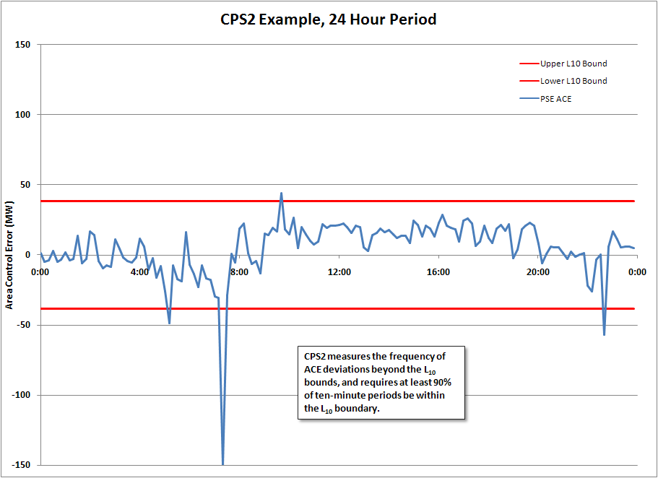

Impact of Variability and Uncertainty on System Volatility

Variability is the moment-to-moment, natural fluctuations in loads and generating resources and is always present on the electric system. Uncertainty is the inability to perfectly predict the hourly values for loads and generating resources. Volatility refers to the collective variability and uncertainty observed system-wide.

Understanding the distinction between variability and uncertainty is essential when discussing ways to manage and potentially reduce volatility across the entire PSE system. Variability is a smaller component of volatility than uncertainty. It is largely uncontrollable, since it is caused by random changes in loads, generating resource power output and fuel availability (such as wind). Uncertainty is the larger component of system volatility, but there are tools that can be used to reduce this uncertainty. For example, improvements in load and wind forecasting can increase the accuracy of load and wind generation schedules, reducing the need to provide balancing energy. Also, shortening scheduling windows can reduce the impact of both variability and uncertainty on system volatility. Currently the PSE BA must manage system volatility over 60-minute scheduling periods. If shorter scheduling windows are ultimately implemented in the region, it would reduce the magnitude of scheduling errors and the length of time PSE has to manage system volatility with generating resources internal to its system. Shorter scheduling windows would also allow PSE to use market transactions more frequently as a tool to address deviations in system conditions.

2015 IRP Update: To help address system flexibility needs, PSE is scheduled to join the voluntary, within-hour Energy Imbalance Market (EIM) operated by the California Independent System Operator (CAISO) effective October 1, 2016. Within the EIM, PSE will be able utilize market resources to fulfill energy flexibility requirements on a 5-minute and 15-minute basis. This will be reflected in future flexibility analyses.

Figures H-2 through H-4 use a 24-hour period at the Wild Horse Wind Facility to illustrate examples of variability, uncertainty and volatility. In Figure H-2, the variability of Wild Horse is shown as the moment-to-moment generation relative to a perfect hourly schedule (a perfect hourly schedule equals the hourly average actual generation). It shows that even equipped with a perfect schedule, PSE must still manage fluctuations in wind generation within the hour, along with other deviations on the system.

Figure H-2: Hourly Variability in Wind Generation
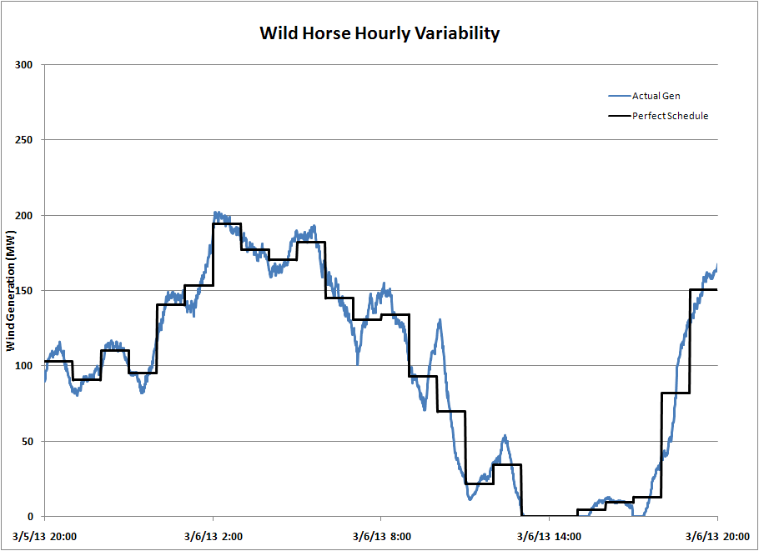

In reality, perfect foresight of wind generation or load for each upcoming operating hour is not possible. In Figure H-3, future wind generation is presented as an expected forecast for the next several hours, along with two additional forecasts that provide the probability of wind generation exceeding those values. At the 10% Exceedence forecast, we would expect actual wind generation to be above this value only 10 percent of the time, whereas at the 90% Exceedence forecast we would expect actual wind generation to be above this value 90 percent of the time. Actual wind generation may come in above or below the forecast, or, as is the case in HE 20 of March 6, 2013, it can exceed the forecasted bounds.

Figure H-3: Hourly Uncertainty in Wind Generation
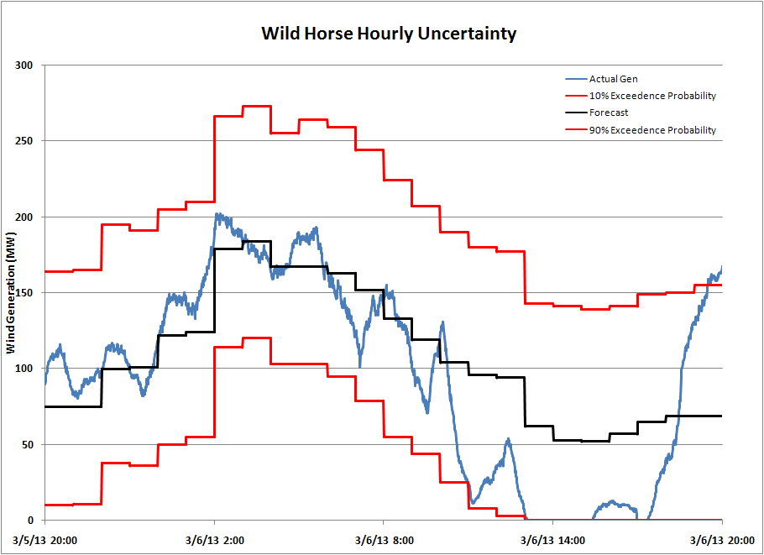

The variability and uncertainty at Wild Horse are combined in Figure H-4 to illustrate the volatility that may be expected each hour. The actual variability observed around each perfect hour in Figure H-2 is imposed on the upper and lower probability forecasts from Figure H-3. It shows how PSE must balance potentially large blocks of energy related to forecast error (uncertainty) while simultaneously balancing within-hour fluctuations (volatility) in order to maintain system reliability. Addressing volatility from sources other than wind requires similar action on PSE’s part.

Figure H-4: Hourly Volatility in Wind Generation
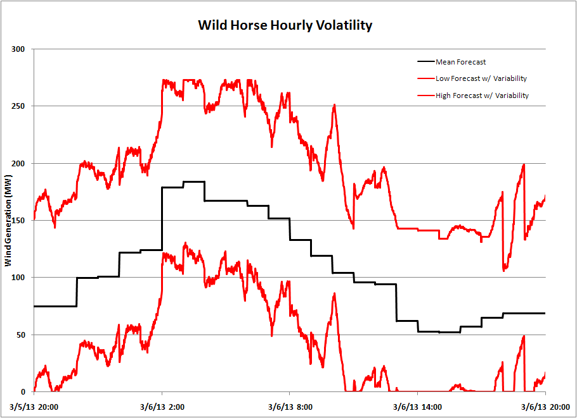

Managing Volatility

System volatility (variability and uncertainty) is managed with balancing reserves. Balancing reserves are generating capacity available to respond to changes in system conditions by either increasing generation (INC capacity) or decreasing generation (DEC capacity). The amount of balancing reserve capacity at PSE is determined by examining historical balancing capacity needs, and then establishing the amount of reserves necessary to cover 95 percent of the historical deviations in net load. This amount of balancing capacity is referred to as a 95 percent Confidence Interval level (95% CI) of reserves.

An overall 95% CI can be calculated that covers all time periods, but developing multiple 95% CIs can provide greater insight into balancing capacity needs. PSE develops 24 distinct 95% CIs for the entire day’s operation. As Figure H-5 shows, the hourly 95% CI values can vary a great deal through the day for both load and wind resources. For load, large amounts of balancing capacity can be needed to manage strong load ramps to meet the 95% CI during morning and evening peaks.

For PSE wind resources, the 95% CI is more constant throughout the day, with a slight transition to more DEC capacity required in the evening and more INC capacity in the morning hours. The fixed range of potential wind generation, from 0 MW to full capacity, suggests the wind forecast can be a criterion for developing additional 95% CI. Taking the extremes, at a 0 MW wind forecast the only potential forecast error (forecast generation minus actual generation) PSE would need to balance is a negative error (forecast is less than actual generation), which would only require DEC capacity reserves. Conversely, when wind generation is forecast at full output, PSE would only need to manage positive forecast errors where the forecasted generation is greater than actual generation. In this case, INC capacity reserves are required.

Figure H-5: Hourly PSE Balancing Capacity at a 95% Confidence Interval
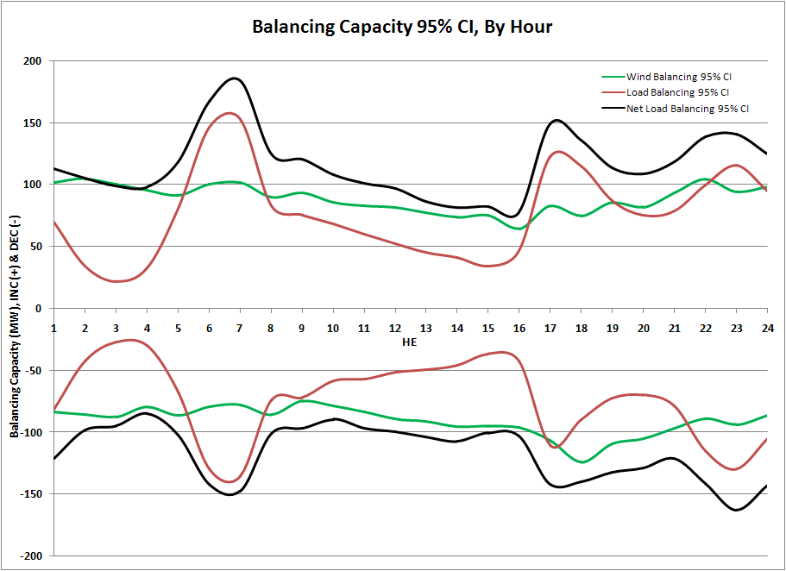

It is important to note that contingency reserves are accounted for separate from balancing reserves. Contingency reserves are dedicated to addressing short-term reliability in the event of forced outages; they cannot be deployed to address hourly system volatility unless a qualifying event occurs, such as a unit tripping off-line.

FLEXIBILITY SUPPLY AND DEMAND

System flexibility is the capability of PSE resources to manage system volatility over varying time periods, rates of change and overall magnitude. Flexibility is supplied by PSE generating resources, primarily PSE’s share of the Mid-Columbia hydroelectric generating facilities (Mid-C), but also PSE’s fleet of simple- and combined-cycle gas-fired units. Flexibility demand is created by the volatility observed in load, generation and transmission curtailments, and the uncertainty inherent in predicting loads, wind generation and unexpected events. Load and wind volatility are the two primary drivers of the demand for flexibility on the PSE system. Regional consensus on flexibility metrics is still developing, but PSE has begun to try to quantify the flexibility supply it has available to meet demand.

Flexibility Supply

All resources provide some measure of flexibility; however, the ability of a resource to supply flexibility is constrained by unit-specific characteristics including availability, operational or environmental limitations, range and ramp rate. These characteristics, coupled with economic dispatch generation set points, affect PSE’s total supply of system flexibility.

Availability depends on whether the resource is online, the speed with which it can be dispatched if off-line, and whether it is out of service due to planned maintenance or unplanned outage.

In terms of operational limitations, the speed with which a resource can transition from off-line to generating and synced to the system is a distinguishing feature of the resources needed to supply flexibility. Resources that take several hours to properly prepare for dispatch, like combined-cycled units, are limited in their availability to respond to short-term system balancing needs.

Resource range refers to the physical and environmental (temperature) constraints that dictate the maximum and minimum levels at which a resource can generate. For any given resource, the difference between this maximum and minimum at any given time is referred to as its operating range. For conventional thermal resources, this range remains fairly constant, but the range for hydro resources changes dramatically during certain times of the year. A portion of PSE’s capacity share of the Mid-C is available to meet PSE flexibility needs for most of the year, but during the spring runoff, high stream flows on the Columbia River reduce the available operating range on the Mid-C. At these times, hydro projects must generate at or near full capacity to avoid flowing excess water over spillways to meet water quality requirements. PSE’s supply of flexibility is severely reduced at this time of year.

Resource ramp rates describe the speed at which a unit can increase or decrease its generation. The ramp rate determines the ability of a resource to respond to all, some or none of the system’s deviations. Slow ramp rates effectively limit the balancing capacity of a resource during a given time increment. A resource with a large operating range but very slow ramp rate may be insufficient to address sudden changes in load and wind generation, while a resource with a small operating range and faster ramp rate can quickly respond to system needs but may not be able to sustain such a rate for an extended period, so multiple resources may need to respond simultaneously.

Flexibility Demand

The demand for flexibility is created primarily by system volatility, the need to manage the scheduled interchange ramp period between hours and potential system contingencies.

Volatility. Continuous demands for flexibility are placed on the system by volatility – the variability of loads and generating resources that fluctuate from moment-to-moment combined with the uncertainty inherent in forecasting load and wind resources hour by hour.

PSE addresses the demand placed by all system loads and resources simultaneously, rather than responding to each deviation individually. The relationship between load and wind is especially important. Because wind generation serves system load, load and wind scheduling errors in the same direction offset each other. The BA does not need to respond to an increase in load if there is an equal increase in wind generation. Load and wind schedule deviations in opposite directions create greater demands on system balancing resources. On a probabilistic basis, the fact that PSE load and wind may often move in the same direction or at the same rate places a smaller total demand for flexibility on PSE than if each were measured individually and then added together.

Scheduled interchange. In addition to managing loads and resources throughout each operating hour, PSE’s BA must integrate hourly imports and exports. This is known as a scheduled interchange. Little volatility is associated with scheduled interchanges (they are generally a flat, hourly amount of energy), but the magnitude of scheduled interchanges can vary each hour, often by several hundred megawatts. To accommodate these large changes, resources are ramped in over a 20-minute period beginning 10 minutes prior to the start of the operating hour and ending 10 minutes after. Even with planned ramps, integrating such large changes in power can be demanding, both in the range required of resources and the speed with which they must respond.

System contingencies. Forced outages place significant demands for flexibility on the system because they create an immediate need for large increases in energy to replace the resource lost to the outage. Forced outages occur when a generating unit, transmission line or other facility becomes unavailable for unforeseen mechanical or reliability reasons.

PSE also faces forced outage-type events as other BAs manage their own system volatility. For example, all wind resources within the BPA BA, of which PSE has 500 MW, are subject to dispatcher instructions meant to address BPA’s need for system flexibility at times when its system reserve capacity is exhausted. One notable BPA business practice is Dispatch Standing Order 216 (DSO-216). DSO-216 states that if wind plants are under-generating and BPA is supplying INC balancing reserves, BPA will have the ability to curtail transmission schedules for each plant, relative to the plant’s actual generation. A schedule cut within the hour is like a forced outage in that the PSE BA must respond instantaneously to a potentially large loss of energy. In addition to wind schedule cuts, PSE’s thermal resources located outside the company’s BA can also be cut due to regional transmission congestion and maintenance requirements. Transmission congestion can mean within-hour schedule cuts of several hundred megawatts.

Procuring and Deploying Balancing Reserve Capacity

The balancing reserves required to manage system operations within every operating hour can be thought of in two phases:

- the procurement of balancing reserve capacity ahead of the operating hour; and
- the deployment of reserves as balancing energy within the hour.

Procuring balancing capacity ideally consists of positioning hydro assets to allow sufficient room to increase generation (INC capacity) or decrease generation (DEC capacity) as needed within the operating hour. Thermal resources (gas and coal) can also be dispatched to provide balancing capacity. It should be noted that procurement of the needed balancing reserve capacity does not always guarantee sufficient flexibility is available to meet actual net load deviations on the system in real time. Meeting the demand for flexibility also requires unit ramp rates that can effectively deploy the capacity procured.

Figure H-6 depicts all aspects considered for balancing capacity and addressing system flexibility. In this 24-hour example, PSE’s Mid-C generation is the source of balancing capacity. The moment-to-moment changes in net load (load minus wind generation) are represented by the purple trace. The blue line representing Mid-C generation is bounded by black minimum and maximum generation targets.

The green trace labeled “Mid-C Balancing” represents the slope, or rate of change in Mid-C generation for each hour. It is presented just below the net load trace in order to highlight how the Mid-C generation is changing within the hour relative to the change in net load. The trace shows that during each hour, the Mid-C is responding in unison with changes in net load. The flexibility of the Mid-C is most evident during the 6:00 to 7:00 a.m. period as it manages an extreme load ramp of nearly 500 MW (over 8 MW per minute through the entire hour).

Figure H-6: Balancing of Net Load with Mid-C Generation
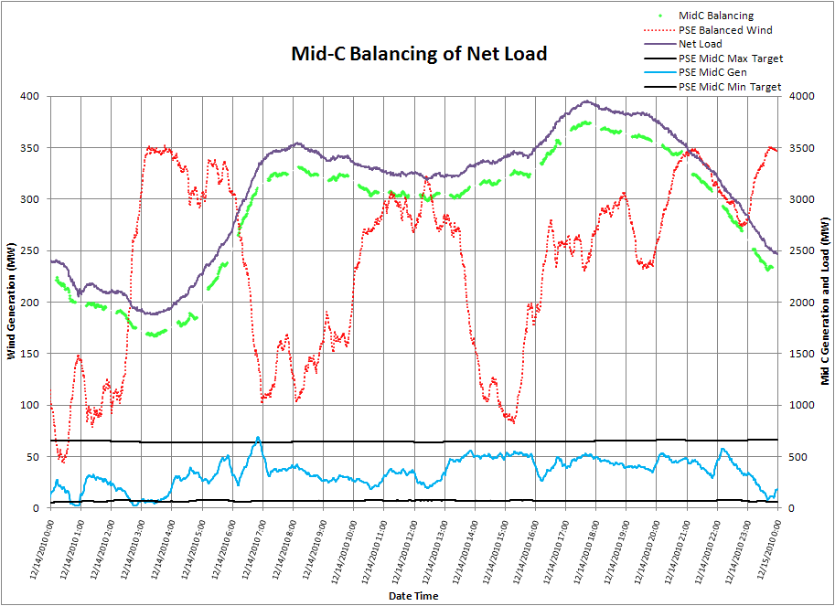

Note how the Mid-C reacts during the 20-minute schedule interchange period, from 5:50 to 6:10 am and from 6:50 to 7:10 am. During these periods Mid-C generation is being pushed down to accommodate new imports and to provide incremental balancing services for the next hour. In these instances, Mid-C frequently changes generation levels by 500 MWs over a 20-minute period (25 MW per minute ramp rate). No other resource in PSE’s fleet is capable of this combination of speed and range. This is why Mid-C hydro is such an important flexibility resource in PSE’s portfolio.

MODELING METHODOLOGY

This analysis focuses on whether PSE has enough flexibility supply to meet system demands and ancillary obligations, and how the costs of meeting those demands can be quantified.

The cost of supplying flexibility takes three forms.

- Reliability. Uncertainty about the levels of generation and load can result in more frequent deployment of contingency reserves or a reduction in PSE’s CPS2 score.
- Market opportunity cost. Procuring reserves can constrain PSE’s operations, because flexibility demands may require PSE to adjust the amount of available PSE-owned dispatchable generation in a manner contrary to market signals.
- Physical wear and tear on units. Ramping up generating units to take advantage of their operational range rather than operating them at their most efficient generating point tends to shorten maintenance timetables. Maintenance costs are difficult to estimate on a pro forma basis, however, and are not included in this 2013 IRP analysis. As we collect more cost data related to system flexibility requirements, maintenance costs may become possible to model.

2015 IRP Update: PSE has completed an update on operations and maintenance (O&M) costs for gas-fired resources. The updated cost assumptions will be included in future flexibility analyses.

Hour-ahead Methodology

The Aurora® production cost model used in the IRP does not feature the ability to set reserve capacity constraints on the PSE system. As a result, the hourly dispatch of generation produced by Aurora does not necessarily provide adequate balancing capacity each hour to meet the demands experienced by PSE. For this reason, the procurement of hour-ahead reserve capacity is modeled outside of Aurora.

Figure H-7 shows an Aurora dispatch in which there is inadequate spinning capacity during HE18 – HE21 and inadequate INC balancing capacity during HE19 – HE21. Adjustments to the dispatch must be made outside the Aurora model to provide sufficient balancing capacity, because Aurora does not take into account PSE-specific balancing capacity requirements in its optimization.

Figure H-7: PSE Balancing Capacity, Based on Aurora Economic Dispatch
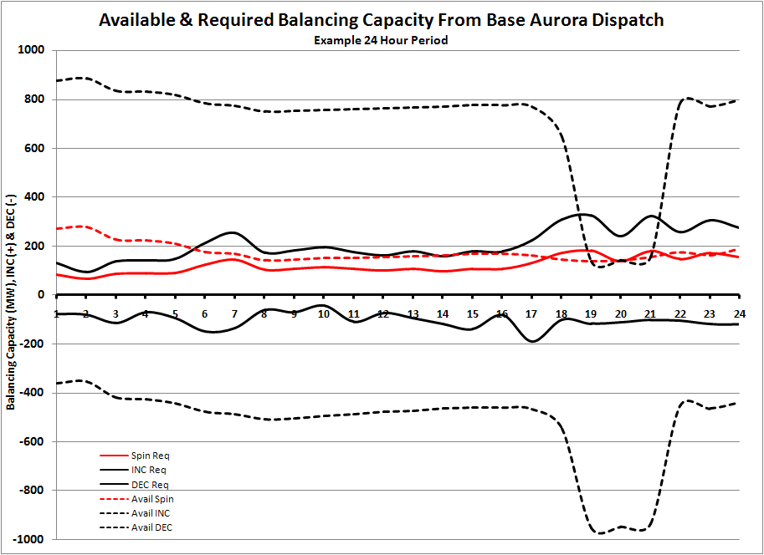

Based on historical deviations in load and hourly wind in PSE’s balancing authority, a 95% CI of INC and DEC balancing capacity was determined for each hour of the Aurora dispatch, and for the contingency reserve requirement. Setting aside this amount of balancing capacity every hour, PSE would expect to capture 95 percent of deviations in load and wind.

Once balancing reserve capacity requirements were set for each hour, the Aurora economic unit dispatch and price simulations were fed through a mixed-integer linear program in SAS-OR. This model adjusted the dispatch of PSE’s Mid-C hydro generation and 13 gas-fired resources to provide the required balancing capacity over a 24-hour period. Net changes to internal PSE dispatch were offset by market transactions to maintain hourly load-resource balance.

Once adjustments were completed, economic costs were tabulated based on the hourly changes to PSE’s market position for power and the fuel costs associated with dispatching off-line gas-fired units or re-dispatching those units to less efficient points on their heat-rate curves. Statistics on unit operations can be gathered from the adjusted dispatch. Finally, if the stack of PSE resources was unable to procure balancing capacity to fulfill the 95% CI in any hour, the hour was flagged and the balancing capacity shortfall was recorded.

Intra-hour Methodology

To model intra-hour deployment of balancing capacity, the adjusted unit dispatch from the hour-ahead model was converted into 10-minute dispatch increments. Aurora’s hourly wind and load values were then treated as hourly schedules, and 10-minute profiles were simulated based on the historical behavior of PSE load and wind resources. The simulated profiles represent deviations from the hourly schedules that require generation to be dispatched to return the system to equilibrium. The hour-ahead resources identified in the previous step were eligible to respond to the net change in load and wind. This also ensured that balancing capacity was held to meet PSE’s contingency reserve obligations.

The intra-hour model also uses a mixed-integer linear program in SAS-OR. Redispatch of internal generation was guided by unit economics and operating characteristics. Each unit was constrained by its ramp rate, minimum and maximum generation points, minimum runtime, minimum downtime and any forced outages modeled by Aurora. The optimization horizon was limited to 3 hours to reflect the limited foresight system operators have when making within-hour unit decisions. The output from the model was a record of unit deployment for PSE’s dispatchable generation that quantified how each unit contributed to system balancing, pinpointed periods of stress, and identified periods when the model could not balance the system.

Modeling Assumptions and Limitations

Some key assumptions made in these modeling efforts should be noted. These relate to Aurora and the Mid-C data used in the analysis.

Relying on Aurora unit dispatch and price information as inputs to the model allows for continuity between the primary production cost calculation and the subsequent modeling of system balancing, but it also assumes the Aurora dispatch reflects a realistic portrayal of hour-by-hour unit dispatch and system conditions and this is not certain.

The uncertainty arises partly from the Mid-C hydro dispatch profiles used in Aurora, which are based on 70 years of historical hydro generation beginning in 1929. These profiles reflect conditions that prevailed many decades ago, but that may not exist today, or may not accurately mirror the current demands on PSE’s system. As discussed previously, hydro dispatch (accessed through Mid-C contracts) is a primary flexibility resource for PSE because it is already synchronized to the system, it has enormous range, it responds instantaneously, and it ramps quickly. Therefore, any inputs that overstate or overly constrain Mid-C availability can have a dramatic impact on the results.

The current models do not make net MWh changes to the Aurora hydro dispatch; generation may be moved between hours but daily, monthly and annual MWh Mid-C generation is constant between the initial Aurora dispatch and the resulting Mid-C generation profile from the model.

RESULTS

For this analysis, a fifty-simulation subset of the 250 Aurora IRP simulations were analyzed, limited to the year 2018. The results are divided into two sections: The first looks at the hour-ahead availability and procurement of balancing capacity, and the second looks at intra-hour deployment of those reserves. The hour-ahead supply of capacity is expressed as the contribution of PSE resources to the total balancing capacity available, while intra-hour demand is input as hourly 95% CI. Once the portfolio is positioned hour-ahead, meeting the system’s flexibility demands was simulated with intra-hour load and wind deviations, hourly scheduled interchanges, and forced outages modeled by Aurora.

The analysis first assessed the ability of the lowest reasonable cost portfolio identified in the analysis for the 2013 IRP Base Scenario to balance these deviations. Then, three additional portfolios were analyzed. Each introduced one additional resource to this portfolio: a CCCT resource, a frame CT resource, and a reciprocating engine CT. Basic operational characteristics of the units are identified in Figure H-8. By comparing these three portfolios to the Base Scenario’s least-cost portfolio, PSE can assess potential benefits to system reliability and reductions in portfolio balancing costs associated with the added resource.

Figure H-8: Overview of Resource Additions Analyzed
Unit | Capacity (MW) | Min Generation (MW) | Heat Rate (Btu/kW)* | 10-Minute Ready
CCCT** | 343 | 189 | 6,682 | No
Frame CT | 221 | 133 | 10,324 | Yes
Recip CT | 18 | 9 | 8,370 | Yes
*Heat rates based on 2013 IRP assumptions for 2017
**Duct-firing portion excluded from analysis

Demand for Hour-ahead Balancing Capacity

Figure H-9, below, translates the hourly 95% CI levels (the balancing capacity PSE should carry to manage 95 percent of load and wind deviations) into a monthly average. These values reflect PSE balancing obligations based on the study assumptions for 2018, and they act as input constraints on the PSE system during the modeling phases. Capacity requirements are expressed as monthly amounts of spinning capacity, INC capacity, and DEC capacity required to meet the total 95% CI. Spinning capacity is a specific type of INC capacity for which resources must already be online and synchronized to the system. The remainder of INC requirements can be met with capacity from off-line, 10-minute-ready resources, or spinning capacity in excess of the minimum spin requirement. In Figure H-9, the spinning and INC capacity requirements include the capacity necessary to meet the contingency reserve obligation.

Figure H-9: Average Hourly Balancing Capacity Requirements (MW) for 2018
Month | Avg. Spin Capacity Required | Avg. INC Capacity Required | Avg. DEC Capacity Required
1 | 112 | 188 | 113
2 | 103 | 171 | 104
3 | 107 | 178 | 114
4 | 100 | 165 | 101
5 | 85 | 135 | 100
6 | 86 | 137 | 97
7 | 93 | 150 | 94
8 | 99 | 164 | 101
9 | 96 | 158 | 90
10 | 103 | 171 | 100
11 | 110 | 185 | 115
12 | 109 | 183 | 114

Supply of Hour-ahead Balancing Capacity

To benchmark the initial state of the PSE system, available balancing capacity from the unaltered Aurora dispatch is tabulated by asset class for the 2013 IRP Base Scenario’s least-cost portfolio for the year 2018. These values are presented as average hourly amounts of balancing capacity available in Figure H-10. (In reality, however, each individual hour’s available balancing capacity can vary widely as market conditions dictate unit dispatch and therefore the actual balancing capacity available.)

Figure H-10: 2013 IRP Base Scenario Portfolio,
Average Hourly Balancing Capacity Available, Initial Aurora Dispatch (MW)
Month | Mid-C Spin | Mid-C DEC | CT Spin | CT INC | CT DEC | CCCT Spin | CCCT INC | CCCT DEC
1 | 141 | 280 | 0 | 587 | 39 | 10 | 10 | 135
2 | 230 | 225 | 0 | 544 | 64 | 6 | 6 | 179
3 | 214 | 201 | 0 | 524 | 58 | 5 | 5 | 163
4 | 162 | 189 | 0 | 417 | 71 | 3 | 3 | 148
5 | 137 | 124 | 0 | 416 | 42 | 5 | 5 | 63
6 | 66 | 95 | 0 | 511 | 17 | 10 | 10 | 70
7 | 150 | 158 | 0 | 521 | 45 | 16 | 16 | 146
8 | 217 | 168 | 0 | 474 | 81 | 17 | 17 | 200
9 | 315 | 89 | 0 | 433 | 106 | 7 | 7 | 215
10 | 229 | 129 | 0 | 534 | 46 | 11 | 11 | 200
11 | 244 | 187 | 0 | 569 | 41 | 16 | 16 | 167
12 | 266 | 217 | 0 | 542 | 71 | 7 | 7 | 177

At this level of granularity, the Aurora dispatch reflects the importance of the Mid-C hydro contracts by illustrating that for the least-cost portfolio in the 2013 IRP Base Scenario, this single resource is sufficient to meet balancing capacity requirements during most of the year. No spinning capacity is provided by the CT fleet (8 units); the Aurora dispatch will commit those resources to their maximum generation. However, when dispatched, the CT resources provide their full operating range as DEC capacity. The CCCT fleet is similar to the CTs. Typically they are dispatched to their maximum generation and rarely provide spinning capacity. At times they may be dispatched to their minimum generation point during brief uneconomic periods of a much longer economic dispatch, at which time they are able to provide some spinning capacity.

The reduced availability of balancing capacity from May through July is due to a confluence of system conditions. Hydro runoff conditions can severely limit the availability of balancing capacity of the Mid-C projects as spring stream flows must pass through turbines to avoid violating environmental constraints related to excessive spill. The abundant hydro generation depresses market prices, reducing the economic commitment of gas-fired units. And finally, due to the predictability of these hydro and market conditions, annual maintenance for CT and CCCT resources is typically scheduled during this time to align their outages with periods of unlikely dispatch.

To address any hours where there is insufficient balancing capacity, unit dispatch is adjusted until the capacity requirements are met. In Figure H-11, the average hourly available balancing capacity is presented after hourly adjustments are made to the unit dispatch of the 2013 IRP Base Scenario portfolio in 2018.

Figure H-11: Average Hourly Balancing Capacity Available,
Adjusted 2018 Base Portfolio (MW)
Month | Mid-C Spin | Mid-C DEC | CT Spin | CT INC | CT DEC | CCCT Spin | CCCT INC | CCCT DEC
1 | 141 | 280 | 26 | 570 | 49 | 16 | 16 | 129
2 | 230 | 225 | 8 | 525 | 78 | 6 | 6 | 179
3 | 214 | 201 | 10 | 515 | 64 | 4 | 4 | 164
4 | 162 | 189 | 17 | 409 | 75 | 9 | 9 | 142
5 | 137 | 124 | 25 | 406 | 48 | 3 | 3 | 64
6 | 66 | 95 | 43 | 477 | 40 | 17 | 17 | 62
7 | 150 | 158 | 14 | 508 | 54 | 19 | 19 | 142
8 | 217 | 168 | 8 | 458 | 92 | 14 | 14 | 202
9 | 315 | 89 | 0 | 415 | 119 | 8 | 8 | 214
10 | 229 | 129 | 0 | 525 | 53 | 11 | 11 | 201
11 | 244 | 187 | 1 | 563 | 44 | 8 | 8 | 175
12 | 266 | 217 | 1 | 537 | 73 | 7 | 7 | 177

The static nature of Mid-C availability is due to a pond constraint imposed on the model, and the level at which these values are presented. If the Mid-C generation is increased by 1 MW in a given hour, this results in a 1 MW addition to DEC capacity and a 1 MW decline in available spin capacity. However to maintain pond balance, this extra 1 MW of generation must be offset by a 1 MW decrease in generation in another hour, which will also lead to inverse changes in the available spin and DEC capacity. At an hourly level the available capacity on the Mid-C is changing, yet the arithmetic for the monthly averages does not show this change.

Only small changes in the available capacity on the CCCT fleet are present. Since these resources are not capable of being ready to dispatch in 10 minutes, they are normally called on only when the resource is already online. In actual practice, CT units are frequently called on more often than in the initial Aurora dispatch, especially during the first half of the year, because of the increased availability of their spinning capacity and DEC capacity. In the fall, there is no change in spin capacity, however, CT resources are being dispatched at maximum generation more frequently to support DEC capacity needs.

Hourly results from the four portfolios show that PSE has adequate hour-ahead balancing capacity (Figure H-5). Across the 50 simulations, approximately two hours of unmet balancing capacity were expected over the entire study year; this primarily involved DEC capacity shortfalls. The shortfalls do not necessarily indicate a failure to balance the PSE system; rather, they indicate hours when PSE is unable to fully meet the 95% CI set aside of balancing reserves, which may or may not be needed in that hour. However, the contingency reserve portion of the spinning capacity and INC capacity are requirements that PSE must meet every hour. Investigation of the hours with either unmet spin or unmet INC capacity reveals that none of the shortfalls impact our ability to meet contingency reserve obligations.

Figure H-12: Summary Hour-ahead Balancing Results, 50 Simulations
2013 IRP  Base Scenario Portfolio | Avg. Unmet Spin Capacity (Hrs) | Avg. Unmet INC Capacity (Hrs) | Avg. Unmet DEC Capacity (Hrs) | Avg. Unmet Spin Capacity (aMW) | Avg. Unmet INC Capacity (aMW) | Avg. Unmet DEC Capacity (aMW)
2018 Base | 0.1 | 0.3 | 1.9 | 0.5 | 9.1 | 17.3
2018 Base + CCCT | 0.1 | 0.3 | 1.7 | 0.5 | 9.1 | 15.7
2018 Base + Frame CT | 0.0 | 0.0 | 0.2 | 0.0 | 0.0 | 0.0
2018 Base + Recip CT | 0.2 | 0.3 | 1.2 | 0.1 | 8.5 | 10.5

Intra-hour Flexibility Results

Once balancing capacity has been set aside in the hour-ahead time frame, the simulated 10-minute level wind and load deviations were introduced, along with the need to balance hourly shifts in scheduled interchange. Then the portfolios were assessed on their ability to respond.

The modeled deployment of PSE balancing resources revealed that PSE can maintain a high degree of reliability; in all portfolios, the expected proxy CPS2 score is 97 percent, well above the requirement of 90 percent. (This does not include frequency bias.) The score reflects a very aggressive constraint in the model, which is set to balance load and resources exactly every 10 minutes. The times when load and generation are not in balance fall into two categories, unserved energy and excess energy. Unserved energy is when the system load is greater than the amount of energy provided by PSE resources, while excess energy is when resources are over-generating relative to demand. While the model solves to have no imbalances, in actual operations small differences in system demand and net resources are permissible over short periods of time, as reflected in the CPS1 and CPS2 metrics. The magnitude of these violations is usually small. Periods of unserved energy average an imbalance of 6 MW, periods of excess energy average a 12 MW deviation.

PSE must also maintain spinning capacity to meet its contingency reserve obligation. Each portfolio has only a handful of 10-minute periods with insufficient spinning capacity, and during those periods the average capacity shortfall is 2 MW.

Figure H-13: Summary Results from Flexibility Analysis, 50 Simulations
2013 IRP  Base Scenario Portfolio | CPS2 Score Proxy (%)* | Spin Capacity Shortfall (%) | Spin Capacity Shortfall (aMW) | Unserved Energy (aMW) | Excess Energy (aMW) | Expected Annual Balancing Savings ($) | Expected Annual Bal. Savings ($/kW Capacity)
2018 Base | 97% | 0.1% | 2.0 | 5.9 | 12.5 | -- | --
2018 Base + CCCT | 97% | 0.1% | 1.8 | 5.7 | 12.2 | $800,000 | $2.33
2018 Base + Frame CT | 97% | 0.1% | 1.9 | 5.9 | 12.1 | $1,037,000 | $4.69
2018 Base + Recip CT | 97% | 0.1% | 1.8 | 5.9 | 12.1 | $328,000 | $18.23
*NERC CPS2 metric requires a score of 90% or greater
As the 2013 IRP Base Scenario portfolio’s set of balancing resources are flexible enough to balance the PSE system, the addition of another resource to the portfolio does not have much room to further improve these reliability metrics. However, this result should not diminish the value of these resources to improve system reliability and flexibility. In addition to the flexibility attributes they bring to the portfolios, they also lower the cost of providing and deploying balancing capacity. Adding a new balancing resource to the portfolio may provide a lower-cost means to meet system reliability than previously existed, although further cost analysis is required.

The annual savings in Figure-13 for each resource addition is the expected reduction in annual production costs compared to the 2013 IRP Base Scenario portfolio as measured by fuel consumption, market purchases and sales associated with providing and deploying balancing capacity. As this value only considers production costs, it is worth noting the savings may be larger or smaller when secondary effects are considered, such as changes in maintenance needs or availability factors.

The expected benefit from adding the CCCT resources is $800,000. As the CCCT is not 10-minute ready it can only contribute to balancing capacity and adjust to meet load and wind deviations if it has already been economically dispatched by Aurora. The unit’s efficient heat rate sees it dispatched 57 percent of the time in the simulations analyzed, and the unit’s large operating range can manage in-hour changes that may otherwise have required multiple units to move. With respect to the two CT resources, the expected annual benefit is $1 million for the frame CT and $328,000 for the reciprocating engine CT. They are dispatched by Aurora less frequently than the CCCT resources, 30 percent of the time for the frame and 32 percent of the time for the reciprocating engine. However, their 10-minute ready status means they can be dispatched as necessary during the hour. On a benefit-per-capacity basis, the reciprocating engine CT represents the highest value at $18.23 per kW, followed by the frame CT at $4.69 per kW, and finally the CCCT at $2.33 per kW.

What distinguishes the two CT units is their relative size. While the frame CT has a large operating range, its minimum generating level is relatively high. Dispatching this unit from an off-line state when there is a small incremental energy need (less than the 133 MW minimum operating level for the unit) may not be beneficial as it could trigger an excess energy situation unless another unit was available to offset it with decremental capacity. On the other hand, the reciprocating engine’s smaller nameplate capacity, operating range, and low minimum generation level make it an ideal resource when there is a marginal energy or spinning capacity need.

CONCLUSION AND NEXT STEPS

While additional work needs to be done, given the assumptions made for this study, the analysis indicates PSE has sufficient capacity and flexibility in the 2013 IRP Base Scenario portfolio to effectively manage its known system flexibility demands in 2018 across both hour-ahead and intra-hour time frames. Comparing three different additions to that portfolio indicates potential production cost savings of $300,000 to $1,000,000 annually, and provides insight into how differing unit characteristics can alter potential balancing benefits.

Perhaps most valuable has been the change in perspective to a more comprehensive view of operational flexibility needs and costs. Efforts to expand on this work are already underway. Further exploration of the maintenance stresses placed on the system by balancing needs, the operational complexity associated with rapid deployment of multiple resources, and the capabilities of different types of resources are primary areas of interest to PSE. The current models use stringent constraints to maintain load-resource balance and will utilize all resources, if necessary. Understanding how increased resource use potentially changes a resource’s operational abilities will help us carry out even more rigorous assessments of operational flexibility.

