Washington State Dairy Federation

February 11, 2016

Washington Utilities and Transportation Commission (UTC)
PO Box 47250
Olympia, WA 98504-7250

RE: Puget Sound Energy Proposed Tariff as It Relates to WA Biomethane Injection to Shared Pipelines; Docket UG-152164

Dear Chairman Danner and Commission Members:

Recently, in UTC Docket 152164, Puget Sound Energy (PSE) proposed a new tariff for injection of renewable natural gas (RNG, biomethane or upgraded biogas) into pipelines, recommending use of standards similar to those recently adopted by the State of California.

The Washington State Dairy Federation, Washington State Farm Bureau, and Northwest Dairy Association represent dairy farmers across the state of Washington. We have worked for years on policies to encourage and incentivize biomethane production on dairy farms. We are concerned this proposal, if adopted as proposed, will have an immediate chilling effect on any future development of renewable natural gas (RNG) production. We are asking the Commission to deny this petition. We, along with the other stakeholders, will work with Puget Sound Energy to develop a new proposal to advance the viability and ability in Washington State to develop more rather than less RNG.

Our primary objection to the PSE tariff is that it will set an unacceptable and deleterious precedent for standards for RNG injection into natural gas pipelines. There are two primary reasons why the tariff is damaging to RNG producers and to the developing RNG industry:

- The policies adopted in California over the past several years have discouraged renewable gas production, by creating onerous standards that would be expensive to meet. California is not the model to look at for policy.
- The proposed standards we believe will discourage RNG production, when we should be incentivizing expanded production and distribution of safe, renewable alternatives to fossil fuels.

RNG production, including the production on our dairy farms, makes Washington State a recognized leader in renewable natural gas production. There are currently and have been innumerable conversations about replacing fossil fuel with renewables. Washington State is considering carbon emission reduction strategies. If these energy and carbon policies are enacted, the demand for carbon offsets and renewable fuels is expected to dramatically increase. We believe we should establish policy that promotes Washington State production of RNG and the accompanying carbon offsets to meet those state goals. With the right policies, RNG projects can provide opportunities for Washington dairy farmers, food processers, and other industries. This proposal moves us in the wrong direction, at the wrong time.

Generally, we share the concerns outlined by a number of RNG advocates who have submitted comments. We urge you to consider the detailed comments of the Coalition for Renewable Natural Gas, Regenis, Promus Energy, LLC and the American Biogas Council.

We look forward to working with Puget Sound Energy on finding a better set of terms for this tariff. PSE has been an excellent partner for many of our farmers and we know they also share a desire to increase RNG production. Please deny this petition so we can work to bring you a proposal that producers, distributors and marketers agree will advance a positive future for RNG production in Washington State.

Thank you for your consideration.

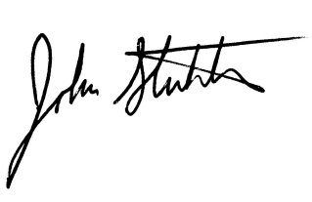
Sincerely, Sincerely, Sincerely,
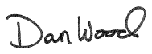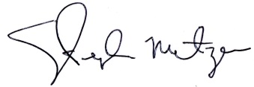

Dan Wood Steve Matzen John Stuhlmiller
WSDF Executive Director NDA Senior Vice President Chief Executive Officer WSFB

