0

January 27, 2010

W.U.T.C.
Tariff Division
1300 S. Evergreen Park Drive SW
Olympia, WA 98504-8002
Re: Shuttle Express Inc. C-975, tariff #6
(Recently filed tariff changes)

In response to Cathy Kern’s email I am resubmitting the following replacement pages:
- Sixteenth Revised Page Three B
Further, these two pages were reformatted to print on one page:
- Seventh Revised Page Three C
- First Revised Page Three C-6

Thank you, again, for all of your help in cleaning up our tariff.

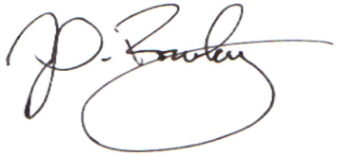
Respectfully,

John Rowley, General Manager

