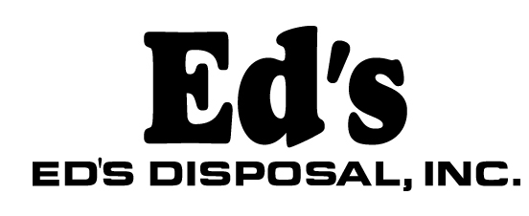

May 8, 2018

Steven King Executive Director Secretary
Washington Utilities and Transportation Commission
1300 S. Evergreen Park Dr. SW, Olympia, WA 98504-7250

Dear Mr. King:
(509)547-2476
800-642-6447
(509)547-8617 fax
2021 N. Commercial Ave.
Pasco, WA 99301

Solid Waste Certificate No. G-110

This letter is to advise that Ed’s disposal has filed a copy of a Facility Lease Agreement with an affiliated company, Property 2021, LLC.

Should you have any questions please feel free to contact me at 509.542.4957.

Sincerely,

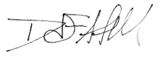

Dave Atwell
Pricing Manager
Ed’s Disposal (G-110)

