June 25th, 2018

Mr. Mark L. Johnson, Executive Secretary
Washington Utilities and Transportation Commission
1300 South Evergreen Park Drive SW
Olympia, WA 98504-7250

Re: ILEC Annual Report Financial Statements for Class B Companies
Docket: UT-160947

Dear Mr. Johnson:

Please find enclosed balance sheets and income statements due July 2nd, 2018.

All information is considered confidential under WAC 480-07-160 due to detailed financial information reported by the company.

Sincerely,

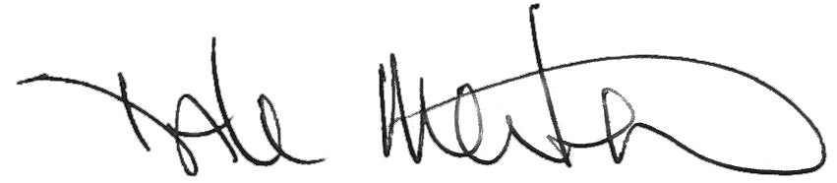

Dale Merten
Chief Operating Officer

Encl/

