Steven King
Executive Director and Secretary
Washington Utilities and Transportation Commission
1300 S. Evergreen Park Dr. S.W.
Olympia WA 98504-7250

June 14th 2016

RE: Eligible Telecommunications Carrier’s annual filling to the Federal Communications Commission pursuant to 47 C.F.R. § 54.313. and 47 C.F.R. 54.422 (Form 481)
Docket UT-160030

Dear Mr. King;

Enclosed please find copies of The Toledo Telephone Company, Inc. (ToledoTel) filling of 2016 form 481 documents as submitted to the FCC and USAC.

Should you have any questions or require additional information please contact me directly.

Best regards,

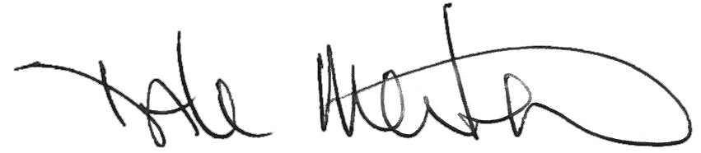

Dale Merten
C.O.O.
ToledoTel
306-864-2044
dale@toledotel.com

Enclosures

