BEFORE THE WASHINGTON STATE
UTILITIES AND TRANSPORTATION COMMISSION

WASHINGTON UTILITIES AND TRANSPORTATION COMMISSION,  Complainant,  v.  AMERICAN DISPOSAL COMPANY, INC., G-87,  Respondent.  . . . . . . . . . . . . . . . . . . . . . . . . . . . . . . . . | )  )  )  )  )  )  )  )  )  )  )  )  )  ) | DOCKET TG-111674  ORDER 01  COMPLAINT AND ORDER SUSPENDING TARIFF; ALLOWING REVENUE SHARING ON A TEMPORARY BASIS, SUBJECT TO REFUND OR CREDIT

BACKGROUND

- On September 15, 2011, American Disposal Company, Inc. (American or Company), filed with the Washington Utilities and Transportation Commission (Commission) revisions to its currently effective Tariff No. 25, designated as Tariff pages 1, 21, 25, 27, 28, 30, 46, 47, 48 and 49. The stated effective date is November 1, 2011.

- In its filing, American proposes to increase the amount it pays to single family and multi-family customers for the value of the recyclable materials that the Company collects in its residential recycling collection service. The monthly credit for single family customers would increase from $1.31 to $1.69 and the monthly credit for multi-family customers would increase from $0.67 per yard to $0.76 per yard for each pickup.

- Also, on September 15, 2011, American, in conjunction with its sister company, Murrey’s Disposal Company, Inc. (Murrey’s), filed with the Commission a request to retain fifty percent of the revenue American receives from the sale of recyclable materials that it collects in its residential single and multi-family recycling collection service from November 1, 2011, to October 31, 2012.

- On September 15, 2011, American and Murrey’s filed their joint “2011-12 Company Recycling Plan: Pierce County Single-Stream Recycling Program, Updated September 2011” (2011-2012 Plan) with the Commission. Included with the plan was a summary of the results achieved from the previous 2010-2011 plan year. In addition, as required in Order 01 in Docket TG-101548, American and Murrey’s also filed the amount of money retained and the amount of money spent during the 2010-2011 plan year. Table 1 below shows that American and Murrey’s spent $469,204 of the $974,336 retained from customers, leaving $505,131 unspent and kept by the companies.
Table 1, 2010-2011 Recyclable Commodity Revenue Retained vs. Revenue Spent
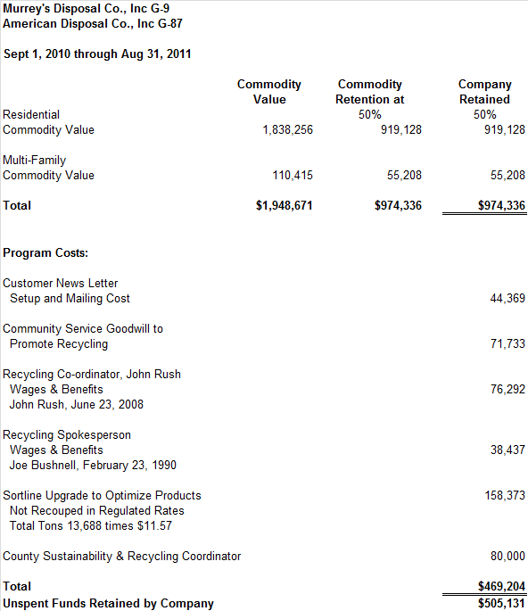
- On September 16, 2011, Pierce County (County) filed a letter with the Commission signed by Stephen C. Wamback, Solid Waste Administrator, Pierce County Department of Public Works and Utilities. The letter confirms that the Company's performance in the past year had achieved the goals and objectives specified in the 2010-2011 plan and that the County recommends to the Commission that the Company should keep the fifty percent of recyclable commodity revenues it retained (summarized in Table 1 above).

- The Company has participated in recyclable commodity revenue sharing since 2005. In 2010, the Legislature increased the maximum revenue sharing amount from thirty percent to fifty percent. The 2010-2011 plan period was the first time the Commission authorized the Company to retain fifty percent of the recyclable commodity revenue. Table 2 below shows year by year results for revenue sharing activities for the Company.
Table 2, American and Murrey’s Plan Year Results
Year | Revenue | Returned to Customers | Retention Percent | Retained by Company | Spent on Plan Activities | Unspent Retained  Revenue | Unspent as Percent of Retained
2005-2006 | $1,467,003 | $1,040,677 | 30% | $426,327
2006-2007 | $2,056,916 | $1,439,841 | 30% | $617,075
2007-2008 | $2,699,701 | $1,889,791 | 30% | $809,910
2008-2009 | $1,323,903 | $926,732 | 30% | $397,171
2009-2010 | $1,626,537 | $1,138,576 | 30% | $487,961 | $408,277 | $79,684 | 16%
2010-2011 | $1,948,671 | $974,336 | 50% | $974,336 | $469,204 | $505,131 | 52%

- The 2009-2010 plan period was the first year that the Commission required the Company to report, at the end of the plan period, the amount of revenue it retained, the amount of money it spent on the activities identified in its recycling plan, and the effect the activities had on increasing recycling.

- RCW 81.77.185 states that the Commission shall allow a solid waste collection company collecting recyclable materials from residential single and multi-family customers to retain “up to fifty percent of the revenue paid” to the company for the material if the company submits a plan to the Commission that is certified by the appropriate local government authority as being consistent with the local government solid waste plan and that demonstrates how the revenues will be used to increase recycling. The remaining revenue must be passed through to residential single and multi-family customers.

- The 2011-12 Plan sets forth specific actions that American will take to increase recycling using recyclable commodity revenues retained by the Company. The plan calls for fifty percent of the retained recyclable commodity revenue to be awarded to the Company on the basis of:
- Ongoing implementation of the single-stream recycling program – up to 5 percent awarded;
- Meeting or exceeding data monitoring and reporting requirements – up to 4 percent awarded;
- Achieving and demonstrating a recycling increase and disposal decrease per household pounds per month compared to 2004 and 2009 baselines – up to 21 percent awarded;
- Providing the County with Direct Financial support for county-wide recycling programs and overall sustainability initiatives – up to 16 percent awarded; and
- Achieving additional goals outlined in the Plan as agreed upon by the County and the Company in 2011 and 2012 – up to 25 percent awarded.

- Included in the letter dated September 16, 2011, from the County, is the certification required by RCW 81.77.185 that the plan submitted by the Company on September 15, 2011, for the upcoming year is consistent with the local government solid waste management plan and that the new plan demonstrates how the revenues will be used to increase recycling. Therefore, the County recommends the Commission allow American to retain fifty percent of the recyclable commodity revenues received during the period of this agreement (November 1, 2011, through October 31, 2012).

- Staff notes that the Company did not spend $505,131 of the retained revenue. Retained revenue is defined as a percentage (fifty percent in this case) of the total gross revenue produced by the Company’s recycling program. Because total revenue will increase or decrease depending upon the quantity of recyclable materials collected and prices paid, the amount of retained revenue will also change. The potential for even greater amounts of unspent retained revenue exists if quantity or prices increase. Staff believes that the amount of American’s unspent revenue is an unintended result or consequence of the Company’s 2010-2011 plan and is otherwise contrary to the public interest. Further, Staff contends that there are no changes or safeguards in American’s proposed 2011-2012 Plan that would prevent even greater unspent revenues, and thus the Commission should consider whether the proposed 2011-2012 Plan may have any unintended results or consequences.

- Staff, therefore, recommends that the Commission issue a complaint and order suspending revisions to American’s Tariff No. 25, and allowing monthly recyclable commodity revenue adjustments filed on September 15, 2011, and revenue sharing on a temporary basis, subject to refund.

DISCUSSION

- The Commission shares Staff’s concern that the proposed 2011-2012 Plan does not demonstrate how the retained revenues from the sale of recyclable materials will be used to increase recycling. The plan does not identify any of the expenses the Company anticipates incurring to undertake the tasks or accomplish the objectives it sets forth. Nor has the Company estimated the revenues it expects to generate from the sale of recyclable materials during the plan period, including the plan’s expected benefits to its recycling program. Nevertheless, the plan allocates a specific percentage of retained revenue to the Company for achieving each stated task or goal. In short, the plan accords the Company an unknown amount of revenue in compensation for incurring unspecified costs to accomplish the stated but otherwise inexplicit tasks and goals. Some of those tasks and goals, moreover, do not appear to be reasonably designed to increase recycling. Under these circumstances, further inquiry is necessary to determine whether the proposed 2011-2012 Plan demonstrates how the retained revenues will be used to increase recycling as RCW 81.77.185 requires.
- We are also troubled by the amount of unspent retained revenues from the 2010-2011 plan the Company proposes to retain. Our prior orders anticipated that the Company would be entitled to keep some of the revenues under the plan as an incentive for accomplishing plan goals, but neither the Commission nor Staff anticipated unspent retained revenues of this magnitude. (Indeed, at the October 27 open meeting, the County representative also expressed surprise at the amount of the revenues the Company proposes to keep.) The statute and our orders authorize the Company to retain up to fifty percent of the total recycling revenues, and the Commission would be remiss in its statutory responsibilities to ensure that the retained revenues are used to increase recycling without some further review of the Company’s implementation of the 2010-2011 plan.
- We nevertheless value the Company’s efforts to develop a recycling plan with Pierce County and believe that Company activities to increase recycling and pass recycling revenues on to residential customers are in the public interest. Those activities and revenue sharing, therefore, should continue pending the Commission’s investigation of the plans at issue.
- Accordingly, the Commission will adopt Staff’s recommendation and will suspend the tariff filings for investigation while permitting them to go into effect on a temporary basis, subject to refund or credit.
FINDINGS AND CONCLUSIONS

- (1) The Washington Utilities and Transportation Commission is an agency of the State of Washington vested by statute with the authority to regulate the rates, rules, regulations, practices, accounts and affiliated interests of public service companies, including solid waste companies. RCW 80.01.040, RCW 81.01, RCW 81.04, RCW 81.16, RCW 81.28 and RCW 81.77.

- (2) This matter came before the Commission at its regularly scheduled meeting on October 27, 2011.

- (3) American is engaged in the business of providing solid waste services within the state of Washington and is a public service company subject to Commission jurisdiction.

- (4) RCW 81.77.185 states that the Commission shall allow a solid waste collection company collecting recyclable materials from single family and multi-family customers to retain “up to fifty percent of the revenue paid” to the company for the material if the company submits a plan to the Commission that is certified by the appropriate local government authority as being consistent with the local government solid waste management plan and that demonstrates how the revenues will be used to increase recycling. The remaining revenue shall be passed through to single family and multi-family customers.

- (5) American in the proposed 2011-2012 Plan has not yet demonstrated how the retained recycling revenues will be used to increase recycling or that the tariff revisions relating to recyclable commodity revenue adjustments would ultimately result in rates that are fair, just, reasonable and sufficient.

- (6) During the pendency of this proceeding, American should be authorized to retain up to fifty percent of the revenue the Company receives from the sale of recyclable materials collected in its residential recycling program on a temporary basis, subject to refund or credit in accordance with the requirements of the proposed 2011-2012 Plan.

- (7) As required by RCW 81.77.185, American bears the burden of proof to show that the proposed 2011-2012 Plan demonstrates how the retained recycling revenues will be used to increase recycling.

- (8) As required by RCW 81.04.130, American bears the burden of proof to show that the proposed recyclable commodity revenue adjustments are just, reasonable and sufficient. Nothing in this Order is intended to limit the issues as to the fairness, justness, reasonableness and sufficiency of the proposed increases.

ORDER

THE COMMISSION ORDERS:

- (1) American Disposal Company, Inc., is authorized to retain up to fifty percent of the revenue it receives from the sale of recyclable materials collected in its residential recycling program on a temporary basis, subject to refund or credit if the proposed 2011-2012 Plan is modified.

- (2) The monthly recyclable commodity revenue adjustments filed by American Disposal Company, Inc., on September 15, 2011, are suspended but shall become effective on November 1, 2011, on a temporary basis, subject to refund or credit if the Commission determines that different rates will be fair, just, reasonable and sufficient.

- (3) The Commission will hold hearings at such times and places as may be required.

- (4) American Disposal Company, Inc., must not change or alter the tariffs filed in this Docket during the suspension period, unless authorized by the Commission.

- (5) The Commission retains jurisdiction over the subject matter and American Disposal Company, Inc., to effectuate the provisions of this Order.

DATED at Olympia, Washington, and effective October 31, 2011.

WASHINGTON STATE UTILITIES AND TRANSPORTATION COMMISSION

JEFFREY D. GOLTZ, Chairman

PATRICK J. OSHIE, Commissioner

While the total for each of these bullets exceeds fifty percent, the plan does not authorize the Company to retain any more than fifty-percent as authorized by law. The additional percentages reflect a menu of deliverables available to the Company to meet the objectives of the plan and earn the full fifty percent retention.

