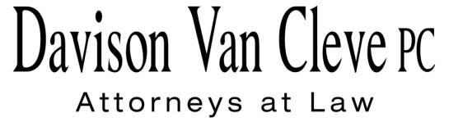
TEL (503) 241-7242 ● FAX (503) 241-8160 ● mail@dvclaw.com
Suite 400
333 S.W. Taylor
Portland, OR 97204

November 27, 2013

Via Electronic Mail

Mr. Steven V. King
Acting Executive Director
Washington Utilities & Transportation Commission
1300 S. Evergreen Pk. Dr. S.W.
P. O. Box 47250
Olympia, WA 98504-7250

Re: Energy Independence Act Rulemaking, WAC 480-109
Docket No. UE-131723

Dear Mr. King:

Enclosed for filing in the above-captioned proceeding, please find the Comment Form of the Industrial Customers of Northwest Utilities.

Thank you for your assistance, and please don’t hesitate to contact our office with any questions.

Sincerely yours,

/s/ Jesse Gorsuch
Jesse Gorsuch
Enclosures

