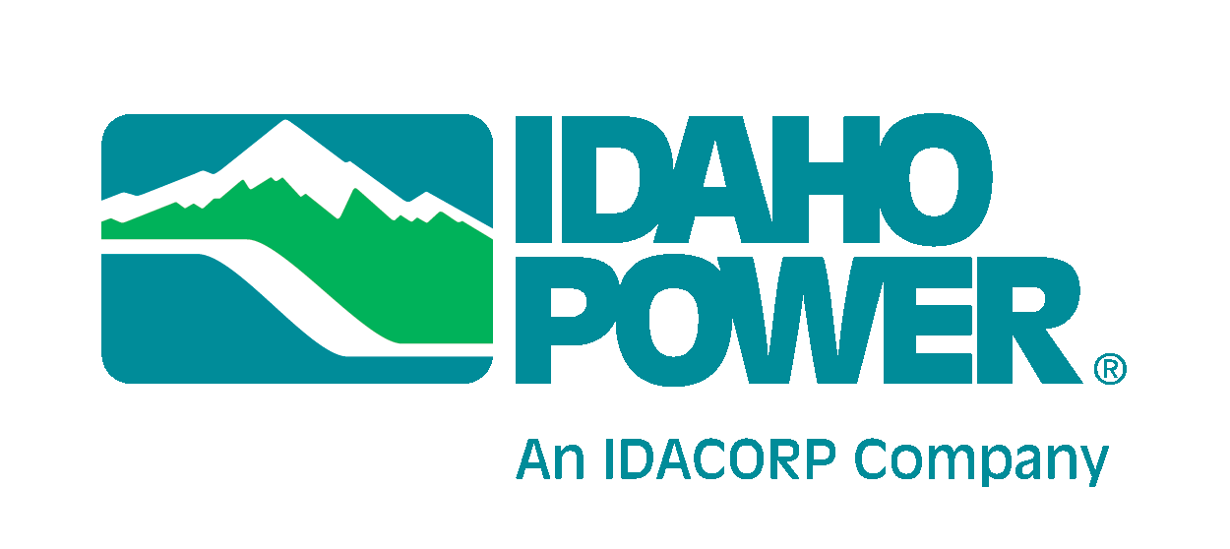
October 5, 2015

California Public Utilities Commission  505 Van Ness Avenue  San Francisco, CA 94102 | Utah Public Service Commission  Heber M. Wells Building, 4th Floor  160 East 300 South  Salt Lake City, UT 84111
Idaho Public Utilities Commission  472 W. Washington  Boise, ID 83702 | Washington Utilities and Transportation Commission  1300 S. Evergreen Park Drive S.W.  P.O. Box 47250  Olympia, WA 98504-7250
Public Utility Commission of Oregon  201 High Street SE, Suite 100  Salem, OR 97301 | Public Service Commission of Wyoming  2515 Warren Avenue, Suite 300  Cheyenne, WY 82002

RE: PacifiCorp—Idaho Power Asset Exchange Update
Docket UE-144136

In December 2014, PacifiCorp and Idaho Power Company filed applications with each of their state commissions and Federal Energy Regulatory Commission (FERC) for approval of an exchange of certain transmission assets. PacifiCorp and Idaho Power are pleased to notify the commissions that they have now obtained necessary approvals, with the docket numbers and the approval dates shown below.

FERC—Docket Nos. EC15-54-000, ER15-683-000, ER15-686-000, ER15-680-000, and
ER15-681-000—June 17, 2015
California—Application (A.)14-12-022—August 27, 2015
Idaho—Case Nos. PAC-E-14-11 and IPC-E-14-41—June 5, 2015
Oregon—Docket No. UP 315—June 9, 2015
Utah—Docket No. 14-035-150—Notice; No commission approval required
Washington—Docket UE-144136—September 24, 2015
Wyoming—Docket Nos. 20000-465-EA-14 and 20005-35-EA-14—August 7, 2015

PacifiCorp and Idaho Power plan to close the transaction on October 30, 2015. This will allow the companies to begin operating under the new agreements by November 4, 2015.

Within 60 days after closing, there will be a net book value true-up and the companies will provide final accounting entries to FERC and the Oregon, Washington, and Wyoming state commissions as required by the approval orders. PacifiCorp and Idaho Power recently became aware of guidance issued by the Internal Revenue Service (IRS) relating to §1031 tax-deferred like-kind exchange transactions (§1031 Exchange). The IRS advised utility taxpayers who are parties to a §1031 Exchange to remove the tax-depreciation-related accumulated deferred income tax liability (ADIT) associated with the exchanged assets from rate base to avoid non-compliance with existing IRS normalization requirements. PacifiCorp, Idaho Power, and their respective external auditors and tax advisors agree that the final accounting for the associated transmission asset exchange will require entries to comply with the new IRS guidance. The expected practical effect of the entries will be an increase of rate base resulting from the removal of ADIT related to the exchanged assets, and no change to the calculation of the income tax provision for regulatory or financial accounting purposes. These anticipated entries will be reflected in the final accounting entries associated with the transaction, and will be filed with FERC and certain state commissions as required in the final orders approving the transaction.

For questions regarding this matter, please contact Bryce Dalley at Pacific Power, Jeff Larsen at Rocky Mountain Power, or Tim Tatum at Idaho Power. Our contact information is shown below.

Sincerely,

_________________________  R. Bryce Dalley  Vice President, Regulation  Pacific Power  503-813-6389 | ________________________  Jeffrey K. Larsen  Vice President, Regulation  Rocky Mountain Power  801-220-4097 | _______________________  Tim Tatum  General Manager, Regulatory Affairs  Idaho Power Company  208-388-5515

PacifiCorp does business in California, Oregon, and Washington as Pacific Power and in Idaho, Utah, and Wyoming as Rocky Mountain Power.

