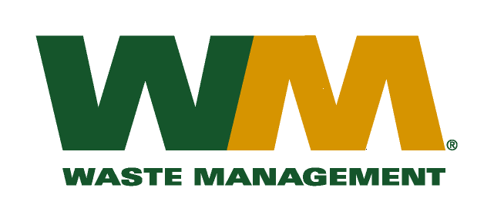

June 16, 2010

Washington Utilities and Transportation Commission
Chandler Plaza Building
1300 S. Evergreen Park Drive SW
P.O. Box 47250
Olympia, WA. 98504-7250

Subject: Waste Management – South Sound and Waste Management of Seattle, divisions of Waste Management of Washington, Inc. (G-237); Tariff No. 22
Enclosed herein, you will find our new Tariff No.22 for the above-referenced company. This tariff replaces Waste Management – South Sound and Waste Management of Seattle Tariff No.21. In this new tariff, we are requesting adjustments to our rates attributed to increased disposal, maintenance, labor, fuel and other operating and administrative costs since our last general rate increase. This company received its last general rate increase on May 1, 2006 more than four years ago. This new tariff, if approved by the commission, would increase Company revenue by approximately $1,700,000 (16%) and collectively, residential and commercial rates by 17%. This new tariff is being filed with a proposed effective date of August 1, 2010.
Enclosed for your review are one paper and two electronic copies (excel and pdf. format) of our accounting workpapers. Please note that our filing includes certain information that is confidential.
Sample customer notices are also enclosed. Customer notices will be mailed on or before July 1, 2010. In addition, a copy of this transmittal letter was mailed to King County on June 16, 2010.
Also enclosed is a “Petition for Rule Exemption”, seeking the Commission’s approval to file Work Papers that comport with the exemption granted in Waste Management of Washington, Inc.’s most recent general rate increase filing. WUTC v. Waste Management of Washington d/b/a Waste Management Sno-King, Docket TG-091933 Order 04 & TG-091945 Order 03 (Consolidated) – Denying Petition For Rule Interpretation; Granting Exemption To Rule (March 23, 2010).
If you have any questions or need additional information, please contact me at:
Address: 13225 NE 122nd Place, Kirkland, WA 98034
Telephone /Fax #: (425) 814-7840 / (425) 814-7866
e-mail: mweinstein@wm.com
Respectfully,

Michael A. Weinstein
Senior Pricing Manager, Pacific Northwest Market Area
cc: Dean Kattler
Tim Crosby
Greg Hale
Tom Leland
Clerk of the Board, King County

