July 30, 2010

VIA ELECTRONIC FILING
AND OVERNIGHT DELIVERY

Washington Utilities & Transportation Commission
P.O. Box 47250
1300 S. Evergreen Park Drive SW
Olympia, WA 98504-7250

Attention: David W. Danner,
Executive Director and Secretary

RE: Service Standards Report Submitted Pursuant to Docket No. UE-051090

Please find enclosed Pacific Power’s semi-annual report for the period January 1, 2010 through June 30, 2010 detailing Pacific Power’s performance in meeting the service standards approved in the above docket.

If you have any questions or require further information, please call me at (503) 331-4306.

Sincerely,

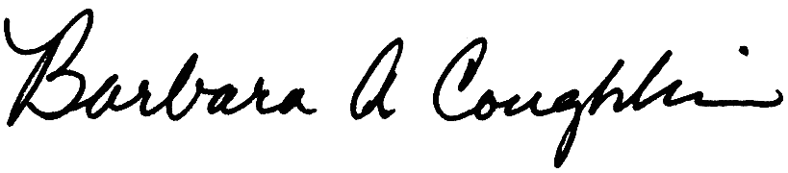

Barbara Coughlin, Director
Customer and Regulatory Liaison

cc: David Pratt - Washington Utilities and Transportation Commission

Deborah Reynolds - Washington Utilities and Transportation Commission

Enclosures

