August 12, 2014

Steven V. King, Executive Director and Secretary
Utilities and Transportation Commission
1300 S. Evergreen Park Dr. SW
P.O. Box 47250
Olympia, WA 98504-7250

RE: Washington Utilities and Transportation Commission v. Estates Water Systems, Inc.

Commission Staff’s Response to Application for Mitigation of Penalties UW-140841

Dear Mr. King:

On May 28, 2014, the Utilities and Transportation Commission issued a $800 Penalty Assessment in Docket UW-140841 against Estates Water Systems, Inc. for 8 violations of Washington Administrative Code (WAC) 480-110-505, which requires water companies to furnish annual reports to the commission no later than May 1 each year.¹

On June 3, 2014, Estates Water Systems, Inc. wrote the commission requesting mitigation of penalties (Mitigation Request).² In its Mitigation Request, Estates Water Systems, Inc. does not dispute that the violation occurred. The company provided information regarding the recent change in accounting agencies and miscommunication regarding the time sensitive nature of the reports.

It is the company’s responsibility to ensure that the regulatory fee is paid and the annual report is filed by the May 1 deadline. On February 28, 2014, Annual Report packets were mailed to all regulated water companies. The instructions for annual report completion page of the annual report informed the regulated company that it must complete the annual report form, pay the regulatory fees, and return the materials by May 1, 2014, to avoid enforcement action.

On May 13, 2014, Estates Water Systems, Inc. filed its completed 2013 annual report and paid the required regulatory fees. The company has been active since 1992. The company was previously delinquent in filing the 2006 annual report. Staff supports the company’s request for

UTC Annual Report
August 12, 2014
Page 2

mitigation due to its recent history of compliance. Staff recommends a reduced penalty assessment of $25 per day for a total penalty assessment of $175.

If you have any questions regarding this recommendation, please contact Amy Andrews, Regulatory Analyst, at (360) 664-1157, or aandrews@utc.wa.gov.

Sincerely,

Sondra Walsh, Director
Administrative Services

ATTACHMENT A
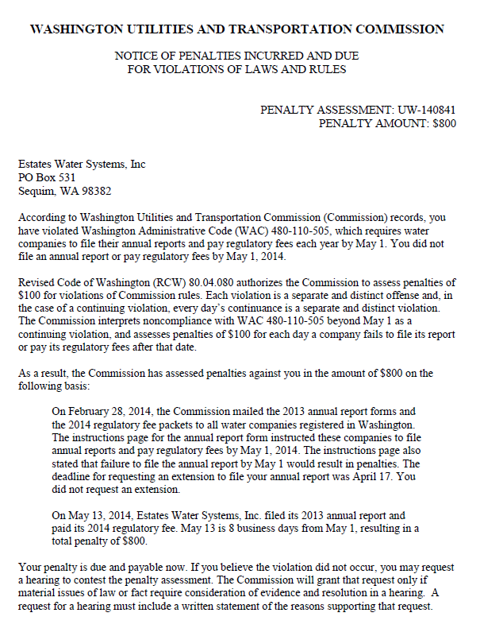

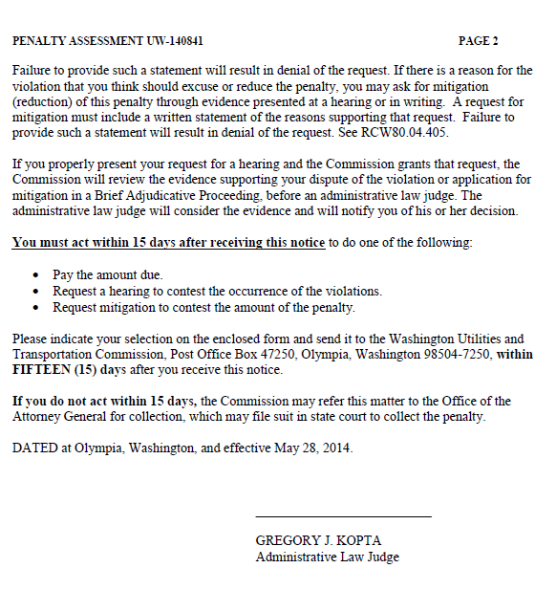

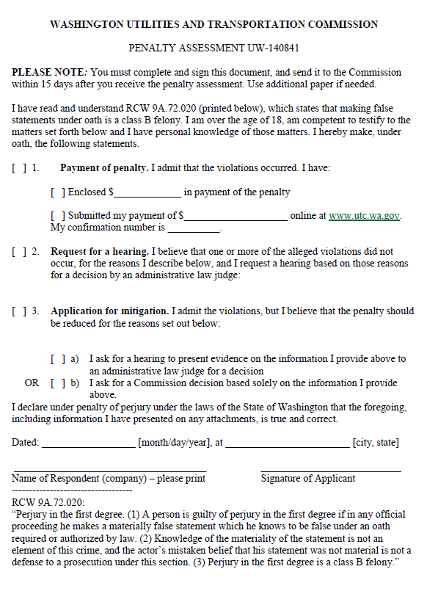

ATTACHMENT B
