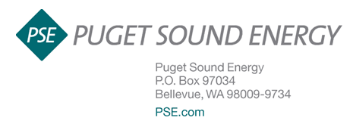

April 3, 2018

Filed Via Web Portal

Mr. Steven V. King, Executive Director and Secretary
Washington Utilities and Transportation Commission
P.O. Box 47250
Olympia, Washington 98504-7250

Re: Docket No. UG-180283 - PSE Advice No. 2018-21

Dear Mr. King:

On March 30, 2018, Puget Sound Energy (“PSE”) filed with the Commission rate revisions to its natural gas base rate schedules. The proposal represents a decrease for all customers. Work papers supporting this filing are attached.

Although not required, pursuant to WAC 480-90-198, Notice Verification and Assistance, PSE is providing the following statements, 1) that it posted the above-referenced filing in accordance with WAC 480-90-193(1) by posting on PSE’s web site, and 2) that it provided public notice in the form of a published notice within 30 days of the requested effective date of May 1, 2018, in accordance with WAC 480-90-194(2). A copy of the published notice that appeared in area newspapers on March 31, 2018, is attached. PSE also provided a copy of the notice to community agencies, posted the notice on PSE.com and provided notice to news editors of area newspapers, television and radio stations.

Please contact Julie Waltari at (425) 456-2945 for additional information about this notice publication or the posting. If you have any other questions please contact me at (425) 456-2110.

Sincerely,
/s/ Kenneth S. Johnson
Ken Johnson
Vice President, Regulatory and Government Affairs
Puget Sound Energy
PO Box 97034
Bellevue, WA 98009-9734
425-456-2110
ken.s.johnson@pse.com

cc: Lisa Gafken-Public Counsel, Sheree Carson-Perkins Coie
Attachment: Customer Notice

