June 9, 2014

Steven V. King, Executive Director and Secretary
Utilities and Transportation Commission
1300 S. Evergreen Park Dr. SW
P.O. Box 47250
Olympia, WA 98504-7250

RE: Washington Utilities and Transportation Commission v. Blue Star Services, Inc.

Commission Staff’s Response to Application for Mitigation of Penalties TE-141054

Dear Mr. King:

On May 23, 2014, the Utilities and Transportation Commission issued a $1,000 Penalty Assessment in Docket TE-141054 against Blue Star Services, Inc. for 10 violations of Washington Administrative Code (WAC) 480-30-071, which requires charter and excursion carriers to furnish annual reports to the commission no later than May 1 each year.¹

On May 30, 2014, Blue Star Services, Inc. wrote the commission requesting mitigation of penalties (Mitigation Request).² In its Mitigation Request, Blue Star Services, Inc. does not dispute that the violation occurred. The company states, “Today we received a Notice of Penalties Incurred and Due for failure to file the 2013 Charter Excursion Annual Report. I was shocked that this was not handled by our Charter Department long before the required due date. I later learned that the report was directed to Blue Star Services, Inc. (A separate legal entity) that only operates an airport shuttle service to the Portland International Airport using passenger vans. Since the report clearly is for Charter & Excursion companies, the report was never completed. I do understand that Blue Star Charters & Tours is required to submit the Annual report since it operates a fleet of motor coaches in Washington. I have included the completed report with this letter. In addition, the actual regulatory fees for 2013 were paid in full on November 26, 2013. For as long as I can remember we have been diligent to respond on time to any request by the WUTC, including the annual report I have completed myself since 2003. I respectfully request the penalty be waived for this first time offense. Furthermore, you have my word the report will be completed long before the due date.”

UTC Annual Reports
June 9, 2014
Page 2

It is the company’s responsibility to ensure that the regulatory fee is paid and the annual report is filed by the May 1 deadline. On February 28, 2014, Annual Report packets were mailed to all regulated charter and excursion companies to the company of record.³ The instructions for annual report completion page of the annual report informed the regulated company that it must complete the annual report form, pay the regulatory fees, and return the materials by May 1, 2014, to avoid enforcement action.

On May 30, 2014, Blue Star Services, Inc. filed the 2013 annual report and timely paid the required regulatory fees on December 2, 2013. The company permit was issued on June 12, 2003. No previous violations of WAC 480-30-071 are on commission record. The UTC also recently adopted new rules requiring the annual report to be filed by May 1 while the regulatory fees remained due on December 31. Despite the commission communication regarding these filing changes to all regulated charter and excursion companies, commission staff supports the company’s request for mitigation but not a fee waiver. Staff recommends a reduced penalty assessment of $200.

If you have any questions regarding this recommendation, please contact Amy Andrews, Regulatory Analyst, at (360) 664-1157, or aandrews@utc.wa.gov.

Sincerely,

Sondra Walsh, Director
Administrative Services

ATTACHMENT A
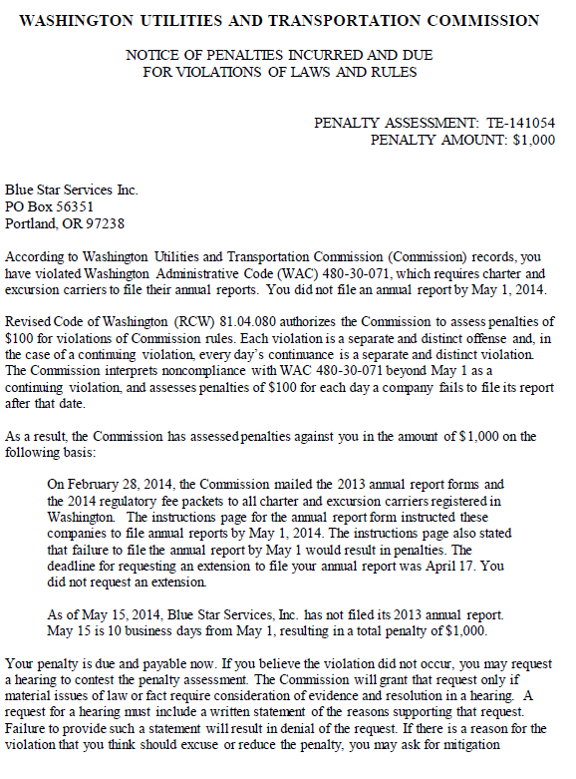
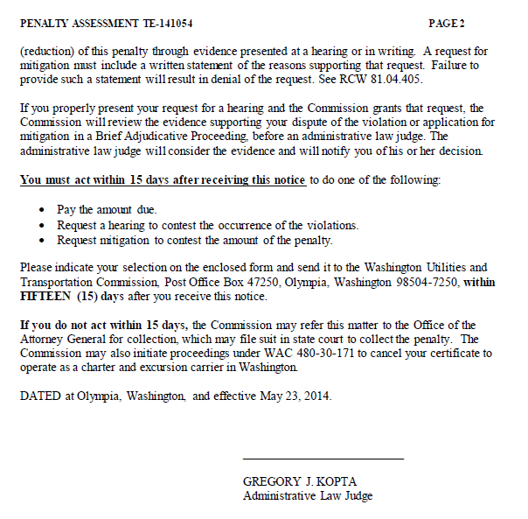

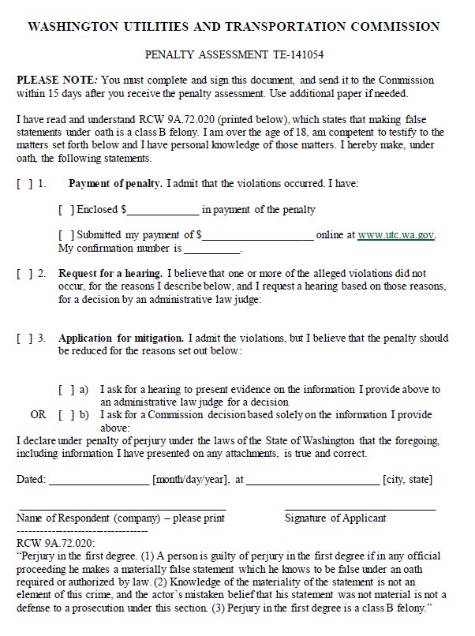

ATTACHMENT B
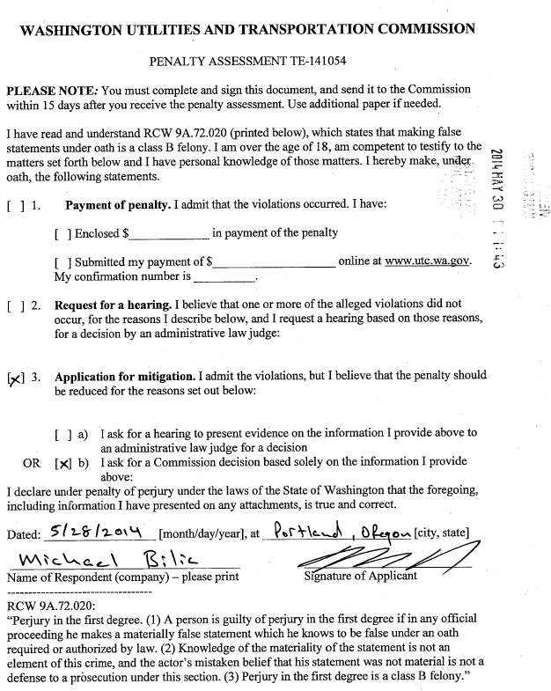

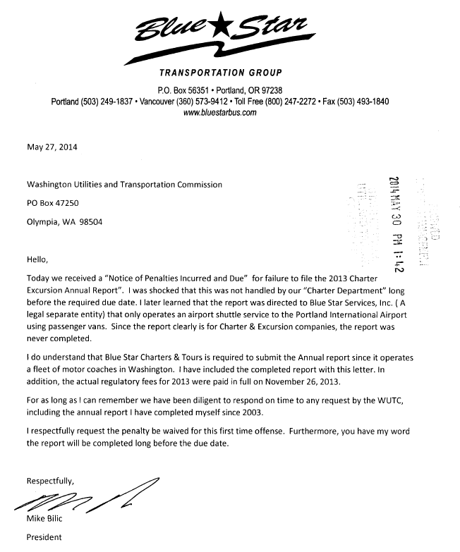

ATTACHMENT C
