September 12, 2012

David W. Danner, Executive Director and Secretary
Washington Utilities and Transportation Commission
1300 S. Evergreen Park Dr. SW
P. O. Box 47250
Olympia, Washington 98504-7250

RE: Washington Utilities and Transportation Commission v. Cristalina L.L.C.
Commission Staff’s Response to Application for Mitigation of Penalties
Docket UW-120861

Dear Mr. Danner:

On July 13, 2012, the Washington Utilities and Transportation Commission issued a $2,100 Penalty Assessment in docket UW-120861 against Cristalina L.L.C. (Cristalina) for 21 violations of Washington Administrative Code (WAC) 480-110-505, which requires water companies to furnish annual reports to the commission no later than May 1 each year. The penalty assessment instructed Cristalina to complete and sign the document, and send it to the commission within 15 days after receiving it. Cristalina had until July 28, 2012 to file its response.

On August 16, 2012, Cristalina wrote the commission requesting mitigation of penalties (Mitigation Request), which is 29 days past the service date of July 13, 2012. In its Mitigation Request, Cristalina does not disputes the violations occurred and states, “We submitted the report on (blank). My assistant made a copy and filed it when we received notice it was late we resubmitted the report. We do not believe we should incur a fine and we will send it registered mail next year. We are a small company worth no $.”

Staff determined the annual was dated April 28, 2012, however it was not received by the commission until May 29, 2012. The company was informed, on the same day, the report was incomplete.

It is the company’s responsibility to ensure that the regulatory fee and the annual report are filed by the May 1 deadline. On February 29, 2012, Annual Report forms and Regulatory Fee packets were mailed to all regulated water companies. In addition to other information, the cover letter informed the regulated company it must complete the annual report form, pay any regulatory fees and return the material by May 1, 2012, to avoid enforcement action. The letter also stated a company may file a written request for an extension, however the request must be filed with the UTC by April 24, 2012, and must state a valid reason for why the extension is needed, along with the date the report will be filed. The company did not file a request for an extension. On May 14, 2012, the commission mailed a letter to those companies that had not yet filed an annual report notifying them that, to date, they had incurred a penalty of $800. The letter went on to explain that companies who filed their annual reports no later than May 25, 2012, would receive mitigated penalties of $25 per day, with an additional $25 per day for each instance in the previous five years that the company received a penalty for filing a late report. The company had substantial time and sufficient notice to file its annual report, if not by the May 1 deadline.

As of September 6, 2012, the commission has not received a completed annual report from Cristalina. Cristalina did not file its annual report by May 31, 2012, which is 21 business days past the deadline of May 1, 2012. The penalty is $100 per business day for a total of $2,100. Cristalina became regulated in February 2003 and received one penalty of $100, for a violation of WAC 480-110-505, which requires water companies to furnish annual reports to the commission no later than May 1 each year.

Staff does not support mitigating the assessed penalty of $2,100. Cristalina failed to file its response within the 15 day timeframe required for the commission to consider mitigation. Staff recommends denying the mitigation request.

If you have any questions, please contact Mathew Perkinson, Compliance Investigator, at (360) 664-1105, or at mperkinson@utc.wa.gov.

Sincerely,

Sharon Wallace, Assistant Director
Consumer Protection and Communications
Attachment A

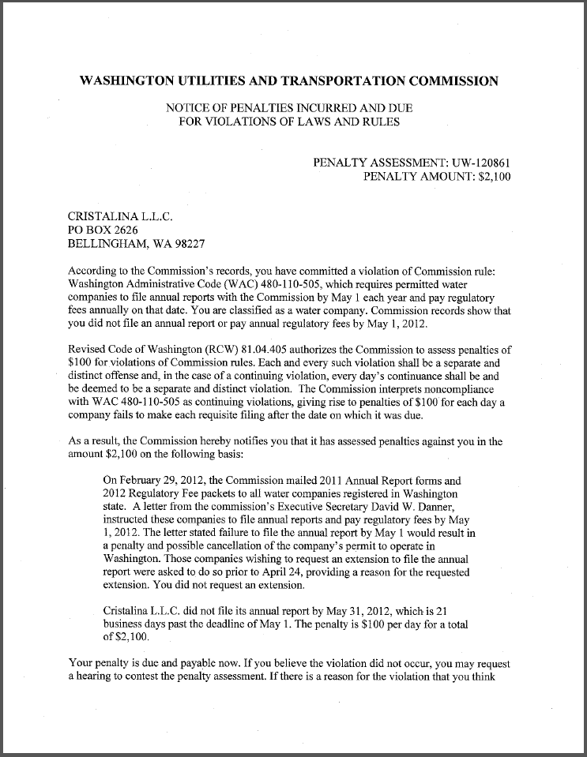
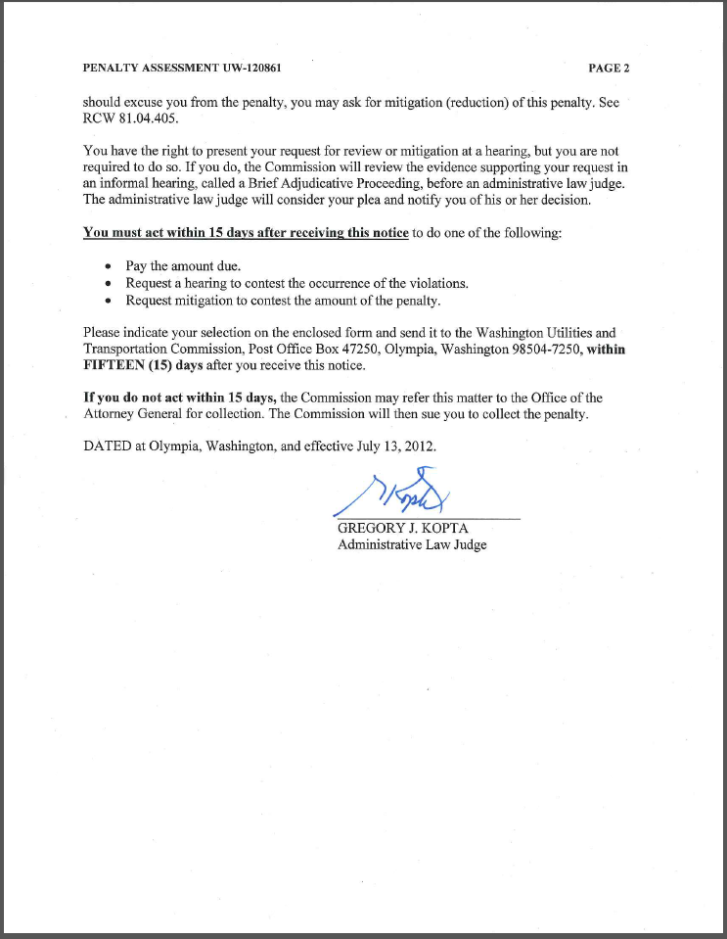
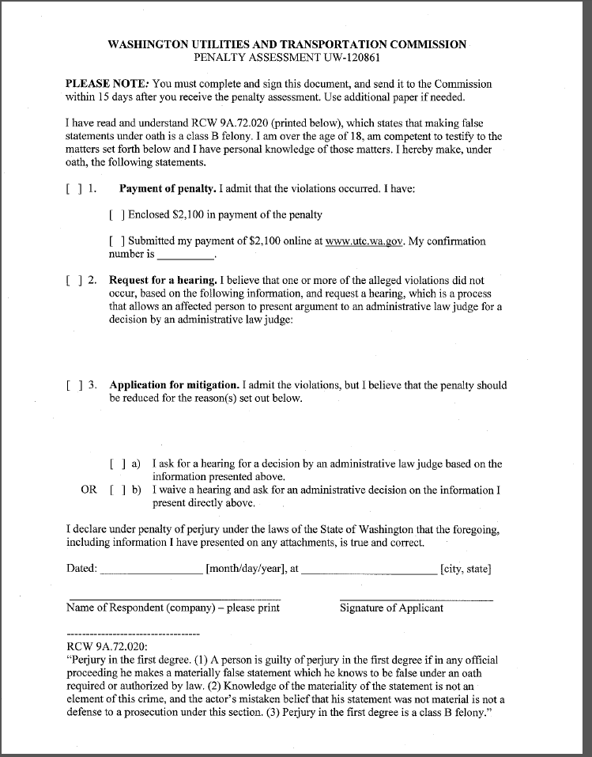

Attachment B

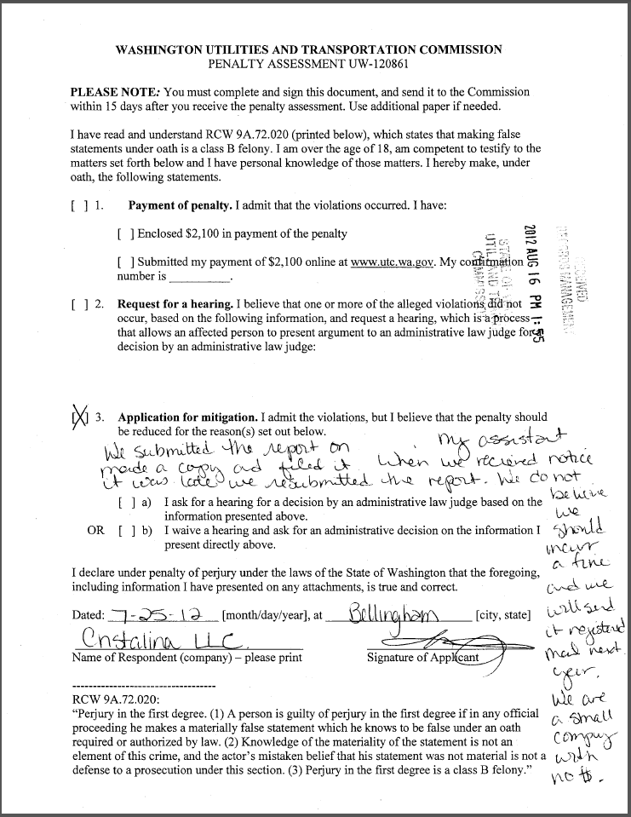

Attachment C

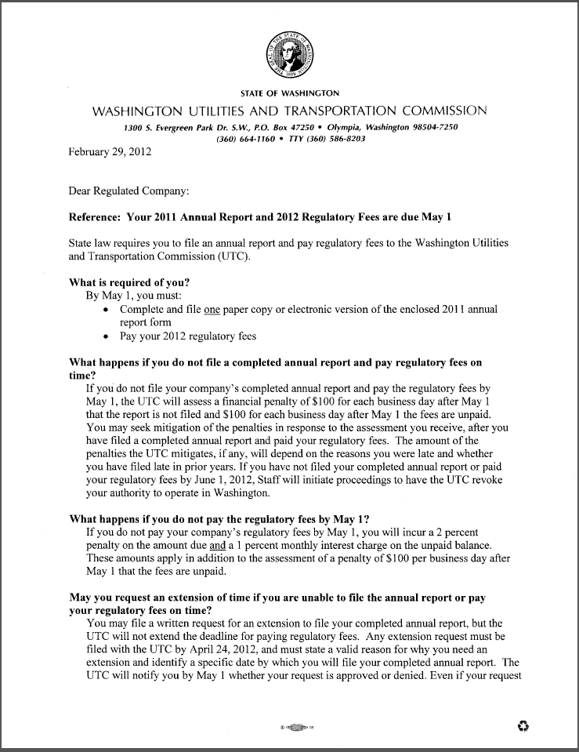
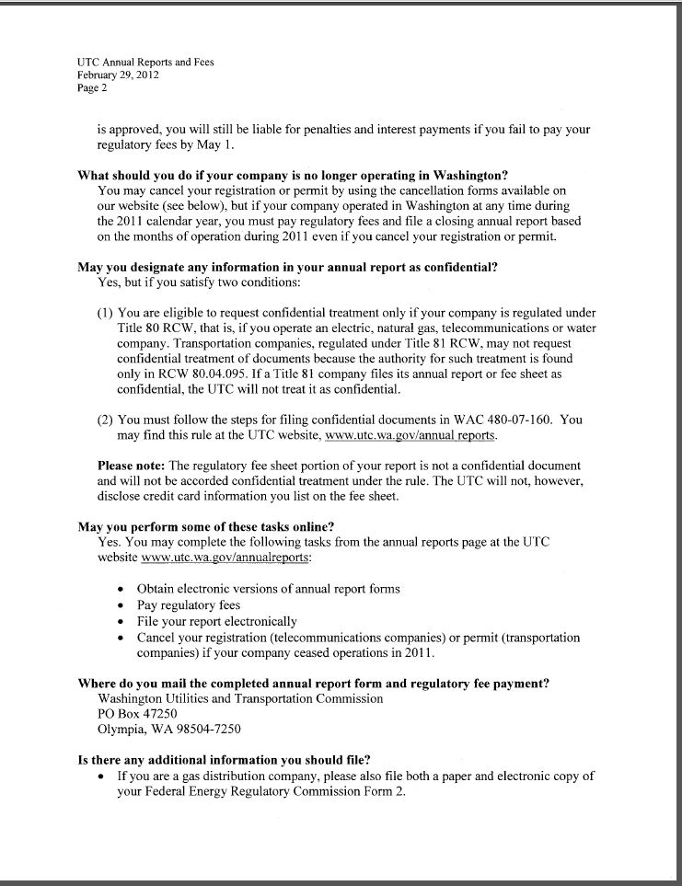
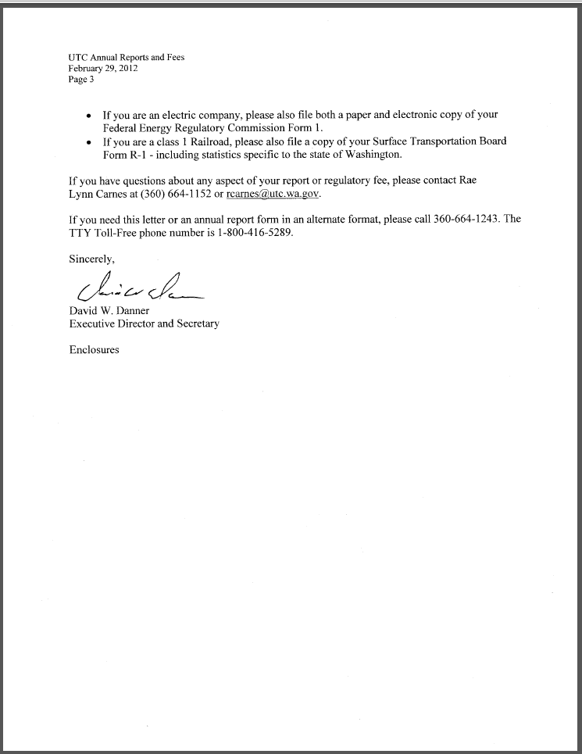

Attachment D

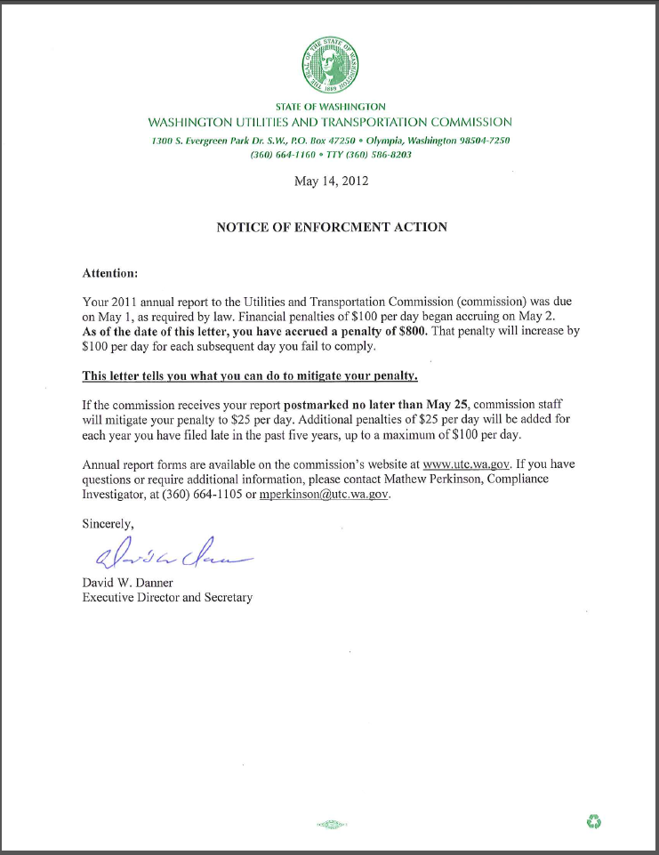

See attachment A for a copy of the penalty assessment sent on July 13, 2012 to Cristalina L.L.C.
See attachment B for a copy of Cristalina’s Mitigation Request received by the commission on August 16, 2012.
See attachment C for a copy of the letter sent to all regulated companies on February 29, 2012.
See attachment D for a copy of the enforcement letter sent to the company of May 14, 2012.

