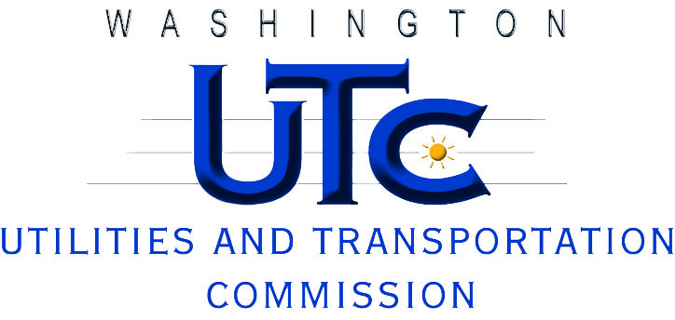

Investigation Report
Avista Corporation

U-101169

Rayne Pearson
Compliance Investigations
December 2010

