June 18, 2012

Mr. David Danner, Executive Director & Secretary
Washington Utilities and Transportation Commission
1300 S. Evergreen Park Drive S. W.
P.O. Box 47250
Olympia, Washington 98504-7250

Dear Mr. Danner:

Pursuant to WAC 480-108-040, Avista hereby submits a copy of the three recently executed Net Energy Metering Interconnection Agreements. These agreements are being filed confidentially with the Commission per WAC 480-07-160 as they contain sensitive customer information. Please direct any questions related to this filing to me at 509.495.8620 or by email at pat.ehrbar@avistacorp.com.

Sincerely,

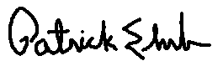
Patrick Ehrbar
Manager, Rates & Tariffs

Enclosures

