November 30, 2016

via electronic mail (sking@utc.wa.gov) and first-class mail

Steven V. King
Executive Director and Secretary
Washington Utilities and Transportation Commission
Docket # TV-161097
P.O. Box 47250
Olympia, WA 98504-7250

re: Docket # TV-161097

Director King:

Enclosed please find Applcant’s Request for Production in the above-referenced matter.

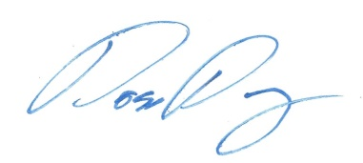
Thank you in advance.

Ross Day
Attorney for Cheryl Ball

cc: Client
Andrew J. O’Connell

