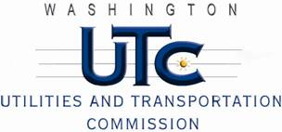

Memorandum
October 31, 2012

To: TR-120142 - File

From: Betty Young, Compliance Investigator, Transportation Safety

Subject: TR-111584 – Clark County
Grade Crossing Protective Fund (GCPF) project to modify active warning devices at 10 crossings located in Clark County

On November 22, 2011, the Washington Utilities and Transportation Commission (Commission) awarded Clark County a GCPF grant in the amount of $19,684.54 to modify active warning devices at 10 crossings in Clark County. The estimated project cost was $19,684.54, with Clark County paying for all costs exceeding the grant amount.

On May 3, 2012, Clark County submitted an amended petition. Prices for LED lights came in substantially lower than Clark County initially estimated, so the county requested a reduced grant amount and the inclusion of two additional crossings in the proposed upgrades. The county also asked for additional time to complete the project.

On May 16, 2012, the Commission granted the amended petition, approved the revised grant amount of $18,600.98, and granted the extension of time for Clark County to complete the project.

On October 29, 2012, Clark County submitted a request for reimbursement for work pursuant to Commission order. Commission staff conducted site visit of a sampling of the crossings and verified that the project was completed according to the specifications outlined in the order approving the grant.

Please close this docket.

