Exhibit No.___(JM-1T)

BEFORE THE WASHINGTON UTILITIES AND TRANSPORTATION COMMISSION

DOCKET NO. UG-16____

DIRECT TESTIMONY OF

JODY MOREHOUSE

REPRESENTING AVISTA CORPORATION

I. INTRODUCTION
Q. Please state your name, business address, and present position with Avista Corp.
A. My name is Jody Morehouse and I am employed as Director of Gas Supply for Avista Utilities (Avista or Company). My business address is 1411 East Mission Avenue, Spokane, Washington. In my current role I am responsible for Avista’s natural gas supply and upstream pipeline transportation resources.
Q. Would you please describe your education and business experience?
A. Yes. I graduated from Montana State University with a Bachelor of Science Degree in Mechanical Engineering and hold a professional engineering license in the State of Washington. I joined the Company in 1989 and have held staff and management positions in our natural gas engineering, natural gas operations, natural gas planning, and natural gas measurement departments. Additionally, I held the position of Manager of Pipeline Integrity and Compliance prior to my current role.
Q. What is the purpose of your testimony in this proceeding?
A. The purpose of my testimony is to describe Avista’s natural gas resource planning process, provide an overview of the Jackson Prairie natural gas storage facility, and provide an overview of the Company’s 2014 Natural Gas Integrated Resource Plan. A table of contents for my testimony is as follows:
Description Page
I. Introduction 1
II. Planning for Commodity Resource Procurement 2
III. Jackson Prairie Storage 9
IV. Integrated Resource Plan 13
Q. Are you sponsoring exhibits in this proceeding?
A. Yes. I am sponsoring Exhibit No.___(JM-2) which is a copy of the Company’s 2014 Natural Gas Integrated Resource Plan acknowledged by this Commission on January 23, 2015.
Q. Is the Company proposing any changes to the cost of natural gas for its retail natural gas customers in this case?
A. No, Avista is not proposing changes in this filing related to the commodity cost of natural gas or upstream pipeline transportation resource costs. Changes in the commodity cost of natural gas and the cost of natural gas pipeline transportation included in customers’ rates are addressed in the Company’s annual Purchased Gas Cost Adjustment (PGA) filing. The Company expects to file its annual PGA on or before September 15, 2016, with new rates proposed to become effective November 1, 2016.

II. PLANNING FOR COMMODITY RESOURCE PROCUREMENT
Q. Please describe Avista’s natural gas portfolio as it relates to the procurement of the natural gas commodity for its local distribution company (“LDC”) customers?
A. Avista purchases natural gas for its distribution customers in wholesale markets at multiple supply basins in the western United States and western Canada. Purchased natural gas can be transported through six inter-connected pipelines on which Avista holds firm contractual transportation rights. These contracts provide access to both US and Canadian-sourced supply. The US-sourced gas represents 25% of the contractual rights and provides transportation from the Rocky Mountain supply basin. The remaining 75% provides access to Alberta and British Columbia supply basins. This diverse portfolio of natural gas resources allows the Company to make natural gas procurement decisions based on the reliability and economics that provide the most benefit to our customers. As natural gas prices in the Pacific Northwest can be affected by global energy markets, as well as supply and demand factors in other regions of the United States and Canada, future prices and delivery constraints may cause the source mix to vary.
Illustration No. 1 below is a map showing our service territory, natural gas trading hubs, interstate pipelines, and natural gas storage facility:
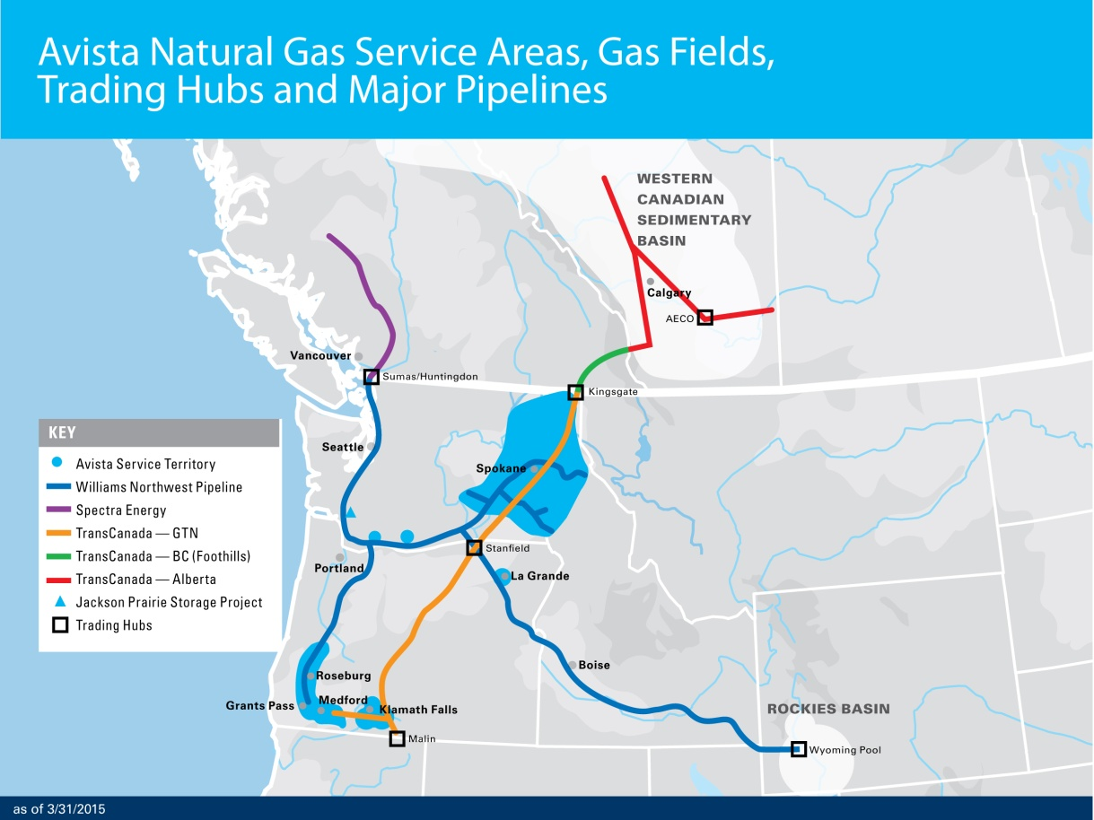
Illustration No. 1

Future natural gas prices cannot be accurately predicted. Market conditions, analysis, and experience shape our overall procurement approach. The Company’s goal is to provide reliable supply at competitive prices, with some level of price certainty, in a volatile commodity market. To that end, the Company utilizes a Procurement Plan which includes hedging (on both a short-term and long-term basis), storage utilization, and index purchases. This approach is diversified by transaction time, term, counterparty, and supply basin. The Procurement Plan is disciplined, yet flexible, and layers in fixed-price purchases over time and term to provide a level of price certainty to customers. A copy of the Company’s Natural Gas Procurement Plan is included as an exhibit to Avista’s Energy Resources Risk Policy (see Confidential Exhibit No.___(SJK-4C)).
The Procurement Plan provides a process that fixes future natural gas prices for a targeted portion of the portfolio through the use of hedge windows. The hedge windows are “open” for a predetermined time period and have upper and lower pricing levels which are determined by the market at the time the window becomes effective. In a rising market, this reduces exposure to extreme price spikes. In a declining market, it can facilitate locking in lower prices. These windows can be executed, or “closed”, if certain pricing levels are met, or upon time expiration if no pricing events occur. The Company always maintains some level of discretion and may choose not to execute within a window or to change some aspect of a window given market conditions.
In addition, a portion of the portfolio that is separate from the defined hedge windows is designated as discretionary. This opportunistic portion of the portfolio allows the Company to hedge additional, targeted volumes in natural gas years beyond the prompt year at potentially favorable pricing levels. In the event those pricing levels are not reached, the unexecuted volumes designated as discretionary hedges will become a part of the prompt year hedging program.
The Gas Supply Department continuously monitors the results of the Procurement Plan, evolving market conditions, variation in demand profiles, new supply opportunities, and regulatory conditions. Although various windows and targets are established in the initial design phase of the portfolio, the plan provides flexibility to exercise judgment to revise and/or adjust the Procurement Plan in response to changing conditions. Material changes to the Procurement Plan are communicated to Avista’s Senior Management and periodically to Commission Staff.
Q. What delivery period does the natural gas Procurement Plan include?
A. The Procurement Plan includes four complete natural gas operating years (November through October) and whole months remaining from the current month until the next October 31 (the current natural gas operating year). The four complete upcoming natural gas operating years are designated “Prompt”, “Second”, “Third”, and “Fourth” years.
Q. Please describe the components of the natural gas Procurement Plan.
A. Each year a comprehensive review of the previous year’s plan is performed. The review includes analysis of historical and forecasted market trends, fundamental market analysis, demand forecasting, and transportation, storage and other resource considerations. The plan includes the following components:
- Previous Year(s) Hedges – longer-term fixed-price purchases executed as a part of a previous year’s Procurement Plan.

- Prompt Year Hedges – the portion of the portfolio addressed through the utilization of hedge windows. In each window, fixed price purchases are made for various prompt year delivery periods (i.e. November to March winter purchase, April to October summer purchase, or individual months). Prior to the execution of each window, market conditions, fundamental market knowledge, and other information are considered to determine if execution will occur.

- Storage Injections and Withdrawals – utilization of the working gas capacity and deliverability of the Jackson Prairie natural gas storage facility (“JP”). With JP, Avista is able to provide natural gas during peak load events during the higher demand winter months. Additionally, JP withdrawals can be executed during volatile daily gas price events. For less critical operational purposes, JP withdrawals and injections are frequently used to alleviate load imbalances on pipelines. In 2015, Avista deployed a new natural gas storage software model enabling Avista the potential to optimize 100% of the working gas capacity. The model tracks the historical price spreads of various time frames for JP injections and withdrawals. This historical analysis quantifies the relative benefit of current forward prices and identifies optimal transactions to lock in more economic value than the traditional summer-winter spread.

- Discretionary Long-term Hedges – purchases based on a set of price levels, or targets, which trigger possible execution. At the time the triggers are reached, evaluation of market conditions, fundamental market knowledge, and other information are considered. These hedges will generally be executed when they can be done at or below the established targets.

- Index Purchases – physical index-based natural gas purchases are procured prior to or throughout the delivery month. These purchases are usually associated with daily pricing. The majority of the amount of index purchases planned is the difference between the forecasted demand less the sum of the previous year hedges and prompt year hedges. Index purchases are also made as part of Avista’s gas storage management process throughout the year. This process is explained in greater detail in Section III.

Q. Please describe how the Procurement Plan manages volatility.
A. The Procurement Plan focuses on managing the costs associated with serving varying retail load with supply from a wholesale market with price volatility. For example, system-wide average daily demand for a month can fluctuate between 29,000 dekatherms (Dth) per day during a summer month and 180,000 Dth/day during a winter month. Further, December’s system-wide daily demand volatility has ranged from a low of 99,000 Dth/day to a high of 300,000 Dth/Day. Finally, from Avista’s 2014 IRP, system-wide peak day demand for the 2015-2016 heating season is forecasted to be approximately 339,000 Dth per day.
In order to manage these seasonal, monthly and daily volume swings, Avista shapes the components of the Procurement Plan by month (i.e. more natural gas is hedged for the winter months than for the summer). Illustration No. 2 below includes a chart that shows the demand volatility:
Illustration No. 2
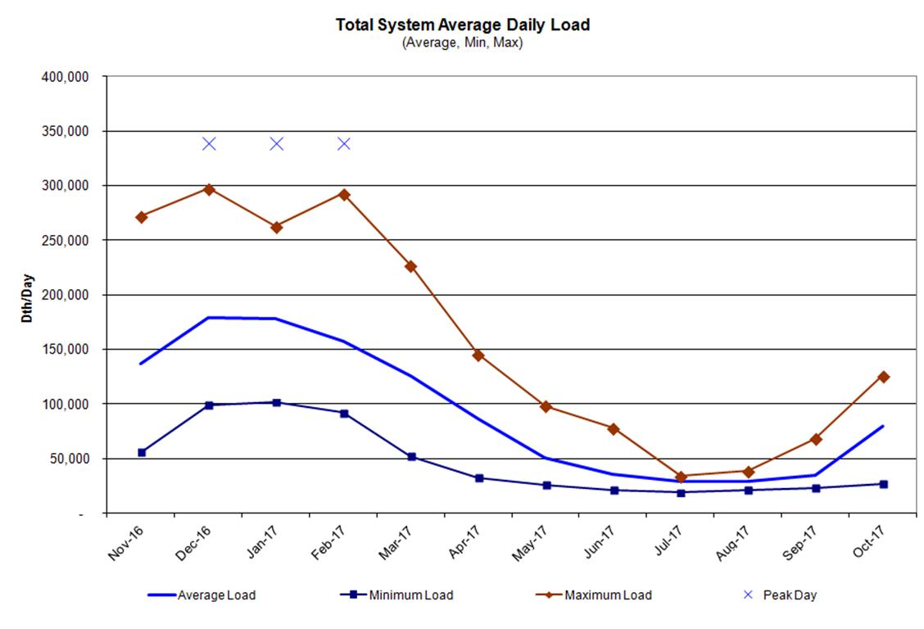

Price volatility can also vary widely by season, month and day. Illustration No. 3, below, includes a chart depicting the natural gas price volatility over time:
Illustration No. 3
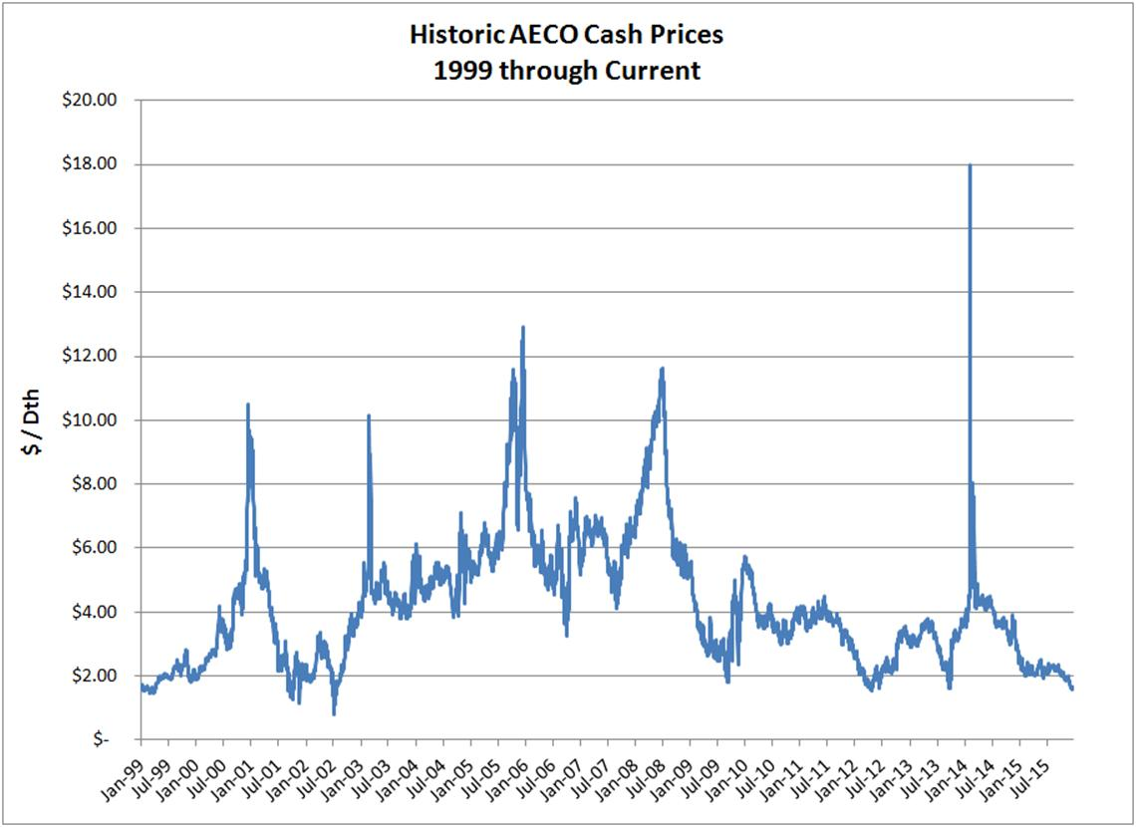
.

Avista cannot predict with accuracy what natural gas prices may be. Our experience and intelligence related to market fundamentals guide our procurement decisions. By layering in fixed price purchases over time, setting upper and lower pricing levels on the hedge windows, opportunistically hedging at pricing levels through the discretionary hedge program, and actively managing storage resources, Avista is able to meet our goal of providing a meaningful measure of price stability and certainty, and competitive prices for our customers.
III. JACKSON PRAIRIE STORAGE
Q. Please describe Avista’s involvement with the Jackson Prairie natural gas storage facility.
A. Avista is one of the three original developers of the underground storage facility at JP, which is located near Chehalis, Washington. Although there have been corporate changes due to mergers, acquisitions and name changes, Avista, Puget Sound Energy (PSE) and Williams Northwest Pipeline each hold a one-third share (equal, undivided interest) of this underground gas storage facility through a joint ownership agreement. Puget Sound Energy is the operator of the facility.
Q. What type of storage facility is JP?
A. JP is an underground aquifer storage facility. Storage and the associated withdrawal and injection capability has been created by a combination of wells, gathering pipelines, compression and dehydration equipment, and the removal and disposal of aquifer water.
Q. Please describe the present level of storage that Avista owns at JP.
A. At the present time, Avista Utilities owns a total of 8,528,013 dekatherms (Dth) of firm working gas capacity. This capacity comes with a withdrawal capability of 398,667 Dth per day (deliverability). Washington/Idaho’s current share of that capacity is 7,704,676 Dth and 346,667 Dth per day of deliverability. The remaining amount is allocated to our Oregon customers.
Q. What are the benefits of storage to Avista’s customers?
A. Access to regionally located storage provides several benefits to Avista’s customers. It enables the Company to capture price spreads between time periods, improve reliability and flexibility of supply, mitigates peak demand price spikes, and provides numerous other economic benefits.
Traditionally, JP has been utilized primarily to capture seasonal price spreads (differentials) between summer and winter in addition to meeting peak day load requirements. Customers have benefitted from Avista’s use of JP to buy traditionally cheaper natural gas in the summer for use in the winter period, thereby avoiding potentially higher priced index gas. In addition a small portion (approximately 10%) of JP’s overall working gas capacity has been utilized for optimization opportunities to capture economic spreads between time periods. Through this optimization strategy, Avista has been purchasing and injecting into storage natural gas in a lower-price period, and selling forward the same natural gas in a forward time period at a higher price, locking in the differential benefit for customers.
Q. What changes in the use of JP have been made in the past year?
A. The natural gas storage software model is governed by a storage management program that sets boundaries on injections and withdrawals as well as tracks real time market data to guide the purchase and sale of natural gas storage transactions. The program enforces storage constraints and requirements such as the storage fill schedule, peak day load requirements, transportation capacity limits, and deliverability constraints.
The information within the model provides the Company’s natural gas buyers the ability to identify additional opportunities to purchase lower cost natural gas in the immediate term for a sale in a future time period. For each storage purchase transaction, a corresponding forward sale is also made, locking in the benefit for our customers. Additional purchases and sales are made continuously as market conditions move into favorable conditions for each transaction. The effect of storage volumes will be that they are more frequently cycled in and out to take advantage of market conditions. It is important to note that JP will still be utilized to meet peak day needs, as well as to help mitigate daily price volatility.
Q. Please describe how this change impacts the Company’s overall level of hedges.
A. With the new optimization strategy, a portion of natural gas stored at JP that was previously utilized to lock in the summer-winter spread will no longer be available as those volumes are now tied to the storage optimization transactions described above. Cognizant that more natural gas supplies would be open to index transactions during the winter time period, the Company added incremental hedges for the winter months to offset some of the volume previously covered from JP.
As a result of that analysis, Avista replaced approximately 50% of the JP storage withdrawals that were previously made to cover winter loads with additional prompt-year hedges. The amount is 35,000 Dth/day for December, January and February. Illustration No. 4 below provides the components of the Company’s 2015-2016 Procurement Plan:
Illustration No. 4
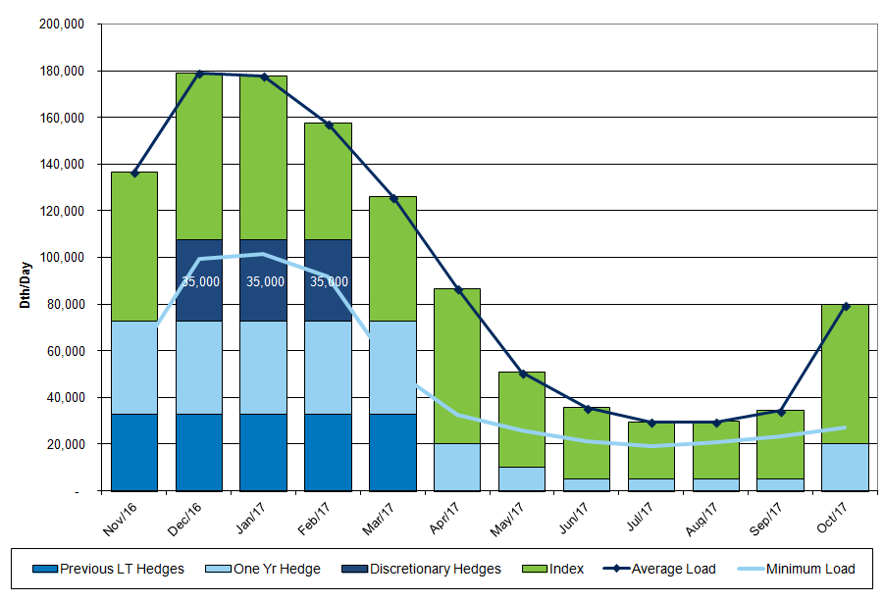

Q. Are the effects of the changes to the use of JP reflected in this general rate case?
A. No, the effects of how JP is being utilized were included in the Company’s 2015 PGA (approved with an effective date of November 1, 2015), and will be included in future PGA filings. The November 1, 2015 PGA provided a bill reduction to customers of approximately 15% due primarily to the decrease in the wholesale price of natural gas, but also due in part to the benefits of optimizing the value of JP.
IV. 2014 NATURAL GAS INTEGRATED RESOURCE PLAN
Q. Please provide an overview of the Company’s development of its 2014 Natural Gas Integrated Resource Plan.
A. The 2014 Integrated Resource Plan (“IRP”) was filed with the Commission on August 29, 2014. The IRP includes forecasts of natural gas demand and any supply-side transportation resources and demand-side measures needed for the coming 20 years, which will help Avista continue to reliably provide natural gas to our customers. A copy of the Company’s 2014 Natural Gas Integrated Resource Plan is included as Exhibit No.___(JM-2).
Q. What are the summary highlights from the 2014 IRP?
A. Highlights from the 2014 IRP are as follows:
- The Company has sufficient natural gas transportation resources well into the future with resource needs not occurring during the 20 year planning horizon in Washington, Idaho, or Oregon;

- Natural Gas commodity prices continue to be relatively stable due to robust North American supplies led by shale gas development; and

- As forecasted demand is relatively flat, the Company will monitor actual demand for signs of increased growth which could accelerate resource needs.
Q. Has the Company’s 2014 Natural Gas IRP been acknowledged by this Commission?
A. Yes, on January 23, 2015, the Commission acknowledged the 2014 Natural Gas IRP (Docket No. UG-131621), finding that the IRP met the requirements of Washington Administrative Code WAC 480-90-238.
Q. When will the Company file its next natural gas IRP?
A. The Company will file its next natural gas IRP on or before August 31, 2016. A courtesy work plan was filed in August 2015 detailing Avista’s IRP planning process as well as tentative dates and content for meetings with the Technical Advisory Group (TAC). TAC meetings will begin in the first quarter of 2016.
Q. Does this complete your pre-filed direct testimony?
A. Yes, it does.

