June 20, 2014

Steven V. King, Executive Director and Secretary
Utilities and Transportation Commission
1300 S. Evergreen Park Dr. SW
P.O. Box 47250
Olympia, WA 98504-7250

RE: Washington Utilities and Transportation Commission v. Clancy’s Transfer & Storage Inc.

Commission Staff’s Response to Application for Mitigation of Penalties TV-140950

Dear Mr. King:

On June 4, 2014, the Utilities and Transportation Commission issued a $100 Penalty Assessment in Docket TV-140950 against Clancy’s Transfer & Storage Inc. for 1 violation of Washington Administrative Code (WAC) 480-15-480, which requires household goods carrier companies to furnish annual reports to the commission no later than May 1 each year.¹

On June 9, 2014, Clancy’s Transfer & Storage Inc. wrote the commission requesting mitigation of penalties (Mitigation Request).² In its Mitigation Request, Clancy’s Transfer & Storage Inc. states, “We mailed the form & made out our payment check on 4/25/14. I thought that would be plenty of time to be received by the due date.”

It is the company’s responsibility to ensure that the regulatory fee is paid and the annual report is filed by the May 1 deadline. On February 28, 2014, Annual Report packets were mailed to all regulated household goods companies. The instructions for annual report completion page of the annual report informed the regulated company that it must complete the annual report form, pay the regulatory fees, and return the materials by May 1, 2014, to avoid enforcement action.

On May 2, 2014, Clancy’s Transfer & Storage Inc. filed the 2013 annual report and paid the required regulatory fees. The company has been active since April 4, 2003. No previous violations of WAC 480-15-480 are on commission record. Staff supports the company’s request for mitigation as this is the company’s first delinquent filing. Staff recommends a reduced penalty of $25 per day for a total penalty assessment of $25.

UTC Annual Reports
June 20, 2014
Page 2

If you have any questions regarding this recommendation, please contact Amy Andrews, Regulatory Analyst, at (360) 664-1157, or aandrews@utc.wa.gov.

Sincerely,

Sondra Walsh, Director
Administrative Services

ATTACHMENT A
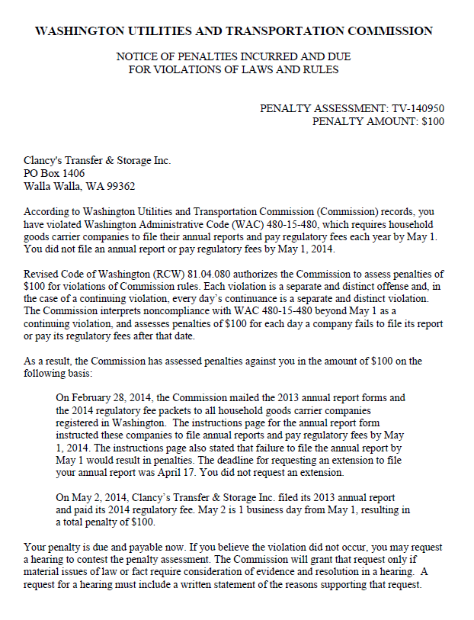

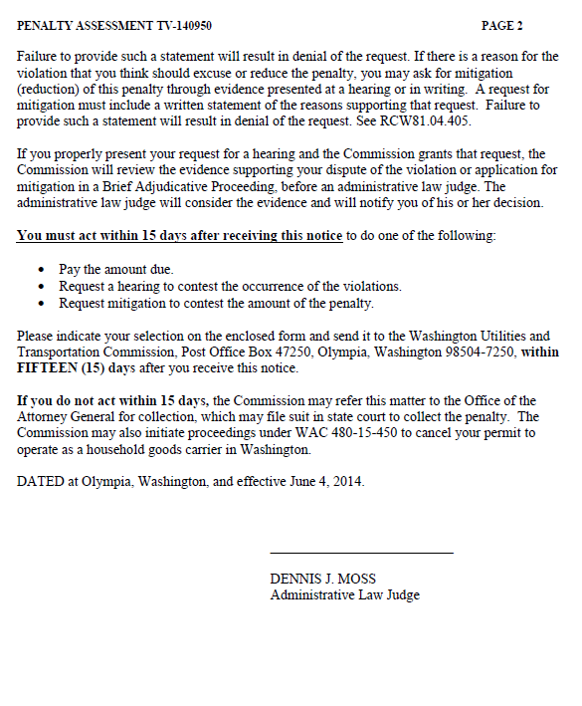

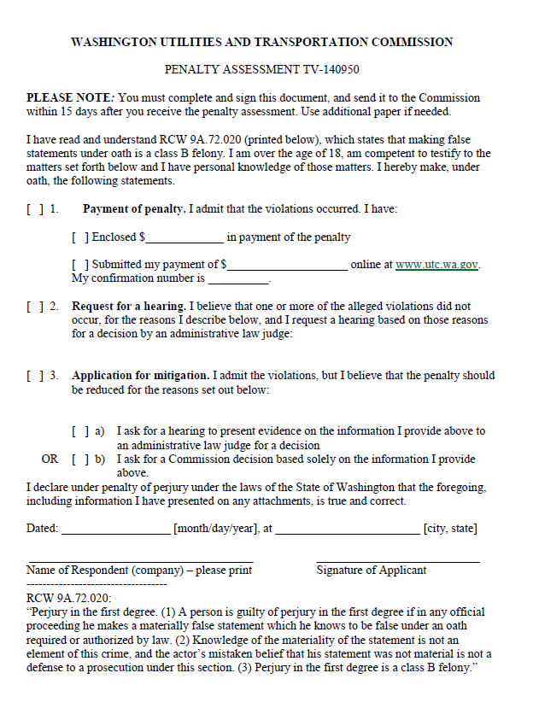

ATTACHMENT B
