August 25, 2016

Steven V. King
Executive Director and Secretary
Washington Utilities and Transportation Commission
1300 S. Evergreen Park Drive SW
Olympia, WA 98504-7250

Re: Courtesy Notice of Transaction – UT-110423
Dear Mr. King:
On behalf of YourTel America, Inc. d/b/a TerraCom (“YourTel”), a Lifeline-only Eligible Telecommunications Carrier (“ETC”) in Washington, this is to provide courtesy notice to the Washington Utilities & Transportation Commission that Global Reconnect Inc. (“GRI”) will become the majority, indirect shareholder of YourTel through GRI’s purchase of a majority interest in YourTel’s parent entity, TerraCom, Inc., in a transaction that will have no impact on consumers. The parties anticipate that the transaction will close sometime in the fall of 2016.
The transaction will be transparent to Washington consumers because YourTel will continue to be their provider, there will be no change in any customer’s rates, service plan or terms of service, and YourTel will continue to operate as in the past.
Should you have any questions concerning this matter, please contact the undersigned.
Very truly yours,
Davis Wright Tremaine LLP
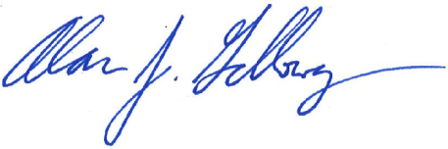
Alan J. Galloway

GRI is owned by Mr. Stan McCright, a well-regarded consultant in the field of public housing who has worked with public housing authorities throughout the country for over twenty years, creating systems to efficiently manage eligibility determinations and re-certifications for recipients of public housing benefits.
YourTel’s parent, TerraCom, Inc. provides Lifeline service to eligible consumers in other states, but does not operate in Washington State.

