MEMORANDUM
To: Nikki Kaparvich, PacifiCorp
From: Jason Christensen and Danielle Kolp, Cadmus
Subject: Impact Results for Washington See Ya Later, Refrigerator
Date: September 18, 2015
Pacific Power contracted with Cadmus to conduct an impact evaluation of its appliance recycling program called See ya later, refrigerator® (SYLR) Program for the 2013 and 2014 program years. To evaluate program gross and net energy savings for the impact evaluation, Cadmus used a method that largely mirrored the 2011-2012 SYLR evaluation and is consistent with the Uniform Methods Project (UMP). The Cadmus evaluation included use of aggregated in situ metering dataset composed of over 600 appliances that were metered for evaluations conducted in California, Wisconsin, and Michigan, conducted 126 telephone surveys with program participants, and a review of the program tracking data. This memo summarizes the evaluation findings for the refrigerator and freezer savings. Evaluated saving estimates for program kits containing energy efficient light bulbs and findings regarding program processes are not included in this memo, but will be in the final report.

Summary of Key Findings

Key Impact Findings
The key impact evaluation findings are:
- In 2013, the SYLR Program recycled 1,304 refrigerators and freezers; in 2014, participation decreased to 1,166. The program achieved 806,583 kWh net savings, roughly 53% of the reported savings of 1,535,138 over the two-year period.
- The part-use factor (portion of the year that the equipment is in operation) fell within expected ranges to 0.96 for refrigerators and 0.94 for freezers. This part-use factor is part of the gross per-unit savings calculation.
- After adjusting for part use, the gross per-unit savings were 1,112 kWh for refrigerators, down from 1,152 in 2011-2012, and 964 kWh for freezers, down from 978 in 2011-2012. Neither gross savings estimate is statistically different from the 2011-2012 evaluation estimates.
- The net per-unit savings were 328 kWh for refrigerators and 321 kWh for freezers. These values are lower than the evaluated per-unit savings for 2011-2012. The main reason for this decline was because a relatively large proportion of survey respondents indicated that, absent the program, they would have disposed of their appliance in a way that would have permanently removed the appliance from the grid (roughly 60% of respondents).
Overall net-to-gross (NTG), including kits, decreased from 52% in the 2011-2012 evaluation to 30%.
Table 1 summarizes program participation, reported savings, and evaluated gross and net savings for 2013 and 2014. The evaluated total net savings for the program are lower than the reported total savings primarily because of the lower NTG ratio. Absent the decrease in the NTG the net realization rate would have been 92%.
Table 1. 2013 and 2014 Program Savings by Measure
Measure | Evaluated Participation | Evaluated Gross Savings (kWh) | Reported Savings (kWh) | Evaluated Net Savings (kWh) | Net Realization Rate
Refrigerator Recycling | 1,959 | 2,177,781 | 1,274,688 | 642,552 | 50%
Freezer Recycling | 511 | 492,829 | 260,450 | 164,031 | 63%
Total | 2,470 | 2,670,610 | 1,535,138 | 806,583 | 53%

Methodology
This memo presents two types of evaluated savings: gross and net. To determine these values, Cadmus applied four steps (Table 2). The evaluation defined reported gross savings as the electricity savings (kWh) that Pacific Power included in its 2013 and 2014 annual program reports.
Table 2. Impact Estimation Steps
Saving Estimate | Step | Action
Evaluated Gross Savings | 1 | Verify accuracy of data in program database
 | 2 | Perform statistical/engineering analysis to evaluate per-unit savings
 | 3 | Adjust evaluated gross savings with installation rate/part-use factor
Evaluated Net Savings | 4 | Apply net-to-gross adjustments

Step one involved verifying the accuracy of data by reviewing the program tracking database to ensure that participation and reported savings matched the 2013 and 2014 annual reports.
Step two was to perform a statistical/engineering analysis to evaluate per-unit savings that involved estimating refrigerator and freezer savings.
Step three was to adjust the evaluated gross savings with the installation rate/part-use factor by determining the mean proportion of the year in which recycled appliances were used. Using a telephone survey, Cadmus collected information to estimate the part-use factor, which it then used to calculate evaluated gross savings.
Step four was to apply the NTG adjustments to determine the net savings. After conducting participant surveys, Cadmus estimated freeridership, secondary market effects (i.e., the program’s impact on the availability of used appliances), and induced replacement.

Telephone Survey Sampling Approach
Cadmus developed survey samples of randomly selected program participants. The evaluation determined sample sizes assuming a 0.5 coefficient of variation (CV) and applying a finite population correction to determine the necessary sample size. Cadmus randomly surveyed 126 participants from the population of 2,322 unique participants. Table 3 shows the planned and achieved sample sizes by target group.
Table 3. Sample Sizes by Target Group
Target Group | Population | Target  Sample Size | Achieved  Sample Size
Refrigerators | 1,844 | 66 | 66
Freezers | 478 | 60 | 60
Total | 2,322 | 126 | 126

Uniform Methods Project and Regional Technical Forum Protocols
Cadmus’ impact evaluation methodology for the 2013-2014 program years was the same as for the 2011-2012 evaluation and was informed by guidelines developed by the U.S. Department of Energy.
This evaluation follows the methodology described in the refrigerator recycling protocol, which largely mirrors the method Cadmus used in evaluation of the 2011-2012 SYLR evaluation and is consistent with the Uniform Methods Project (UMP) and the Regional Technical Forum (RTF). More information about the UMP is available on the Department of Energy’s website.
A detailed comparison of Cadmus’ approach with the RTF approach is included in Table 12.

Evaluated Gross Savings

Gross Annual Unit Energy Consumption
Cadmus used the UMP-specified regression model to estimate unit energy consumption (UEC) for refrigerators and used an analogous model developed by Cadmus outside of UMP to estimate freezer UEC. The coefficient of each independent variable indicates the influence of that variable on daily consumption, holding all other variables constant.
- A positive coefficient indicates an upward influence on consumption
- A negative coefficient indicates a downward effect on consumption
The value of the coefficient indicates the marginal impact of a one-point increase in the independent variable on the UEC. For example, a 1-cubic foot increase in refrigerator size results in a 0.059 kWh increase in daily consumption.
In the case of dummy variables, the value of the coefficient represents the difference in consumption if the given condition is true. For example, in Cadmus’ refrigerator model, the coefficient for the variable indicating whether a refrigerator was a primary unit is 0.560; this means that, all else being equal, a primary refrigerator consumes 0.560 kWh more per day than a secondary unit.

Refrigerator Regression Model
Table 4 shows the UMP model specification Cadmus used to estimate annual energy consumption of refrigerators in 2013 and 2014, along with the model’s estimated coefficients.
Table 4. Refrigerator UEC Regression Model Estimates
(Dependent Variable = Average Daily kWh, R-square = 0.30)
Independent Variables | Coefficient | p-Value
Intercept | 0.805 | 0.166
Age (years) | 0.021 | 0.152
Dummy: Manufactured Pre-1990 | 1.036 | <.0001
Size (cu. ft.) | 0.059 | 0.044
Dummy: Single Door | -1.751 | <.0001
Dummy: Side-by-Side | 1.120 | <.0001
Dummy: Primary | 0.560 | 0.008
Interaction: Unconditioned Space x HDDs | -0.040 | 0.001
Interaction: Unconditioned Space x CDDs | 0.026 | 0.188
* Cooling Degree Days (CDDs) and Heating Degree Days (HDDs) are the weighted average from Typical Meteorological Year (TMY3) data for weather stations that Cadmus mapped to participating appliance ZIP codes. TMY3 uses median daily values for a variety of weather data collected from 1991–2005.

Freezer Regression Model
Table 5 details the final model specifications Cadmus used to estimate the energy consumption of participating freezers, along with the results.
Table 5. Freezer UEC Regression Model Estimates
(Dependent Variable = Average Daily kWh, R-square = 0.38)
Independent Variables | Coefficient | p-Value
Intercept | -0.955 | 0.237
Age (years) | 0.045 | 0.001
Dummy: Manufactured Pre-1990 | 0.543 | 0.108
Size (ft.³) | 0.120 | 0.002
Dummy: Chest Freezer | 0.298 | 0.292
Interaction: Unconditioned Space x HDDs | -0.031 | <.0001
Interaction: Unconditioned Space x CDDs | 0.082 | 0.028
* Cooling Degree Days (CDDs) and Heating Degree Days (HDDs) are the weighted average from Typical Meteorological Year (TMY3) data for weather stations that Cadmus mapped to participating appliance ZIP codes. TMY3 uses median daily values for a variety of weather data collected from 1991–2005.

Extrapolation
After estimating the final regression models, Cadmus analyzed the corresponding characteristics (the independent variables) for participating appliances (as captured in the program administrator’s program database). Table 6 summarizes the program averages or proportions for each independent variable.
Table 6. 2011-2012 Participant Mean Explanatory Variables
Appliance | Independent Variables | Participant Population  Mean Value
Refrigerator | Age (years) | 23.91
 | Dummy: Manufactured Pre-1990 | 0.48
 | Size (ft.³) | 18.36
 | Dummy: Single Door | 0.07
 | Dummy: Side-by-Side | 0.22
 | Dummy: Primary | 0.62
 | Interaction: Unconditioned Space x HDDs* | 5.22
 | Interaction: Unconditioned Space x CDDs* | 0.76
Freezer | Age (years) | 30.65
 | Dummy: Manufactured Pre-1990 | 0.74
 | Size (ft.³) | 18.18
 | Dummy: Chest Freezer | 0.18
 | Interaction: Unconditioned Space x HDDs* | 13.1
 | Interaction: Unconditioned Space x CDDs* | 1.88
* Cooling Degree Days (CDDs) and Heating Degree Days (HDDs) are the weighted average from Typical Meteorological Year (TMY3) data for weather stations that Cadmus mapped to participating appliance ZIP codes. TMY3 uses median daily values for a variety of weather data collected from 1991–2005.

To estimate the average annual UEC, Cadmus applied the model coefficients to the independent variables. For example, using values from Table 5 and Table 6, the estimated annual UEC for freezers can be calculated as:
$$Freezer UEC=365.25 days*\left(-0.955+0.045*\left[30.65 years old\right]+0.543*\left[74\% units manufactured pre-1990\right]+0.12*\left[18.18 {ft.}^{3}\right]+0.298*\left[18\% units that are chest freezers\right]- 0.031*\left[13.1 HDDs\right]+0.082*\left[1.88 CDD\right]\right)=1,026 kWh$$

UEC Summary
Table 7 reports the evaluated average annual UEC for refrigerators and freezers recycled through the SYLR Program during 2013 and 2014. The section following the table describes adjustments Cadmus made to these estimates to determine the gross per-unit savings estimates for participant refrigerators and freezers.
Table 7. Estimates of Per-Unit Annual Energy Consumption
Appliance | Ex Post Annual UEC  (kWh/year) | Relative Precision  (90% confidence)
Refrigerators | 1,158 | 10%
Freezers | 1,026 | 19%

Appliance Part-Use Factor
Participants used some of the refrigerators and freezers recycled through the program for part of the year. Cadmus calculated and applied a prospective part-use value to account for how appliances were used historically prior to being recycled as well as how they would likely have been used if the program had not been available—for example, if a primary appliance would have been relocated and used as a secondary absent the program. The part-use calculation methodology is identical to the one used in the 2011-2012 evaluation.
The information about how refrigerators and freezers were operated prior to recycling is in Table 8 and the likely future usage scenarios are in Table 9. The final part-use factor for SYLR’s 2013-2014 refrigerators is 0.96 and freezers is 0.94.

Table 8. Historical Part-Use Factors by Category
Usage Type and Part-Use Category | Refrigerators |  |  | Freezers
 | Percent of Recycled Units | Part-Use Factor | Per-Unit Energy Savings (kWh/year) | Percent of Recycled Units | Part-Use Factor |  | Per-Unit Energy Savings (kWh/year)
Secondary Units Only | n=23
Not in Use | 9% | 0.00 | 0
Used Part Time | 0% | 0.00 | 0
Used Full Time | 91% | 1.00 | 1,158
Weighted Average | 100% | 0.91 | 1,057
All Units (Primary and Secondary) | n=64 |  |  | n=58
Not in Use | 3% | 0.00 | 0 | 2% |  | 0.00 | 0
Used Part Time | 0% | 0.00 | 0 | 7% |  | 0.38 | 385
Used Full Time | 97% | 1.00 | 1,158 | 91% |  | 1.00 | 1,026
Weighted Average | 100% | 0.97 | 1,122 | 100% |  | 0.94 | 964

Table 9. Prospective Part-Use Factors by Appliance Type
Use Prior to Recycling | Likely Use Independent of Recycling | Refrigerator |  | Freezer
 |  | Part-Use Factor | Percent of Participants | Part-Use Factor | Percent of Participants
Primary | Kept (as primary unit) | 1.00 | 6%
 | Kept (as secondary unit) | 0.91 | 5%
 | Discarded | 0.97 | 51%
Secondary | Kept | 0.91 | 12% | 0.94 | 20%
 | Discarded | 0.97 | 26% | 0.94 | 80%
Overall |  | 0.96 | 100% | 0.94 | 100%

Net-to-Gross
Cadmus used the following formula to estimate net savings for recycled refrigerators:
$$Net savings=Gross Savings-Freeridership and Secondary Market Impacts- Induced Replacement$$
Where:
Gross Savings = The evaluated in situ UEC for the recycled unit, adjusted for
part-use;
Freeridership and
Secondary Market Impacts = Program savings that would have occurred in the program’s absence;
Induced Replacement = Average additional energy consumed by replacement units purchased due to the program.

Applying the UMP and RTF protocol requires an additional parameter related to net savings—secondary market impacts—and involves a decision-tree approach to calculating and presenting net program savings.
The decision tree—populated by the responses of surveyed participants and assumptions outlined in the UMP—presents savings under all possible scenarios concerning the participants’ actions about the discarded equipment. Cadmus used a weighted average of savings under these scenarios to calculate the net savings attributable to the program. This approach is also the same as the 2011-2012 evaluation. Full details of the freeridership, secondary market impacts, and induced replacement will be included in the full evaluation report.
The refrigerator full NTG decision tree is presented in Figure 1 and the freezer full NTG decision tree is presented in Figure 2.
Figure 1. Refrigerator Full NTG Decision Tree
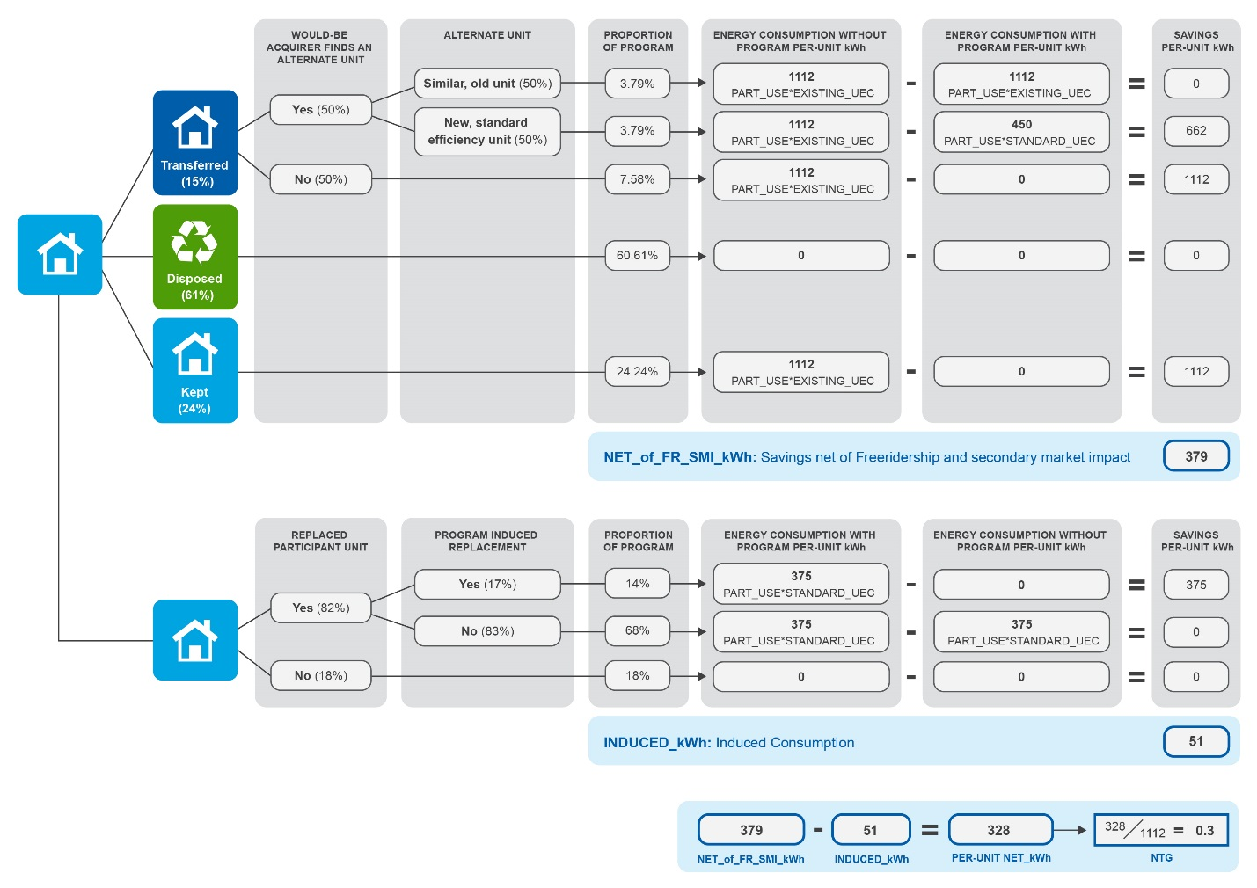
Figure 2. Freezer Full NTG Decision Tree
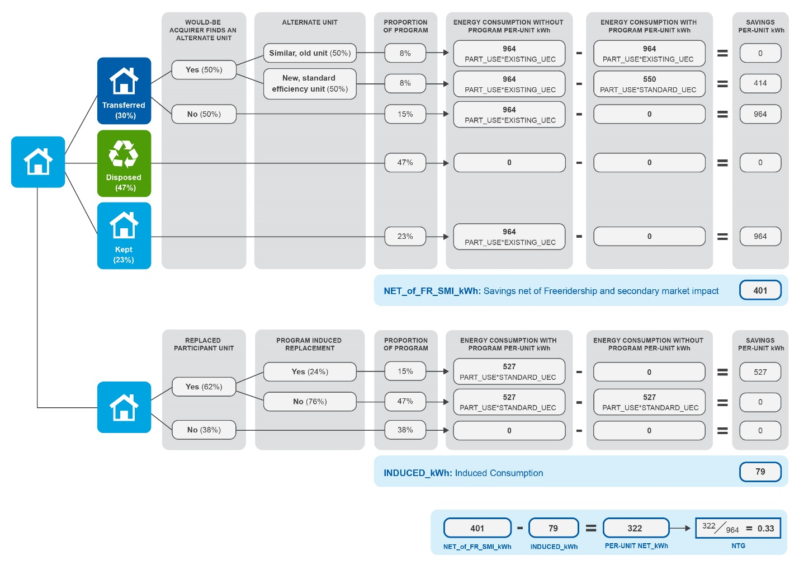

As shown in Table 10, Cadmus determined the final net savings as gross savings less freeridership, secondary market impacts, and induced replacement kWh.
Table 10. 2013 and 2014 NTG Ratios – UMP Assumptions
Scenario | Gross  Per-Unit Savings | Freeridership and Secondary Market Impacts (kWh) | Induced Replacement (kWh) | Net Savings  (kWh) | NTG
Refrigerator | 1,112 | 733 | 51 | 328 | 30%
Freezer | 964 | 564 | 79 | 321 | 33%

The assumptions used in Figure 1 and Figure 2 are consistent with those described in the UMP. However, the RTF does include different assumptions regarding the distribution of would-be acquirers who find an alternate unit (the first of the columns with the grey background in both figures).
Cadmus also calculated the NTG ratio with the RTF assumptions, which leads to a lower NTG. These results are presented in Table 11.
Table 11. 2013 and 2014 NTG Ratios – RTF Assumptions
Appliance | Gross Savings (kWh) | Freeridership and Secondary Market Impacts (kWh) | Induced Consumption (kWh) | Total Program Net Savings (kWh) | NTG
Refrigerator | 1,112 | 762 | 51 | 299 | 27%
Freezer | 964 | 620 | 79 | 265 | 27%

The RTF assumes that 75% of would-be acquirers would find an alternate unit rather than the 50% split assumed in the UMP (all other factors in the NTG decision tree are identical). This difference means that the net reduction in appliances operating on the grid is smaller than assumed by the UMP, thus leading to lower net savings.

Impact Analysis Inputs and RTF Savings Calculation Inputs
Cadmus’s impact evaluation methodology aligned with the RTF’s methodology for calculating savings. However, since Cadmus used some inputs that are specific to Pacific Power’s program in 2013 and 2014, there are some differences in specific values, as described in Table 12.
Table 12. Cadmus Impact Analysis Inputs and RTF Savings Calculation Inputs
RTF |  |  | Cadmus
Parameter | Value | Sources | Value | Sources
Part-Use Factor | Refrigerator - 91%  Freezer - 91% | Weighted average of Impact Evaluation studies: Avista 2011; PacifiCorp ID 2011-2012; PacifiCorp WA 2011-2012 | Refrigerator - 96%  Freezer - 94% | Participant survey
Base Year | 2011 | This year is used to define profile of age of recycled units. | Not applicable; Cadmus in situ regression accounts for these factors
Annual Degradation Factor | 1.25% | ADM Associates, NV Energy 2009 Refrigerator Recycling Program M&V Report, 2010
In Situ Factor | 0.81 | Cadmus Group, CA Residential Retrofit High Impact Measure Evaluation Report, 2010
Left on Grid Factor | Refrigerator - 66%  Freezer - 66% | Weighted average of Impact Evaluation study results: Avista 2010-2011; PacifiCorp ID 2011-2012; PacifiCorp WA 2011-2012; ETO 2011 Fasttrack Report | Refrigerator- 39%  Freezer- 53% | Average of participant survey (transfer + kept from UMP diagram)
Kept Factor | Refrigerator- 7%  Freezer- 13% | Weighted average of Impact Evaluation study results: Avista 2010-2011; PacifiCorp ID 2011-2012; PacifiCorp WA 2011-2012; ETO 2011 Fasttrack Report | Refrigerator- 24%  Freezer- 23% | Participant survey
Induced Replacement (R1) | Refrigerator- 6%  Freezer- 6% | Avista 2010-2011; PacifiCorp WA 2010-2011 | Refrigerator- 14%  Freezer- 15% | Participant survey
Replacement by Would-be Owner (R2) | 0.75 | RTF updated from 0.5 but no source cited. | 0.5 | Same as RTF/UMP
Fraction of New replacement units | R1 case: 79%  R2 case: 59% | Applies to refrigerators only.  R1 case source: JACO 2012-2013 Program Data;  R2 case source: ADM 2004-2005 CA Statewide survey | R1: Refrigerator- 90%  Freezer-89%  R2: 50% | R1: Participant survey R2: Deemed from UMP
C-Factor | Refrigerator: -2%  Freezer: 1% | JACO data, average efficiency improvement from program year 2010 to 2011; and 2009 to 2010. | Not applicable; Cadmus in situ regression accounts for these factors

Kit savings are not included as evaluated savings were not yet determined.
Evaluated per-unit net savings in the 2011-2012 evaluation were 583 kWh for refrigerators and 495 kWh for freezers with a NTG of 50.6% and 50.5% respectively.
Again, energy savings kit savings were not final at the time this memo was written. The program-level NTG ratio will increase slightly once kit savings are included as kits have a 100% NTG.
Throughout this report, the table totals may not sum due to rounding. Precision estimates, for means and totals (such as savings), are expressed in relative terms, while those for proportions and ratios (such as NTG) are expressed in absolute terms.
This memo’s Net-to-Gross section provides a description of how Cadmus estimated these parameters.
National Renewable Energy Laboratory. “Chapter 7: Refrigerator Recycling Evaluation Protocol” Last modified April, 2013. Accessed September 17, 2015. http://energy.gov/sites/prod/files/2013/11/f5/53827-7.pdf
Since the future usage of discarded refrigerators is unknown, Cadmus applied the weighted average part-use value of all refrigerators that would have been discarded independent of the program (0.91). This approach acknowledges that the next owner of a discarded appliance might use it as a primary or secondary unit.

