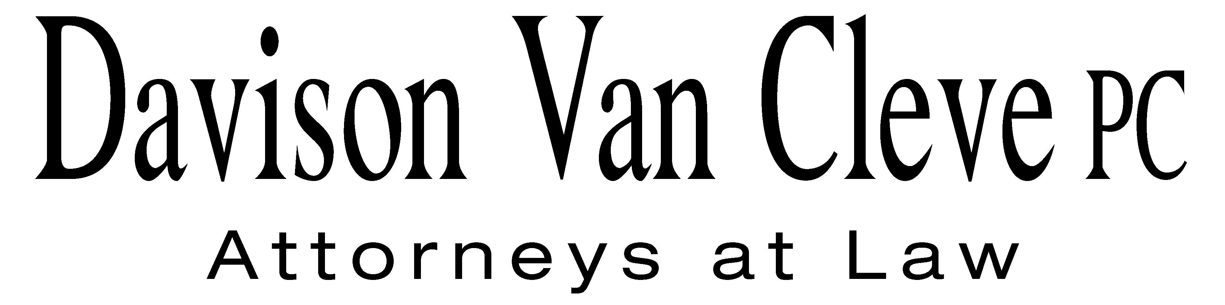
TEL (503) 241-7242 ● FAX (503) 241-8160 ● mail@dvclaw.com
Suite 400
333 SW Taylor
Portland, OR 97204
July 25, 2013

Via Electronic Mail and Federal Express
Chairman Dave Danner
Commissioner Jeff Goltz
Commissioner Phillip Jones
Washington Utilities and Transportation Commission
PO Box 47250
1300 S. Evergreen Park Drive, SW
Olympia, WA 98504-7250

Re: In the Matter of Puget Sound Energy Docket No. UE-131099
Application for an order authorizing the sale of the water rights and associated
assets of the Electron Hydroelectric Project
Washington Utilities and Transportation Commission v. Puget Sound Energy, Docket No. UE-130617
Puget Sound Energy Petition for an accounting order authorizing accounting treatment related to payments for major maintenance activities, Docket No. UE-130583

Dear Commissioners:

The Industrial Customers of Northwest Utilities (“ICNU”) sends this letter in response to Puget Sound Energy’s (“PSE”) application for an order authorizing the sale of water rights and associated assets of the Electron Hydroelectric Project (“Electron”) (Docket No. UE-131099), Staff’s motion to consolidate the Electron sale proceeding with PSE’s power cost only rate case (“PCORC”) (Docket No. UE-130617), and PSE’s petition for an accounting order authorizing accounting treatment related to payments for major maintenance activities (Docket No. UE-130583). ICNU supports consolidation to address all related issues in the three proceedings in one case. ICNU, however, recommends that the Washington Utilities and Transportation Commission (“WUTC” or the “Commission”) not find that the Electron sale is in the public interest, is not necessary or useful, or otherwise address any accounting or ratemaking issues until the completion of the PCORC proceeding.

1. ICNU Supports Consolidation

Staff filed a motion to consolidate all three proceedings on the grounds that they include related facts and principles. ICNU agrees that the proceedings are related as they all address PSE’s costs and decisions related to its generation assets, including maintenance costs at the Mint Farm facility, the sale of its Electron project, and other power cost issues. ICNU agrees that it may promote administrative efficiencies to address the ratemaking treatment of PSE’s maintenance costs, Electron sale and other power cost issues in one proceeding. As PSE’s PCORC proceeding is the only one of the three proceedings with an established schedule, ICNU agrees that it would be appropriate to address all issues jointly in the PCORC.

2. The Commission Should Not Address the Substantive Issues in the Electron Sale Until the End of the PCORC Procceeding

The Electron sale is scheduled to be addressed at the Commission’s July 26, 2013 open meeting. PSE has proposed to sell the Electron facility and buy back the power through a 20-year power purchase agreement, and has requested Commission action by August 9, 2013. Staff has recommended that the Commission allow the sale to proceed as being consistent with the public interest, but that the Commission should not make a finding that the Electron project is no longer necessary or useful nor address accounting or ratemaking issues. Staff recommends that these issues be addressed in the PCORC proceeding. ICNU agrees that issues related to whether the Electron project will be necessary or useful, accounting and ratemaking should be addressed in the PCORC; however, the issue of whether the sale is in the public interest should also be addressed in a formal proceeding.

ICNU recommends that the issue of whether the Electron sale is prudent, reasonable and consistent with the public interest should be addressed in the PCORC. The Commission’s rules allow it to consider property sales after holding an evidentiary hearing. WAC § 480-143-170. The Commission utilizes different considerations for determining if a transaction is consistent with the public interest based upon the facts of the specific case, but generally seeks to ensure that transactions do not harm ratepayers and appropriately balance the interests of shareholder and customers. Re PSE application for approval of sale of Colstrip, Docket No. UE-990267, Third Suppl. Order (Sept. 30, 1999). There is insufficient information at this time to definitively conclude that the sale of Electron is in the public interest and will not harm customers. Therefore, ICNU recommends that the Commission defer consideration of whether the Electron sale is reasonable, will not harm ratepayers and is otherwise in the public interest until the completion of the PCORC proceeding.

Sincerely yours,

/s/ Irion A. Sanger
Irion A. Sanger

cc: Jason Kuzma
Katherine Barnard
Don Trotter
Dave Gomez
Christopher Mickelson
Simon ffitch

