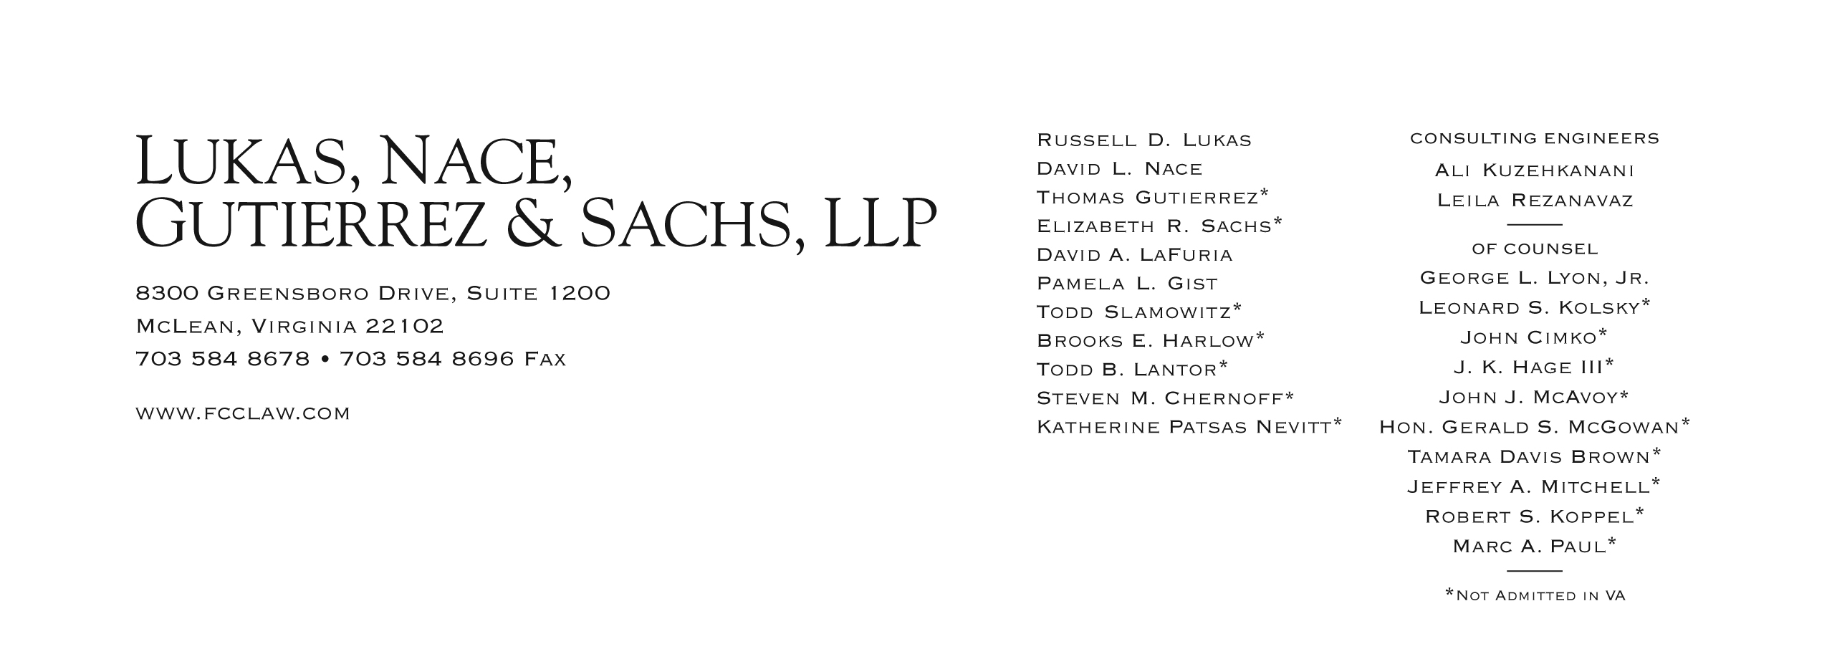

Brooks E. Harlow
(703) 584-8680
bharlow@fcclaw.com
August 24, 2012

VIA WUTC WEB PORTAL

Mr. David Danner, Executive Director
Washington Utilities and Transportation Commission
1300 S. Evergreen Park Drive, S.W.
Olympia, WA 98504-7250

Re: UT-111570
Petition Of Budget Prepay, Inc. For Limited Designation As An Eligible Telecommunications Carrier In Washington

Dear Mr. Danner:

Please find enclosed for filing the Compliance Filing of Budget PrePay, Inc. (“Budget”) in response to Condition 2 of the “Washington State Conditions on Designation of Budget PrePay, Inc. as an Eligible Telecommunications Carrier” attached to the Order issued in the above docket on August 6, 2012.

Specifically, Condition 2 requires, and Budget complies with Condition 2, as follows:

Within 30 days of approval of its ETC designation in Washington and prior to offering Lifeline services, Budget must make a compliance filing for approval by the Commission containing the following:

- Budget’s Lifeline rate plans, terms and conditions. The rates, terms and conditions shall include all provisions that apply to the Lifeline services offered by Budget in Washington state and detailed procedures explaining how customers can participate in a particular Lifeline plan.
Budget’s wireless Lifeline service offerings are set forth in Exhibit 1. Budget’s terms and conditions are set forth in Exhibit 2. Both of these documents have previously been submitted to the WUTC in this proceeding.
- Budget’s proposed language to be used in all advertising of Lifeline services and on its websites. The language shall include information directing customers to the Washington State Office of the Attorney General for complaints regarding any Lifeline service issues.

A sample Budget direct mailing is enclosed as Exhibit 3. Budget plans to use the same or substantially similar language in all print advertisements and direct mailings in Washington and on Budget’s web site. In addition, as required by Condition 2, Budget will add the following language:
Complaints concerning Lifeline service can be directed to Budget Mobile at 888-424-5588 or the Washington State Office of the Attorney General at 206-464-6684, 800-551-4636, or by visiting www.atg.wa.gov.

- Budget’s Lifeline Customer Application Form.
Budget’s Lifeline customer application and certification form is enclosed as Exhibit 4. This document has previously been submitted to the WUTC in this proceeding.

Budget acknowledges that it cannot offer Lifeline services until the Commission has approved its compliance filing.

Feel free to contact the undersigned with any questions or requests for supplementation or clarification regarding the application.

Respectfully submitted,
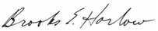
Brooks E. Harlow
Todd B. Lantor
Marc Paul
Robert S. Koppel

Counsel for Budget PrePay, Inc.

cc:
Mr. William Weinman (via email, with attachments)
Ms. Jing Liu (via email, with attachments)

Attachments

This paragraph on Page Three of the Terms and Conditions has recently been modified: New BUDGET MOBILE customers must choose a plan upon enrollment. Existing BUDGET MOBILE customers who wish to switch plans may do so by visiting a Budget Mobile store, at www.budgetmobile.com or by calling 1-888-777-4007. (The revised language is underlined.)

