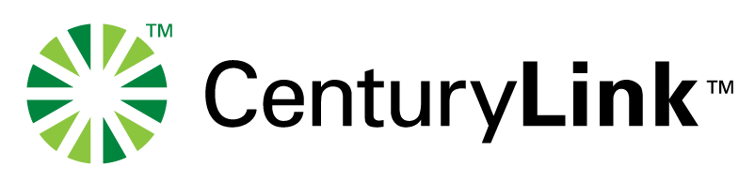

May 14, 2018

Via Web Portal

Mr. Mark L. Johnson, Executive Secretary
Washington Utilities & Transportation Commission
1300 S. Evergreen Park Drive SW
P.O. Box 47250
Olympia, WA 98504-7250

Re: Docket No. UT-
Request for Approval of Fully Negotiated Interconnection Agreement and VOIP Amendment

Dear Mr. Johnson:

In accordance with WAC 480-07-640, attached are:

♦ The Interconnection Agreement By and Between United Telephone Company of the Northwest d/b/a CenturyLink and Onvoy, LLC for the State of Washington;
♦ Carrier Partner for Interconnected VOIP Provider Amendment to the Interconnection Agreement between United Telephone Company of the Northwest d/b/a CenturyLink and Onvoy, LLC for the State of Washington
♦ Request for Approval forms.

The enclosed Agreement and Amendment do not discriminate against non-party carriers. They are consistent with state and federal law, and are in the public interest. CenturyLink respectfully requests that the Commission approve this Agreement and Amendment.

Sincerely,

/s/ Maura Reynolds
Maura Reynolds
1600 7th Avenue, Room 1506
Seattle, Washington 98191
206-733-5178
maura.peterson@centurylink.com

Attachments
cc: Teliax, Inc.

