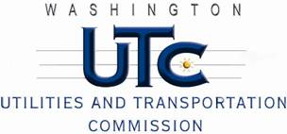

Memorandum
July 11, 2011

To: TR-110927 - File

From: Kathy Hunter, Deputy Assistant Director Transportation Safety

Subject: TR-110927 Simpson Lumber Company LLC
Grade Crossing Protective Fund (GCPF) Project at the Intersection of
Railroad Avenue/11th Street and Simpson Lumber Company LLC’s Tracks in the City of Shelton, Washington

On May 27, 2011, the Washington Utilities and Transportation Commission (Commission) awarded a GCPF grant totaling $6,342.90 to install flashing lights, power off light and gate lamps from incandescent to LED type lights, replace the cross-bucks, and install an electronic bell at the Railroad Avenue/11th Street crossing in the City of Shelton. The USDOT number assigned to this crossing is 856749G. On June 6, 2011, the Commission issued Order 02, extending the project completion date to June 24, 2011.

On July 11, 2011, the applicant, Simpson Lumber Company LLC submitted a request for reimbursement pursuant to Commission Order. On July 1, 2011, Commission staff conducted a site visit and verified that the project is completed according to the specifications outlined in the order approving the grant.

Please close this docket.

