March 16, 2016

Mr. Steven King
Executive Director and Secretary
Washington Utilities and Transportation Commission
1300 South Evergreen Park Drive SW
Olympia WA 98504-7250

RE: Replacement Cover Letter for Tariff Revision - YCOM Networks, Inc. d/b/a FairPoint Communications: Docket UT-160289

Dear Mr. King:

Please replace the original cover letter for the tariff filing made on 3/11/16, YCOM Networks, Inc. d/b/a FairPoint Communications with this cover letter that includes additional information requested by Staff and corrects a rule reference.

The annual revenue effect for the Company for unlimited service is an increase of $75,417.
The annual revenue effect for the measured service is an increase of $3,297.

This filing conforms the Company's tariff to the "urban rate floor" provisions of FCC Order No. 11-161 and subsequent rules and is in compliance with WAC 480-80-121. The Notice to customers has been filed in this docket and was mailed to customers on or prior to the date of this letter.

Please contact me at the number below or Beth Westman at 207.535.4249 or bwestman@fairpoint.com with any questions or concerns regarding this filing.

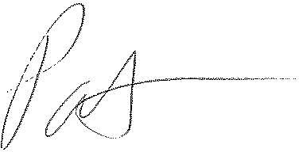
Patrick L. Morse
Senior VP Governmental Affairs
FairPoint Communications
P: 620-227-4409
F: 620-227-8576

