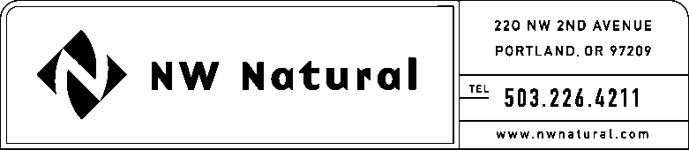

GAIL A. HAMMER
Tariffs and Regulatory Compliance
Tel: 503.226.4211, ext. 5865
Fax: 503.721.2516
email: gail.hammer@nwnatural.com

January 6, 2017

DO NOT REDOCKET

VIA ELECTRONIC FILING

Steven King, Executive Director and Secretary
Washington Utilities and Transportation Commission
1300 S. Evergreen Park Drive, S.W.
P.O. Box 47250
Olympia, Washington 98504-7250

RE: UG-161259, NW Natural Supplement to the 2017 Energy Efficiency Plan

Northwest Natural Gas Company, dba NW Natural (“NW Natural” or the “Company”) hereby submits its supplement to the 2017 Energy Efficiency Plan.

The Plan was initially filed December 1, 2016. Upon Staff’s request, the Company is now filing a supplement explaining the current budget status of the program including costs associated with direct benefits to customers.

If you have any questions, please contact me at (503) 226-4211, extension 5865.

Sincerely,

/s/ Gail A. Hammer

Gail A. Hammer
Rates & Regulatory Affairs

Enclosure

