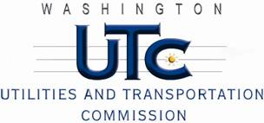

Memorandum
June 26, 2013

To: TR-121746 - File

From: Betty Young, Compliance Investigator, Transportation Safety

Subject: TR-121746 – Washington State Department of Transportation
Grade Crossing Protective Fund (GCPF) project to modify a railroad-highway grade crossing at SR-271in Oakesdale, USDOT #058905N

On December 6, 2012, the Washington Utilities and Transportation Commission (Commission) awarded the Washington State Department of Transportation (WSDOT) a GCPF grant in the amount of $20,000 to modify and improve active warning devices at the SR-271 crossing in Oakesdale. The USDOT is #058905N. The total project cost was $42,595.59, with WSDOT paying for all costs exceeding that amount.

On June 26, 2013, WSDOT submitted a request for reimbursement for work pursuant to Commission order. Because the commission does not currently have its own signal inspector, Bryan Morris, a certified FRA signal inspector, conducted a site visit on June 21, 2013, and verified that the project was completed according to the specifications outlined in the order approving the grant.

Please close this docket.

