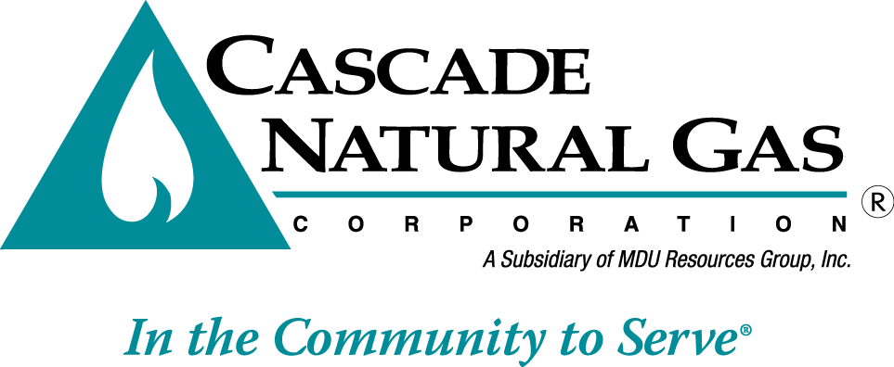 | 8113 W. GRANDRIDGE BLVD., KENNEWICK, WASHINGTON 99336-7166  TELEPHONE 509-734-4500 FACSIMILE 509-737-7166  www.cngc.com

February 20, 2015

Mr. Steven V. King
Executive Director and Secretary
Washington Utilities & Transportation Commission
P.O. Box 47250
Olympia, WA 98504-7250

RE: UG-150187 Tariff Revision
Advice No. CNG/W15-02-01

Dear Mr. King:

Cascade Natural Gas Corporation (“Company”) respectfully withdraws its tariff filing of February 4, 2015, Advice No CNG/W15-02-01. The Company is withdrawing the original filing in order to incorporate Staff recommended changes and to allow additional time for Staff to complete its review. The Company will be re-filing the tariff sheets under separate cover.

Any questions regarding this filing may be directed to Michael Parvinen at (509) 734-4593.

Sincerely,

Pamela Archer
Supervisor, Regulatory Analysis

