CERTIFICATION

I am Vice President – Regulatory Operations for the CenturyLink Operating Companies together with Qwest Corporation d/b/a CenturyLink QC (CenturyLink). I have overall responsibility for supervision of the personnel who prepare all of the data supporting CenturyLink’s annual access charge tariff filings with the Federal Communications Commission (FCC) and I am authorized to execute this certification. I provide this certification based upon the information provided to me by employees responsible for the preparation of the data submitted in support of CenturyLink’s FCC annual access charge tariff filings as well as the data that will be submitted in support of annual state access charge tariff filings as necessary to implement the FCC’s November 18, 2011 USF ICC Transformation Order, FCC 11-161 (WC Docket No. 10-90)(Transformation Order). I have prepared this certification for submission in connection with each of CenturyLink’s state tariff filings as necessary to implement the Transformation Order in 2014. I hereby certify, pursuant to 47 C.F.R 51.915(d)(3), that CenturyLink is not seeking duplicative recovery in the state jurisdiction for any Eligible Recovery subject to the recovery mechanism established by the Transformation Order.

April 30, 2014

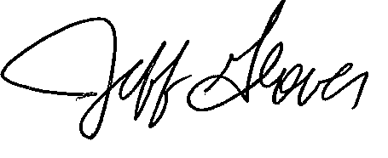

Jeff Glover
Vice President – Regulatory Operations

Contact Person: Gary Kepley
Director, Regulatory Operations
Telephone Number: (913) 345-7572

