July 9, 2018

Via electronic filing

Mr. Mark L. Johnson, Executive Director and Secretary
Washington Utilities and Transportation Commission
1300 South Evergreen Park Drive SW
Olympia, WA 98504-7250

Re: Docket No. UT-180004 – Copy of FCC From 481

Dear Mr. Johnson:

Please find enclosed the FCC Form 481 for Virgin Mobile USA, L.P.

Please let me know if you have any questions about this submission.

Sincerely,

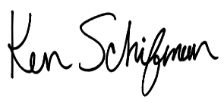
Ken Schifman

