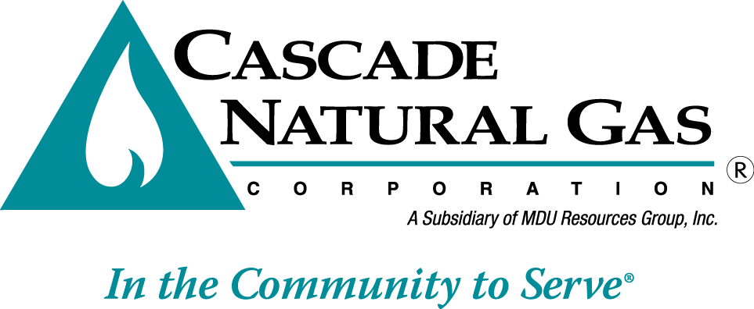
8113 W. GRANDRIDGE BLVD., KENNEWICK, WASHINGTON 99336-7166
TELEPHONE 509-734-4500 FACSIMILE 509-737-9803
www.cngc.com

8113 W. GRANDRIDGE BLVD., KENNEWICK, WASHINGTON 99336-7166
TELEPHONE 509-734-4500 FACSIMILE 509-737-9803
www.cngc.com

CNG/W16-09-04
September XX, 2016

Mr. Steven V. King
Executive Director and Secretary
Washington Utilities & Transportation Commission
1300 S. Evergreen Park Drive, SW
P.O. Box 47250
Olympia, WA 98504-7250

Re: Schedule No. 663 “Distribution System Transportation Service”

Dear Mr. King:

Enclosed for filing is the following tariff sheet to become effective with service on and after November 1, 2016:

Seventeenth Revision Sheet No. 663, Canceling Sixteenth Revision Sheet No. 663

The purpose of this filing is to update Cascade Natural Gas Corporation’s (“Cascade” or “Company”) 5-year average lost and unaccounted for percentage under the fuel use requirements section of this tariff. As stated by the tariff, this percentage is to be updated on an annual basis. The effect of this filing updates the percentage from .1348% to .1615% as of July 2016. This change represents an increase of 20% from last year’s amount. This filing is in compliance with the order in UG-060256.

The proposed change does not have any revenue impact on the Company and there is no rate impact on Washington ratepayers. The attached exhibit details the calculation of the updated lost and unaccounted for percentage.

If you have any questions, please direct them to me at 509-734-4593.

Sincerely,

Michael Parvinen
Director, Regulatory Affairs

Attachments

