June 25, 2014

Steven V. King, Executive Director and Secretary
Utilities and Transportation Commission
1300 S. Evergreen Park Dr. SW
P.O. Box 47250
Olympia, WA 98504-7250

RE: Washington Utilities and Transportation Commission v. Rocket Enterprises, LLC

Commission Staff’s Response to Application for Mitigation of Penalties TE-141076 and TC-141037

Dear Mr. King:

On May 22, 2014 and May 27, 2014 the Utilities and Transportation Commission issued a $1,000 Penalty Assessment in Dockets TC-141037 and TE-141067 respectively against Rocket Enterprises, LLC for 10 violations of Washington Administrative Code (WAC) 480-30-071, which requires both auto transportation and charter and excursion carriers to furnish annual reports to the commission no later than May 1 each year.¹

On June 11, 2014, Rocket Enterprises, LLC wrote the commission requesting mitigation of penalties (Mitigation Request).² In its Mitigation Request, Rocket Enterprises, LLC does not dispute that the violation occurred. The company states, “Although it does not excuse the tardiness of the report, we ask that you take into account that Rocket moved our office location the weekend prior to this report being due…The report work became buried within the move and was thought to have been completed and paid.”

It is the company’s responsibility to ensure that the regulatory fee is paid and the annual report is filed by the May 1 deadline. On February 28, 2014, Annual Report packets were mailed to all regulated auto transportation and charter and excursion companies. The instructions for annual report completion page of the annual report informed the regulated company that it must complete the annual report form, pay the regulatory fees, and return the materials by May 1, 2014, to avoid enforcement action.

UTC Annual Reports
June 25, 2014
Page 2

On June 10, 2014, Rocket Enterprises, LLC filed the 2013 annual report and paid the required regulatory fees. Late payment fees remain outstanding for the auto transportation authority. The charter and excursion regulatory fees were timely paid on December 27, 2013. No previous violations of WAC 480-30-071 are on commission record.

Commission staff supports the company’s request for mitigation as this is the first delinquent filing. As this is the first year for a combined authority report, staff recommends a reduced penalty assessment of $100 per operating authority for a total penalty assessment of $200.

If you have any questions regarding this recommendation, please contact Amy Andrews, Regulatory Analyst, at (360) 664-1157, or aandrews@utc.wa.gov.

Sincerely,

Sondra Walsh, Director
Administrative Services

ATTACHMENT A
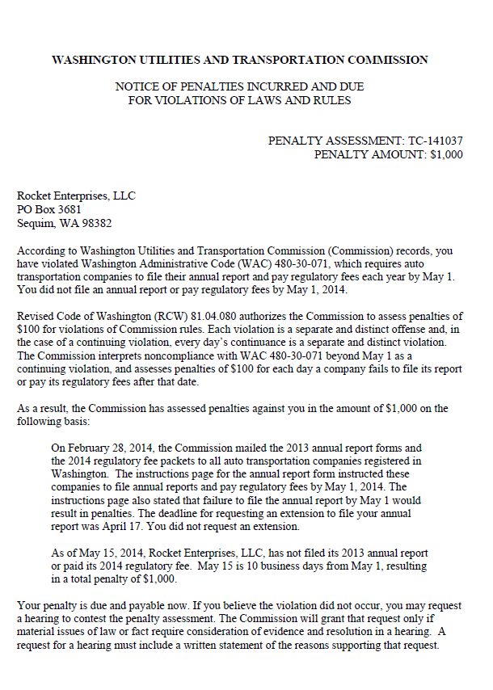

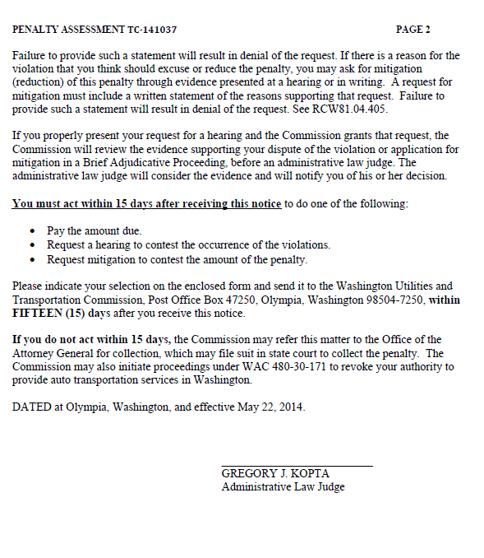

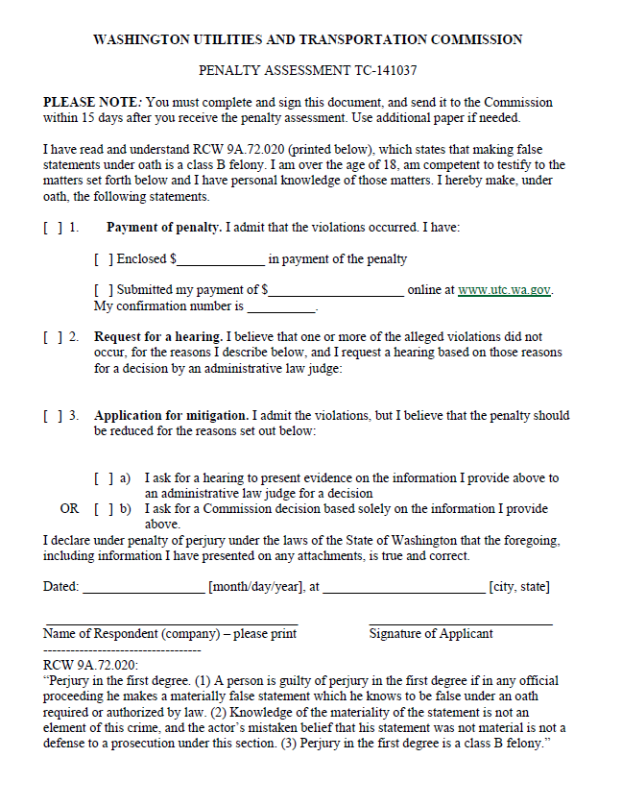

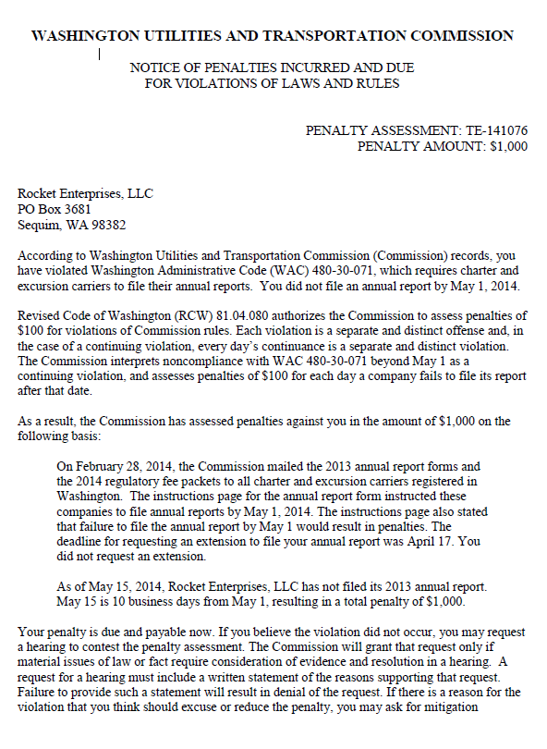

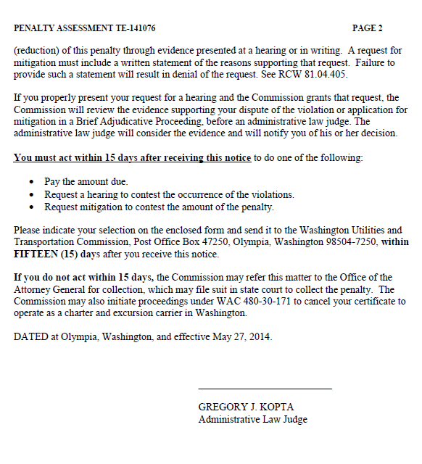

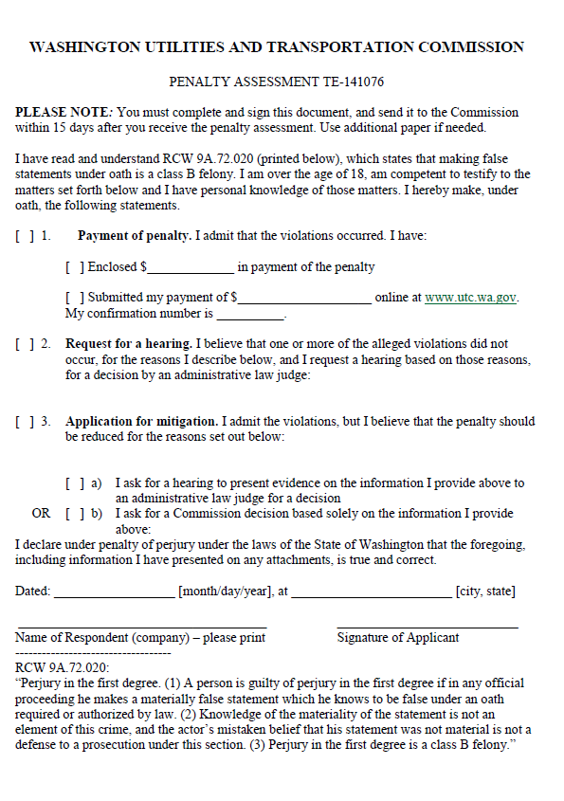

ATTACHMENT B
