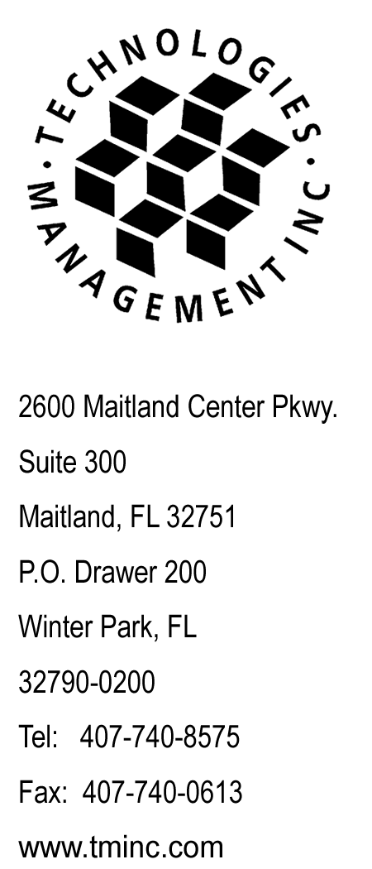
April 4, 2013
Webfile

Utilities and Transportation Commission (Webfile)
Washington Utilities and Transportation Commission

RE: Budget PrePay, Inc. d/b/a Budget Mobile
WA Annual Consumer Complaint Report Filing
For the quarter of October 1, 2012 to December 31, 2012

Dear Jing Lui:

Please accept this letter as the WA Annual Consumer Complaint Report Filing for the year 2012, filed on behalf of Budget PrePay, Inc. d/b/a Budget Mobile.

For the 2012 calendar year, Budget Prepay, Inc. d/b/a Budget Mobile had zero consumer complaints.

Questions regarding this filing should be directed to my attention at 407-740-8575. Thank you for your assistance in this matter.

Sincerely,

Craig Neeld
Compliance Reporting Specialist

SERVICE REQUEST FOR COMPLIANCE REPORTING

Due Date: January 10, 2013
Today’s Date: January 4, 2013
Process By: January 7, 2013
Client Name: Budget PrePay, Inc. d/b/a Budget Phone
Acct#: 7465

BILL BACK:

Shipping: | Y |  | N |  | US Mail $ |  | (per pkg) x |  | (# sent) = $ |  | (total billback)
Page Count: | Y |  | N |  |  |  | (TOTAL pgs) x $ |  | / page = $ |  | (total billback)
Diskettes: | Y |  | N |  |  |  | (TOTAL dsks) x $ |  | / disk = $ |  | (total billback)
TOTAL TO BE BILLED $

SHIPPING NAME/ADDRESS:

Ship TML and Report to:
Mr. Reece McAlister
Georgia Public Service Commission
244 Washington Street S.W.
Atlanta, GA 30334-9052

REPORT INFORMATION:

GA Docket 9108-U - Prepaid LEC Quarterly Information Request - for the quarter of October 1, 2012 to December 31, 2012

No check is enclosed as there are no remittance fees due.

Please enclose the original and two copies of this report.

Do NOT include Date-Stamped copy.

SHIPPING METHOD:

ORIGINAL: | UPS: Next Day |  | FED: AM |  | US Mail |  | Other: |  | Bill Back #
COPIES: | UPS: Next Day |  | FED: AM |  | US Mail |  | Other: |  | Bill Back #

