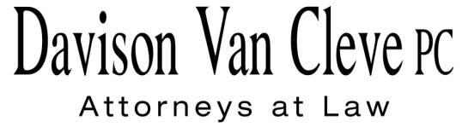
TEL (503) 241-7242 ● FAX (503) 241-8160 ● jog@dvclaw.com
Suite 400
333 S.W. Taylor
Portland, OR 97204

November 2, 2016

Via Electronic Filing

Mr. Steven V. King
Executive Director
Washington Utilities & Transportation Commission
1300 S. Evergreen Pk. Dr. S.W.
P. O. Box 47250
Olympia, WA 98504-7250

Re: In the Matter of WASHINGTON UTILITIES AND TRANSPORTATION COMMISSION
Rulemaking for Integrated Resource Planning
Docket No. UE-161024

Dear Mr. King:

Enclosed please find the Comments of the Industrial Customers of Northwest Utilities, including Attachment A, in the above-referenced docket.

Thank you for your assistance. If you have any questions, please do not hesitate to contact me.

Sincerely,

/s/ Jesse O. Gorsuch
Jesse O. Gorsuch
Enclosure

