Avista Utilities

Natural Gas Procurement Plan

and Hedging Framework

- Background
On October 30, 2013, the Commission opened a Staff Investigation in Docket No. UG-132019 regarding policy issues related to the Washington natural gas utilities’ hedging practices and transaction reporting. Staff and Public Counsel co-sponsored a White Paper on natural gas hedging practices written by Michael Gettings of RiskCentrix, LLC. The White Paper provided examples and detailed instruction concerning hedge practices and how to incorporate risk-responsive hedging methods into the overall portfolio. Avista provided comments in this docket and participated in several workshops. In UG-132019, the Commission distributed a “Policy and Interpretive Statement on Local Distribution Companies’ Natural Gas Hedging Practices” (“Policy Statement”). This Policy Statement outlines the process each LDC should follow in order to incorporate such risk-responsivehedges into their individual portfolios. In summary, the Policy Statement provided the following guidance:
- We therefore direct each company to submit, as part of the 2017 PGA filing, a preliminary hedging plan that outlines the company’s intended path to incorporate risk-responsive hedging strategies for the upcoming year. This plan should articulate the company’s hedging objectives and communicate its approach to address the basic elements of risk-responsive hedging: objectives and goals, exposure quantification, strategic initiatives, and oversight and control.

- When making their 2018 PGAs filings, we require the Companies to submit annual comprehensive hedging plans that demonstrate the integration of risk responsive strategies into the Companies’ overall hedging framework. The Commission expects full implementation will take no longer than 30 months.

- As part of the comprehensive annual hedging plan, the Companies should incorporate a retrospective hedging report. This report should provide a narrative of the utility’s perspective on the execution of its prior year hedging strategy. Additionally, the report should include a discussion providing insight about whether the metrics and tolerances identified in the previous year’s plan continue to be appropriate and how the Company’s retrospective evaluation has informed modifications to the forthcoming year’s hedging plan.

The information required by the Commission is contained within this report as follows:
Description Page
I. Background 1
II. Objectives and Goals 2
III. Oversight and Control 2
IV. Strategic Optimization 4
V. Procurement Plan Components 5
VI. Risk Responsive Hedging Tool 10
VII. Exposure Quantification 11
VIII. Next Steps 11

- Objectives and Goals
Avista’s mission is to provide a diversified portfolio of reliable supply with a level of price certainty in volatile markets.
No company can accurately predict future natural gas prices, however, market conditions and experience help shape Avista’s overall approach to natural gas procurement. Our Natural Gas Procurement Plan (Plan) process seeks to acquire natural gas supplies while reducing exposure to short-term price and load volatility. The procurement strategy includes hedging, storage utilization and index purchases. The Plan is disciplined, yet flexible, allowing for modifications due to changing market conditions, demand or resource availability or other opportunities. Material changes to the Plan are communicated to senior management and Staff.
The Plan is diversified through time, location and counterparty. Hedge transactions may be executed for a period of one-month through thirty-six months prior to delivery period. Due to Avista’s geographic location, transactions may be executed at different supply basins in order reduce our overall portfolio risk. Finally, transactions are made with multiple counterparties in accordance with Risk Management credit terms.
- Oversight and Control
The Company’s Plan is the framework under which natural gas supply is acquired in order to reach our goal of providing reliable natural gas supply for customers, while at the same time managing the volatility and cost of that supply.
The Plan is governed by the Avista Utilities Energy Resources Risk Policy (“Risk Policy”) which addresses certain risks inherent in supplying energy and managing energy resources, and outlines certain important roles, responsibilities and processes to manage and control those risks. The Rick Policy governs Avista Utilities transactions to purchase or sell electricity or natural gas in the wholesale energy market, transactions for electric generation, financial contracts and derivatives (relating to electricity, natural gas and fuel), and agreements for use of Avista Utilities’ natural gas storage and transportation rights.
The Risk Management Committee, which includes corporate officers and senior-level management, is responsible for oversight of the Risk Policy and associated Natural Gas Plan (which includes hedging). The Committee establishes the Risk Policy and monitors compliance through regular meetings including, but not limited to, hedge activity, and discussions on market conditions, and other power supply and natural gas-related matters.
Specific to natural gas, the Risk Policy addresses several variables which affect natural gas supply and customer load. It is the intent of the Risk Policy to recognize and actively manage the interaction and dynamics among these variables by establishing a process for load estimation, resource procurement (including natural gas storage), and management of the expected Short Term and Immediate Term gas requirements. The Policy spells out the following processes:
- Natural Gas Load and Obligations estimation, Natural Gas Resource estimation, and management of associated surplus or deficit.
- Responsibility and approvals for transactions and operating decisions related to natural gas procurement, wholesale natural gas purchases and sales, scheduling natural gas resources, and providing good stewardship of natural gas resources.
- Reporting. All changes that affect the Short Term natural gas position (per the Plan) will be reflected each business day in a natural gas position report. This includes status of estimated load and obligations, estimated open positions (net surplus or deficit) for each month in the hedge windows described above. The position report also includes the current status of the Plan, daily prices, and estimated current market value of overall natural gas positions.
In addition to the Risk Management Committee, the Company also has an internal Strategic Oversight Group (SOG) which is comprised of other natural gas-related stakeholders who provide guidance and input on decisions made to the Plan. The SOG serves as a reference/sounding board for strategic decisions made by the Natural Gas Supply department regarding natural gas procurement. Members include representatives from the Gas Supply, Resource Accounting, State & Federal Regulation, Credit Management, Power Resources, and Risk Management departments. Although the Gas Supply department is ultimately responsible for the execution of hedge transactions, the Strategic Oversight Group provides input and advice.
- Strategic Optimization
As previously noted, the goal of the Procurement Plan is to provide reliable supply at competitive prices, with some level of price stability, in a volatile commodity market. This is accomplished through the use of a hedge “window” mechanism (described below). Through this mechanism, the Company is able to mitigate natural gas price volatility for a portion of the portfolio in various time increments. The Plan also addresses seasonal, monthly and daily load variability, by shaping the components of the plan (i.e. more natural gas is hedged for winter months than for summer months). The Natural Gas Supply Department continuously monitors the results of the Plan, evolving market conditions, variation in demand profiles, new supply opportunities and regulatory conditions.
In striving to be good stewards of customer resources, existing pipeline and storage resources are optimized in order to mitigate costs incurred by customers until the resource is required to meet demand. Unutilized resources such as transportation and storage capacity are optimized when possible, in order to reduce costs for our customers. Avista may be able to optimize its transportation capacity by purchasing natural gas, transporting it on existing unutilized capacity, and selling it into a higher priced market to capture savings that reduce costs for our customers. In addition, Avista may be able to release a portion of its contracted firm transportation capacity to third parties reducing its firm transportation expense.
Jackson Prairie Storage Facility is optimized for the benefit of our customers through the natural gas storage model. The model is governed by a storage management program that sets boundaries on injections and withdrawals as well as tracks real time market data to guide the purchase and sale of natural gas storage transactions with favorable spreads. Through this model, the Company is able to purchase natural gas in one period and sell into a lower priced market, effectively locking in a benefit for our customers. Illustration No. 1 below is an example of storage optimization:
Illustration No. 1
The program enforces storage constraints and requirements such as the storage fill schedule, peak day load requirements, transportation capacity limits, and deliverability constraints.
The Plan is not intended to be a static document with a “set-it-and-forget it” program. It is formally reviewed no less than annually, with existing results discussed monthly with the SOG and Risk Management Committee. Should there be new methods considered for incorporation, such as risk responsive hedging, it is developed, tested and reviewed extensively prior to implementation. The goal is to utilize the best methods available to provide reliable supply at competitive prices, with some level of price stability, in a volatile commodity market.
- Procurement Plan Components

The Company secures/purchases natural gas supply to fulfill average monthly load requirements through the transactions and procedures described below.

1. Fixed-Price Purchases: To provide a level of price certainty in volatile natural gas commodity markets, Gas Supply will hedge some customer load with fixed-price transactions, either with fixed-price physical purchases or with financial swaps or financial futures. Swaps or futures will be matched prior to product settlement to purchases of index-priced physical products in order to secure the fixed price. These hedges will be structured to diversify procurement in terms of timing of the transaction and duration of committed supplies. This diversification will be accomplished by developing Hedge Windows for the planned purchases. Volumes and other details related to the Hedge Windows are detailed in the daily natural gas position report. Hedge Window volume will be in “procurable” quantities to avoid paying a market premium. The daily gas position report will show the status of any active Hedge Windows.

2. Storage Injections and Withdrawals: Avista owns and contracts for storage services at Jackson Prairie. Avista has contractual operational requirements to have its share of the storage facility full by September 30 of each year. Gas Supply retains flexibility in terms of the timing and volume of the injection and withdrawal schedules. Actual storage injections and withdrawals will be executed to optimize the economic value of storage within the reliability constraints of the project and the ability to serve retail customers’ peak day needs.

3. Index-Based Physical Purchases: Gas Supply generally purchases physical index-based natural gas for up to the difference between the average daily load forecast for each month and the sum of the fixed-price purchases and projected storage withdrawals. Gas Supply retains flexibility to modify the components of its purchases in a month due to operational or other reasons. The selected indices may be first-of-month indices or daily-based indices.

4. Daily Adjustments Due to Load Variability: To the extent actual loads differ from the average daily load forecast for the month, the difference will be managed through a combination of: a) Daily purchases or sales of natural gas, or b) withdrawals from, or injections into, natural gas storage facilities.

5. Use of Derivative Contracts: Subject to limitations in the Risk Policy, Gas Supply may enter into derivative-based contracts intended to reduce or manage exposure to rising prices or fluctuating loads.

6. Optimization: Gas Supply may enter into transactions that create value for customers using unutilized supply, transportation or storage. Utilization of these resources reduces fixed costs and lowers overall costs to customers.

Load Forecast

The basis for the Procurement Plan is the development of the load forecast. This load forecast is developed for each individual area and class of customer by day. The key inputs for the load forecast model are the forecasted number of customers, a set of demand coefficients (Dth consumed per customer per heating degree day), and historical heating degree-days.

For purposes of the Procurement Plan, the daily load forecasts are consolidated into average daily volumes for each month for customers in Oregon and for the combined Washington and Idaho jurisdictions. These estimates are adjusted to compensate for pipeline fuel and estimated daily requirements for Interruptible Customers to derive “Average Load”.

Hedge Target Delivery Periods

The natural gas Short Term period starts with the next whole operating month after the current date. Its duration varies from 30 to 36 months. It begins with five to eleven individual months and includes the next four to five seasonal November – March and/or April – October blocks. For any given hedge period as shown in the first column in the table (singular month or block of multiple months), an assessment of potential hedges for that period would look to the sequential future periods shown in the column below that period. The first five to eleven periods are addressed in monthly blocks, depending on the time of year and the rolling nature of the specified Gas Supply target delivery periods. After these monthly blocks, a minimum of four seasonal blocks are addressed in consecutive November – March and April - October blocks. Additional November – March or April – October blocks are added so that in any given delivery period, there are between 30 and 36 months to be monitored and eligible for hedge. By the time the delivery period is reached, each individual month will have been available for hedging for a full 36 months prior to delivery.

Hedge Window Development

Load for each period is secured through a Hedge Window (“window”) mechanism and broken into quantities which can easily be transacted in order to hedge a pre-determined percentage of the portfolio. Transactions are programmatic in nature, with upper and lower price thresholds intended to capture downward price trends and “stop losses” for upward price runs. As previously mentioned, the Risk Policy provides for a certain level of management flexibility should market indicators or other factors deem necessary.

The components of the window mechanism are as follows:

Set-price (SP) – Based on the closing price of the selected supply basin for the delivery period.

Supply Basins – AECO, Sumas, or Rockies based on a Value-At-Risk (VaR) calculation which provides the greatest reduction to the open position and market conditions at the time of execution.

Upper Control Limit (UCL) - Based on historical prices over the previous 60 days with a 90% confidence level.

Lower Control limit (LCL) - Based on historical prices over the previous 60 days with a 90% confidence level.

Expiration Dates - Determined by Gas Supply based on the annual volumes to be hedged and the choice of market period in which to transact market-scale pieces of the planned annual hedges (i.e., the number of hedge windows and an appropriate distribution of time to be in the market for each will indicate a series of expiration dates).

The UCL and LCL will adjust (“Noose”) daily depending on the movement in current pricing. When a window is closed the next window will be opened (if a window remains to be processed). The next window’s SP and price band will be determined based on the current day’s closing price, but the new window will retain its original expiration date.

Illustration No. 2 is an illustration of the Window Mechanism set up:

Illustration No. 2
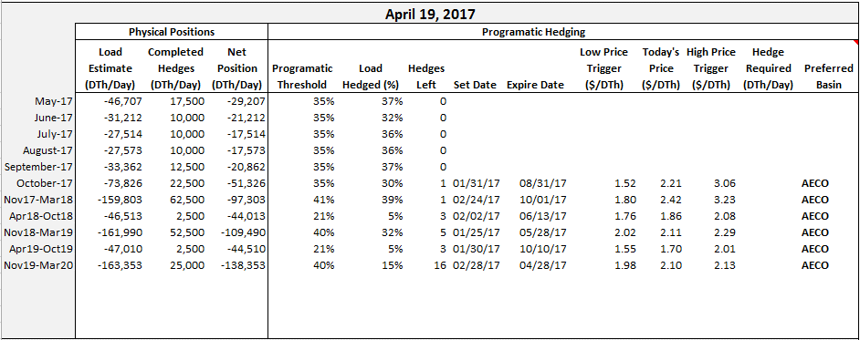

Hedge Window Procedures

Hedge Windows remain “open” as long as the previous day’s forward delivery period price remains between the UCL and the LCL, and the window has not reached its time expiration. The daily LDC Natural Gas Position Report (Position Report) closing price for the selected basin will be the determining benchmark of the forward delivery period price.

Hedge Window status is examined each business day. If the Position Report price indicates that a UCL has been exceeded or if the Position Report price falls below an LCL, then the planned transaction is triggered. If a window does not exceed the UCL or fall below the LCL prior to time expiration, then the planned transaction is triggered on the last day of the hedge period.

A price “noose” calculation will be performed daily for each open window. The purpose of the noose calculation is to ratchet either the UCL or the LCL toward the SP. The noosing occurs daily based on the market closing price for a hedge delivery period. If the closing price is above the SP, the LCL is increased by the amount the closing price is above the SP. If the closing price is below the SP, the UCL is decreased by the amount the closing price is below the SP. Noosing of the LCL and UCL values is limited to the maximum extent that closing prices have risen above the SP (for LCL) or below the SP (for UCL) over the life of the open Hedge Window. The noose-adjusted LCL and UCL values are not moved away from the SP regardless of price volatility.

Illustration No. 3 shows a hedge which was executed for the November 2019-March 2020 time period and the associated limits.

Illustration No. 3
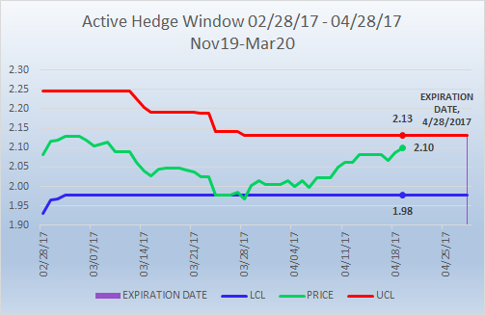
Illustration No. 4 below shows the target delivery periods included in the Plan.
Illustration No. 4
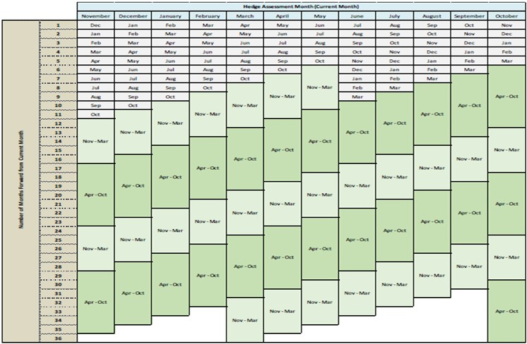

Execution

A hedge transaction window may be executed upon time expiration or reaching UCL/LCL limits. The transaction price for the hedge is based on market quotes or ICE bid/offers either on the day following the control limit trigger or the day of expiration. Due to the flexibility inherent within the Plan, however, management may elect to take other action, partial action, or no action, based on market indicators, changes in resource or demand, etc. Deviations from plan trigger guidance will be documented in the daily natural gas position report and communicated to senior management and Staff as necessary.

- Risk Responsive Hedging Tool
As previously noted, the Company is continuously reviewing the Plan to ensure we are incorporating the best methods possible within our Plan. The existing methods described above, are primarily programmatic with a built-in risk responsive mechanism for determining a hedge basin. Programmatic hedging is necessary to protect customers against potential dramatic market swings associated with the day-ahead natural gas market which can exhibit some of the highest volatilities in the overall commodity market. Further, hedging into future months and years protects customers against forward market volatility. Programmatic Hedging reduces the cost risk and increases the loss risk.
While we continue to believe in Programmatic Hedging as a fundamental component of our Plan, we are also moving forward with the modeling and evaluation of a risk-responsive defensive hedging mechanism. In order to minimize loss risk without jeopardizing cost risk, Avista is considering reducing programmatic hedging percentages and incorporating a new Risk-Responsive Hedging Tool (RRHT). While Programmatic Hedging would continue to systematically hedge to a certain level through the use of time limits and UCL/LCL, RRHT would monitor the market and call for additional hedging if pre-determined risk tolerance limits were triggered.
The RRHT includes all utility purchase and sales transactions, estimated customer load, storage injections and withdrawals, to derive open positions (by basin) that are marked to forward market prices. These monthly financial positions, along with market volatility, are then used to calculate the Value at Risk (VaR) by basin, which in turn is used to evaluate defensive hedging.
- Exposure Quantification
A test model for the RRHT is currently running parallel to the current Plan and is being modeled in a test Position Report which details Natural Gas Supply’s open gas positions. Positions are reported on a daily basis for a forward time horizon of approximately 3 years. Overall financial exposure is quantified volumetrically and in dollars, calculated by valuing the volumetric positions using the associated forward prices. In addition, VaR is reported for the entire portfolio of positions which helps to measure the at risk dollar amount above and beyond the current financial exposure. VaR is also used to create the metric used to drive the Risk Responsive hedging.
- Next Steps
The final determination for implementation of risk-responsible components into the Plan will depend on a variety of factors including the determination by Avista’s internal SOG that the results of testing has been consistent with expectations and meets plan goals, and ultimately approval by the RMC. The next steps in this process are as follows:
- Complete testing in the second quarter of 2018.

- Retain external consultant for verification (as an independent, secondary check) of Plan assumptions and calculations

- Receive approval for implementation from the RMC

- Incorporate the RRHT (to some extent) no later than 30 months from the filing of the 2017 PGA filing as required per the Policy Statement in Docket No. UE-132019.

- Provide a Comprehensive Hedging Plan, including retrospective report, with the 2018 Washington Natural Gas PGA filing.

The Company will continue to monitor the results of the RRHT through the test position reports and modify as necessary. The process will continue to communicate and update Staff and other parties, as necessary, through our semi-annual Natural Gas Update meetings.

Long Term Transactions: The Long Term gas horizon is time beyond the Short Term gas horizon. Currently, our Procurement Plan does not extend beyond the 36 month period. However, planning for the Long Term time horizon is incorporated in Avista Utilities natural gas Integrated Resource Plan (IRP) and specific facility acquisition, construction and betterment plans.
When a planned transaction is triggered prior to time expiration, Gas Supply will solicit at least one market quote, or document the relevant bids and offers from ICE on the following business day to verify the Position Report price. If a market quote indicates that the actual current market price is still within the UCL or the LCL, then Gas Supply may defer a transaction and the window will remain open. If a market quote indicates the actual current market price exceeds the UCL or is below the LCL, Gas Supply will solicit at least three market quotes ICE bids and offers for potential execution. If the quotes remain outside of the UCL or the LCL, the gas buyer will transact with the most favorably priced counterparty unless credit limits and/or significant counterparty exposure dictate that Gas Supply should not transact with the lowest priced counterparty when attempting to close a Hedge Window. In instances where there is significant intra-day price movement, Gas Supply may deem it appropriate to close a Hedge Window on that day to avoid further price increases.
Loss risk is the potential to pay more than the daily gas price with a forward hedge. Cost risk is the potential for daily prices to rise above the hedge price.

