Corporate Profits Are Soaring. Here's Why It Can't Last
Fortune
http://fortune.com/2017/12/07/corporate-earnings-profit-boom-end/
By SHAWN TULLY December 7, 2017
Some of the trends behind America’s earnings boom and stock market surge are about to change. Investors beware.
Milton Friedman wasn’t buying the profit boom. It was late 1997, corporate earnings had surged to heights unseen in over a decade, and the Wall Street crowd was predicting years of near-double-digit gains to come. So I called the Nobel Prize–winning economist, the most celebrated monetarist of the 20th century, to get his take on whether the bull case for long-term profit growth was reasonable—or mostly bull.

The 85-year-old Friedman phoned back, collect as usual, from his office at the Hoover Institution. “Would you accept the charges from Milton?” asked the operator. I said I would, and Friedman got straight to the point. “Beware of predictions that earnings can grow faster than the economy for long periods,” he warned. “When earnings are exceptionally high, they don’t just keep booming.” Eventually, Friedman explained, profits must move back down to their traditional share of GDP. Earnings can get only so high, Friedman said. “They can’t break loose from economic gravity.”

Two decades later, Friedman’s warning is as timely as ever. Earnings are again in the stratosphere: Consider that in the second quarter, corporate profits in the U.S. were equal to 9.5% of GDP vs. the long-term average since 1950 of 6.6%. And Wall Street analysts are forecasting that cumulative earnings per share for the S&P 500 will jump by 11% in 2018 and another 10% in 2019, according to analytics and data provider FactSet.
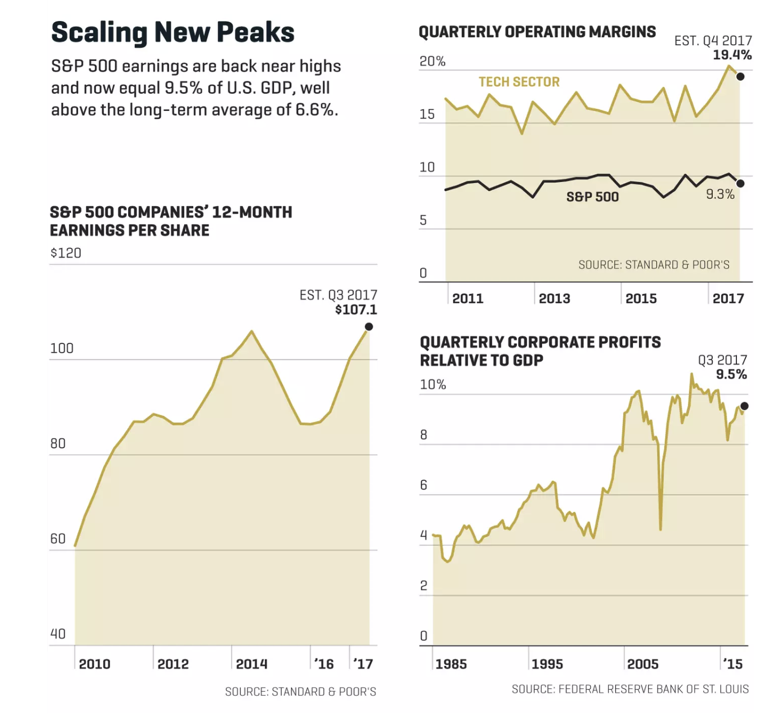

Nic Rapp
Here’s one problem with that projection: The S&P 500’s profit margins are now near all-time highs. Even if they remain elevated, a questionable assumption, earnings can grow only as fast as sales. “And sales grow along with the economy,” says Roger Ibbotson, professor emeritus at Yale and chief of investment firm Zebra Capital. In other words, as Friedman preached, it’s the fundamentals underpinning GDP—basics such as consumer spending and capital investment—that will guide earnings growth in the years ahead. Nobody is projecting GDP growth of 11% in 2018; the consensus, including inflation, is around 4%.

ADVERTISING

inRead invented by Teads
It’s highly uncertain, however, that profits can even manage to climb in step with GDP. That’s because they’re already highly elevated thanks to those super-rich margins. Put simply, U.S. companies have benefited in recent years from an unusual combination of tailwinds—including flat labor costs, super-low interest rates, and, in 2017, a falling dollar. Those factors have outraced a plodding economy, so that the share of the economic pie flowing to corporate profits has swelled while the slice going to labor has shrunk. Last year, wages and salaries were just 43% of GDP—well below the long-term average of 47%.

Those factors are starting to reverse. Labor costs are rising, interest rates are poised to trend higher, and the greenback is starting to strengthen. It all adds up to a looming squeeze on profits. What does that mean for stocks?

To bring the profit picture into tighter focus, Fortune spoke to a number of market experts with strong academic credentials—all of whom are largely unswayed by the herd mentality of Wall Street. Although their outlooks varied, the differences in their forecasts were relatively narrow.

In the pessimistic camp is Rob Arnott, founder and CEO of Research Affiliates, a firm overseeing strategies for $200 billion in index funds. He says that workers are due for a raise. “Companies and shareholders have been taking a bigger and bigger share of the pie at the expense of labor,” says Arnott. “That can’t last. Labor’s share will rise as wages and other factors normalize.” He predicts that the crunch will slow earnings gains to at least a point below GDP growth over the next decade. That’s at best 3% annual growth—or well below the Congressional Budget Office’s estimate of an average of 4% nominal GDP growth over the next several years (consisting of 1.9% real increases annually, plus 2.1% inflation).

Mark Zandi, chief economist at Moody’s Analytics, takes a middle position. “Earnings are peaking or have already peaked,” he says. “At best, they’ll track U.S. GDP going forward. And that includes a boost from the rebound in economic growth overseas.” (All of our discussion on profits refers to earnings per share, or EPS, the number that really counts for investors.)

A notable optimist, relatively speaking, is Jeremy Siegel, the renowned professor of finance at the Wharton School. Siegel thinks that earnings per share can grow about half a point faster than nominal GDP—in the 5% range including inflation—chiefly because of big gains in the technology sector. “In tech today, it’s all about ideas that don’t require much capital, not about building $100 million plants. Margins for the tech titans can expand from here,” says Siegel. Still, he dismisses Wall Street’s projections as bogus. “The idea of 8% or 10% or 12% growth is ridiculous,” he says. “It will not happen.”

“Earnings are peaking or have already peaked. At best, they’ll track U.S. GDP going forward.”
- MARK ZANDI, CHIEF ECONOMIST, MOODY’S ANALYTICS
All of the experts agree, however, that the sluggish outlook could improve if Congress enacts robust tax reform. (Republicans appeared to be closing in on a bill at press time.) The potential benefits are twofold. First, a reduction in the nominal corporate rate from 35% to 20% should give companies a healthy boost in after-tax profits. Not that the average U.S. company pays the official 35% rate now: Howard Silverblatt, senior industry analyst for S&P, calculated that the average effective levy for the S&P 500 in 2016 was 24.8%. Still, dropping down to 20% will have a significant impact.

It won’t necessarily be America’s big multinationals that gain the most under the tax plan proposed by Republicans. The GOP wants to erase their biggest shelter—deferring payments to the Treasury by leaving foreign-generated profits in overseas subsidiaries. That kind of strategy helped Alphabet (GOOGL, +1.94%), for instance, pay an effective tax rate of just 19.3% in its most recent fiscal year. Rather, the leading beneficiaries would be enterprises that do most of their business in the U.S. Grocery giant Kroger (KR, -4.43%), for example, pays over 30% in federal taxes. Michael Arone, chief investment strategist at State Street Global Advisors, reckons that new legislation that drops the rate all the way to 20%, and contains other levy-lowering provisions such as immediate expensing of capital expenditure, could raise EPS for the S&P 500 by 8% in the first year. A weaker package would deliver substantially less juice, he says.

Tax reform could also provide a more long-lasting tonic to earnings. A 20% corporate rate would greatly lower the break-even point for investments in the U.S. “Corporate profits right now are great,” says Urooj Khan, a professor at Columbia Business School. “But they’re not translating into economic growth in the U.S. And that’s because of the way the U.S. taxes foreign earnings, as well as the drag from a rate that’s extremely high by international standards.” Khan cites research showing that companies invest in foreign projects and acquisitions that aren’t as profitable as those available in the U.S. just to avoid taxes. Lower U.S. rates would make overseas shelters far less attractive and encourage companies to bring the money home, potentially causing a surge in capital expenditure, says Khan.

“Companies and share-holders have been taking a bigger and bigger share of the pie at the expense of labor. That can’t last.”
- ROB ARNOTT, CHAIRMAN AND CEO, RESEARCH AFFILIATES
Wall Street, meanwhile, is jacking up its forecasts based on recent history. Analysts at big banks are touting a big surge in earnings that started in 2016. In Q1 of that year, cumulative EPS for the S&P 500 was $23.97. That figure has risen strongly in every quarter since. For the most recent three months, ended Sept. 30, the S&P 500’s EPS was $31.50—a robust 9.8% gain compared with the same quarter last year. Boosters on Wall Street are suggesting that springboard can turn into a trampoline going forward. But digging into the S&P’s numbers over a longer stretch reveals a more discouraging picture.

In real terms, EPS actually peaked three years ago, in the third quarter of 2014. The reason the S&P 500’s recent performance looks so good is that earnings cratered for six quarters (stretching from that peak in late 2014 to early 2016), thanks to a collapse in oil prices that pushed earnings for energy giants deeply into the red. EPS (specifically, “as reported” GAAP earnings per share) hit bottom in Q1 of 2016 at a trailing, 12-month reading of $86. Now that we’re past that period of easy year-over-year comparison, the earnings hill will get harder to climb.

The profit boom looks even more mirage-like when you examine S&P profits in raw dollars. At its high point in Q3 2014, the S&P 500 had earned $943 billion in the previous 12 months. Three years later, the comparable number was $885 billion—or 6.2% lower. “Basically, we’re just back to where we were at the previous peak,” says Silverblatt of S&P.

Earnings per share have managed to stay flat partly because of a massive surge in share buybacks. But that’s a departure from the norm that likely won’t repeat. From Q3 of 2014 to Q3 of 2016, S&P members went on a rampage of stock repurchasing. “After their stocks took a big fall, they raised repurchases to extremely high levels,” says Silverblatt.

A study of the S&P 500 by Research Affiliates finds that since 2012, buybacks have modestly boosted growth in earnings per share—adding around 0.16 percentage points per year. But that period has been highly unusual, the study concluded. Over the long term, new issuance exceeds repurchases by a large margin, eroding rather than bolstering EPS. From 1988 to 2017, the S&P 500 saw average dilution of 1.2% a year. That’s because many big enterprises regularly issue more stock than they buy back, using the proceeds for repurchase of new shares from newly exercised options and vested restricted stock, for M&A, and for secondary offerings. Adding to dilution are IPOs that flood the market with new shares, funding the expansion of newly public companies that snatch profits from the established incumbents.

But annualized spending on buybacks has dropped by at least 15% from its high point last year, according to Silverblatt. And investors shouldn’t count on another buyback boom. Given the long-term history of new issuance exceeding buybacks, it’s more likely that future EPS could actually suffer from net dilution.

So if earnings growth has been so anemic, why have stocks continued to soar over the past few years—with the S&P 500 rising 29% since September 2014? “It’s all multiple expansion,” says Silverblatt, noting that the price-to-earnings ratio for the 500 has jumped over those three-plus years from 18.9 to the current, super-rich 24.3. Let’s look at the S&P as one big company. Its current annualized earnings of $107 haven’t budged in three years, yet its “price” has risen from 2,018 to 2,602. Hence, investors who three years ago paid less than $19 for $1 of earnings now pay $24.30—an extra $5.30, or an almost 30% premium, for a dollar of earnings.

Much of the bullishness driving that multiple expansion derives from enthusiasm about the tech sector. And indeed, tech is the star when it comes to profit growth. From Q3 2014 to Q3 2017, the sector boosted EPS by a phenomenal 31% while S&P 500’s earnings overall remained flat. The jump wasn’t primarily generated by annualized revenues, which rose a modest 11% per share over that period. The engine was an explosion in margins from 15.9% to 20.4%. By contrast, energy profits dropped over the same period by 76%, explaining in large part why EPS didn’t budge overall.

The energy sector should rebound in 2018 because of the resurgence in oil prices. But it accounts for a surprisingly small portion of index earnings; Silverblatt reckons that the oil and natural-gas giants will contribute around 4% of the S&P 500’s total in 2018. “The energy rebound is a nice tailwind, but it doesn’t move the total much,” he says. By comparison, tech is by far the dominant industry, accounting for around one-quarter of all S&P earnings. Financial services is No. 2, at approximately 18%.

The most powerful hit to profits will come from rising labor costs, which account for between two-thirds and three-quarters of all business expense. For years shareholders have garnered big returns while workers’ incomes have remained flat. “Labor costs have been depressed for a long time, and that can’t continue,” says Zandi. “They will accelerate and cut into margins.” That balance is already starting to flip. Today’s 4.2% unemployment rate signals an extremely tight market for workers. The Department of Labor’s Employment Cost Index calculates that total compensation rose at an annual rate of 2.51% in the third quarter of 2017. That’s 1.2 percentage points higher than inflation, and far above the 1.77% increase in early 2014.

Let’s step back and do a little math to see how this applies to stocks. Even if you hold on to some very bullish assumptions about the near future, the numbers argue that prices must come down. For example, let’s assume that the S&P 500’s P/E stays at its current elevated level. Then imagine that earnings drop from 9.5% of GDP to 8%—a figure that’s still well above the historical average. In that scenario, the S&P 500 index would fall by 13%, even if economic growth meets expectations.

Earnings bulls invariably cite the recent, synchronized rise in global growth as a major boon to U.S. multinationals. And they’re correct. What’s mostly ignored is a heavy counterweight—the ­meager prospects at home. The S&P 500 is highly international: Around 30% of total sales, and 40% of profits, flow from abroad. Increasingly, it’s been fast-growing overseas operations supplying the juice. According to FactSet, S&P companies with more than 50% of their sales outside the U.S. raised their earnings 13.4% in Q3 of 2017 vs. the same quarter a year ago, compared with just 2.3% for those with more than half their sales in the U.S. Europe has turned from a millstone into a motor. Nike (NKE, +1.96%) recently reported seven straight quarters of rising sales in Europe. And DowDuPont (DD, +0.00%), Apple (AAPL, +1.00%), and McDonald’s (MCD, +0.65%) all highlighted strong results in the most recent quarters from Europe, Asia, and emerging markets.

The dollar’s 9% decline this year against a basket of global currencies helped greatly. But since the end of October, the greenback has stabilized and even gained slightly against the euro. The prospect of higher U.S. rates and lower corporate taxes is likely to arrest or even reverse the dollar’s decline, curbing the recent pace of overseas profits.

Still, U.S. multinationals should benefit from robust growth abroad, especially in developing markets. The Organization for Economic Cooperation and Development (OECD) projects real global GDP of 3.7% in 2018. But non-OECD countries, including China, are forecasted to grow by 4.9% in aggregate, while the OECD estimates that U.S. GDP will grow just 2.5% next year. Among the top beneficiaries of this overseas growth story should be tech titans such as Apple, Google, Facebook (FB, +0.51%), and Amazon (AMZN, +1.95%). Technology is by far the most global sector in the S&P, garnering no less than 60% of revenues from abroad. “U.S. tech companies have tremendous market power globally,” says Zandi. “Google and Facebook have 60% of all ad revenue. That power will continue to grow.”

Chiefly because of tech’s global strength, Zandi predicts that foreign profits for the S&P 500 will grow faster than U.S. national income. But he also projects that domestic earnings will lag GDP. The bottom line: The domestic drag will offset the global boost, so that future profits will simply track the economy. Even in a tech-driven global world, it comes back to cold, hard math.

Zandi’s scenario isn’t exciting, but unlike the Wall Street consensus, it makes sense. In 1999, Warren Buffett wrote an influential article for Fortune arguing that corporate profits as a share of GDP tend to go far higher after periods where they’re depressed—and drop sharply after they’ve been hovering at historically high levels. So whom should you believe? Today’s Wall Street crowd, or Buffett and Friedman? When two such sages agree, you should think twice before following the herd in the other direction.

A version of this article appears in the Dec. 15, 2017 issue of Fortune with the headline “When Will the Profit Boom Fizzle?”

