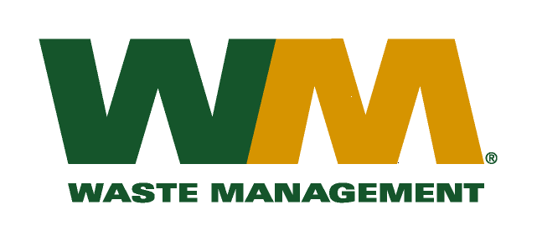
September 20, 2010
Washington Utilities and Transportation Commission
Chandler Plaza Building
1300 S. Evergreen Park Drive SW
P.O. Box 47250
Olympia, WA 98504-7250

Subject: Brem-Air Disposal, a division of Waste Management of Washington, Inc. (G-237); Tariff # 20
Enclosed are revised pages 2, 22 and 25 to the above-referenced tariff. The purpose of these tariff revisions is to reflect the change in the commodity credits for residential and multi-family customers receiving recycling collection services. These tariff revisions reflect a change in the current recycling charge from $1.19 to a credit of <$1.76> per month for residential customers and a change in the current recycling charge of $0.21 per unit to a credit of <$0.35> per unit for multi-family customers.
These changes are jointly due to the significant change in commodity values, tonnages and materials composition since our last commodity credit adjustment on November 1, 2009. We are requesting that the proposed effective date of these tariff revisions be November 1, 2010.
Enclosed for your review are our accounting work papers. Customers will be notified of the change in their recycling credit adjustment on their next regularly scheduled billing after approval by the Commission. In addition, the county has been notified of these proposed tariff changes.
If you have any questions or need additional information, please contact or me at (425) 814-7840.
Very truly yours,

Michael A. Weinstein
Senior Pricing Manager, Pacific Northwest Market Area

cc: Tim Crosby
Joe Krukowski
Alan York
Clerk of the Board, Kitsap County Chair

