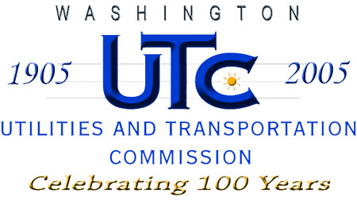
REGISTRATION AND COMPETITIVE CLASSIFICATION
OF TELECOMMUNICATION COMPANIES

All telecommunications companies must register with the Utilities
and Transportation Commission (UTC) prior to beginning operations in the state of Washington. Refer to RCW 80.36, WAC 480-121, 480-80, and 480-120.

1300 South Evergreen Park Drive SW  PO Box 47250  Olympia, WA 98504-7250 | Telephone 360-664-1160 / Fax 360-586-1150  TTY 360-586-8203 or 1-800-416-5289  Website: www.wutc.wa.gov
The UTC has a policy of providing equal access to its services. To request this document in alternate formats, please call 360-664-1133.

- Complete the application form.
- Submit these forms via the Records Center Web portal or e-mail to records@wutc.wa.gov as an electronic attachment. UTC encourages electronic submission of filings.
- UTC will issue a registration certificate with an effective date 30 days from the date the completed application is received and approved.

Include the following:
Current Balance Sheet Latest Annual Report, if any

Competitive Classification

Yes No | Applicant is subject to effective competition and requests waiver of regulatory requirements outlined in WAC 480-121-063 (1).

Telecommunications Company Information

Company Name: TTC Telecommunications, LLC |  | d/b/a:

Company Mailing Address: PO Box 3022

City/State/Zip: Pasco, WA 99302
Web Site Address:

Unified Business Identification Number (UBI): 602-872-656
(If you do not know your UBI number or need to request one contact the Department of Licensing at 360-664-1400)

Questions regarding this application should be directed to:

Name: Aaron R Seelye
Phone Number: 5093403424 | Fax Number: 5092325556 |  | E-mail: aseelye@ttctelecommunications.com

Mailing Address: PO Box 3022

City/State/Zip: Pasco, WA 99302

Registered Agent (A Washington Agent is required if the company is located outside Washington State):

Name: Stella E Pederson

Mailing Address: 6725 W. Clearwater Ave

City/State/Zip: Kennewick, WA 99336
Phone Number: 5097836154

Name, address and title of each officer or director (attach additional pages if needed)

Name | Address | Title
Aaron R Seelye | 4302 W. Hood Ave. Apt F108, Kennewick, WA 99336 | President

Regulatory Contact:

Name: Aaron Seelye
Mailing Address: PO Box 3022, Pasco, WA 99302
Phone Number: 5093403424 Fax Number: 5092325556
E-mail: regulatory@ttctelecommunications.com

Consumer Questions and/or Complaint Contact:

Name: Aaron Seelye
Title: President
Phone Number: 5093403424 Fax Number: 5092325556
E-mail: regulatory@ttctelecommunications.com

Emergency Contact:

Name: Aaron Seelye
Title: President
Phone Number: 5093403424 Fax Number: 5092325556
E-mail: aseelye@ttctelecommunications.com

Telecommunication services that will be provided (check all that apply):

Local Exchange Service (Resale) Data Services

Calling Cards Prepaid Calling Cards

Alternate Operator Services Directory Assistance

Long Distance Interlata WATS (800/888)

Long Distance Intralata

Other, please specify:_Local Exchange Services (facilities based)__________________

