July 7, 2016

Mr. Steven King
Executive Director and Secretary
Washington Utilities and Transportation Commission
1300 South Evergreen Park Drive SW
Olympia WA 98504-7250

RE: YCOM Networks, Inc. d/b/a FairPoint Communications – Universal Service Certification
47 USC 254(e); 47 CFR ' 54.314: Docket UT-160030

Dear Mr. King:

Attached for filing in the above referenced docket, YCOM Networks, Inc. d/b/a FairPoint Communications respectfully submits the ETC annual report per WAC 480-123-070 and WAC 480-123-080, including reports required by WAC 480-123-060 and 070.

Please contact Beth Westman at 207.535.4249 or bwestman@fairpoint.com with any questions or concerns regarding this filing.

Sincerely,
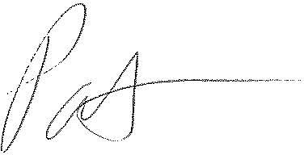
Patrick L. Morse
Senior VP Governmental Affairs
FairPoint Communications
P: 620-227-4409
F: 620-227-8576

