BEFORE THE WASHINGTON

UTILITIES AND TRANSPORTATION COMMISSION

BNSF RAILWAY COMPANY,  Petitioner,  v.  YAKIMA COUNTY,  Respondent.  . . . . . . . . . . . . . . . . . . . . . . . . . . . . . . . . . | )  )  )  )  )  )  )  )  )  ) | DOCKET TR-140382 and  DOCKET TR-140383  ORDER 03  INITIAL ORDER DENYING PETITIONS

INTRODUCTION

- On March 10, 2014, BNSF Railway Company (BNSF or Company) filed with the Washington Utilities and Transportation Commission (Commission) petitions seeking closure of the North Stevens Road highway-rail grade crossing near the City of Toppenish, Yakima County (Docket TR-140382), and closure of the Barnhart Road highway-rail grade crossing near the City of Mabton, Yakima County (Docket TR-140383). Yakima County and the Confederated Tribes and Bands of the Yakama Nation (Yakama Nation) objected to the proposed closures.

- At a prehearing conference held on May 23, 2014, an administrative law judge granted Yakama Nation’s oral motion to intervene. On October 28, 2014, Commission staff (Staff) filed a Motion to Withdraw as a party to this proceeding. At a second prehearing conference held on November 4, 2014, Administrative Law Judge Rayne Pearson granted Staff’s Motion and revised the procedural schedule.

- Judge Pearson performed a site visit and toured the area on April 27, 2015. The Commission conducted an evidentiary hearing before Judge Pearson upon due and proper notice to all interested parties on April 28-29, 2015, in Union Gap, Washington. The parties stipulated to the admission of all 99 exhibits.

- Judge Pearson conducted a public comment hearing for the Commission on the evening of April 28 in Union Gap. In addition, the Commission accepted written and electronic public comments on these matters from the date of BNSF’s initial filings until April 28, 2015. In sum, the Commission received and considered comments from 17 individuals and organizations, all of whom oppose the closure of the North Stevens Road crossing and/or the Barnhart Road crossing.

- On June 1, 2015, the parties filed simultaneous post-hearing briefs.

- Bradley Scarp and Michael Chait, Montgomery Scarp MacDougall, PLLC, Seattle, represent Petitioner BNSF. Quinn Plant, Menke Jackson Beyer, LLP, Yakima, represents Respondent Yakima County. R. Joseph Sexton, Galanda Broadman, PLLC, Seattle, represents the Yakama Nation.

BACKGROUND

- BNSF runs a mainline track east and west through the cities of Toppenish and Mabton in Yakima County. Numerous roads running north and south cross the BNSF line as it runs eastbound/westbound, including North Stevens Road and Barnhart Road. Presently, 12 to 14 trains come through both crossings each day at the maximum speed of 49 miles per hour. Citing its interest in improving public safety by reducing the potential for train-vehicle crossing accidents, BNSF seeks permission to close both crossings.

- The North Stevens Road and Barnhart Road crossings are located in a primarily agricultural area surrounded by open farm fields. To the south, State Route 22 (SR-22) runs parallel to the BNSF main line. South Track Road runs parallel with the BNSF line to the north in the vicinity of the North Stevens Road crossing.

- Barnhart Road is controlled by stop signs and white crossbuck highway-rail grade crossing signs on both sides of the tracks, and pavement markings on the south side of the tracks. North Stevens Road is controlled by stop signs and white crossbuck highway-rail grade crossing signs on both sides of the tracks.

- The closest alternate crossings to Barnhart Road are Indian Church Road, approximately 1.4 miles to the northeast, and Satus Longhouse Road, approximately two miles to the southeast. The Indian Church Road crossing is controlled by active warning devices, and the Satus Longhouse Road crossing is controlled by passive devices.

- The closest alternate crossings to North Stevens Road are Meyers Road, approximately 1.4 miles to the northeast, and South Track Road, just over one mile southwest. Both crossings have active warning devices.

EVIDENCE

- Proponents – BNSF

- BNSF presented testimony and exhibits to illustrate the safety concerns motivating the Company to seek closure of both crossings. The following witnesses testified on behalf of the Company: David Agee, manager of field safety and support for BNSF; Terry Stephens, division trainmaster for BNSF; Michael Tycksen, road foreman of engines and former locomotive engineer for BNSF; Foster Peterson, partner and consultant at Full Service Railroad Consulting, Inc. in Marietta, Georgia; and Gary Norris, project manager and senior traffic engineer at DN Traffic Consultants in Preston, Washington.

- The witnesses testified generally about the inherent danger of at-grade crossings and the risk of collisions at crossings with passive warning devices. Mr. Norris expressed his opinion that all at-grade crossings should be closed, and concluded that the Barnhart Road and North Stevens Road crossings are particularly dangerous because they lack active safety controls.

- In its post-hearing brief, BNSF argues that at-grade crossings present a substantial danger to the public and should be closed absent a strong showing of public necessity and convenience. BNSF characterizes the crossings at issue as “sparsely used by a small handful of agribusinesses” who will be minimally inconvenienced by their closure. BNSF claims that both crossings have visibility obstructions, and that each of the alternate crossings is safer by virtue of having active controls. BNSF further argues that any increase in slow-moving farm equipment on SR-22 caused by closing the crossings would be statistically insignificant. Finally, BNSF argues that Respondents Yakima County and Yakama Nation have failed to present evidence demonstrating a public need so great that the crossings must be kept open despite their “uniquely dangerous” conditions.

- Opponents – Yakima County and the Yakama Nation

- Yakima County. Yakima County presented testimony from the following witnesses: Kent McHenry, transportation engineering manager for Yakima County Public Services; Ed Boob, field consultant for Husch and Husch Fertilizer and Chemicals; Andy Curfman, manager for T & K Farms; Curtis Parrish, co-owner of S & P Farms and Ranch; Allen Zecchino, owner of Zecchino Farms; Dave Trautman, crop advisor with Simplot Soilbuilders; and John Hood, senior engineering technician with the Yakima County Department of Public Services. All were opposed to closing the crossings on the grounds that diverted traffic − and slow moving, oversized farm equipment in particular – would increase safety risks on S-22 and South Track Road.

- Several witnesses testified that closing either crossing would require substantial rerouting of heavy farm equipment along SR-22 and county roads during planting and harvesting seasons, as well as rerouting semi-trucks and other vehicles involved in daily farming operations.

- In its post-hearing brief, Yakima County argues that BNSF failed to meet its burden of proving, by a preponderance of the evidence, that public safety requires closure of either crossing. Contrary to BNSF’s assertion, Yakima County claims that visibility is excellent at both crossings, and both crossings are substantially safer than each of their nearest alternatives. Yakima County also argues that both crossings are used extensively by area farmers who would otherwise be required to reroute oversized farm equipment onto SR-22 and South Track Road, which would impede traffic traveling in both directions and may, as the Washington Department of Transportation (WSDOT) posits, increase the risk of collisions.

- Finally, Yakima County notes that petitions for closure usually arise in the context of a proposed track modification that renders a crossing “particularly dangerous,” “especially dangerous,” or “especially hazardous,” which is not present here. Instead, the alternate crossings to which vehicles would be rerouted each have features that the Commission has deemed “especially dangerous.”

- Yakama Nation. Yakama Nation offered testimony from the following witnesses: Al Pinkham, engineering planner for the Yakama Nation Engineering Program; Roy Dick, Elder at the Satus Longhouse; and Johnson Meninick, Elder of the Yakama Nation and program manager of the Yakama Nation Cultural Resources Program. All were opposed to closing the Barnhart Road crossing, which is part of a traditional route that Satus Longhouse members and others use for funeral processions and to access the Satus Longhouse. All were similarly opposed to closing the North Stevens Road crossing because doing so will pose an increased risk to drivers traveling on or through the Yakama reservation.

- In its post-hearing brief, Yakama Nation argues that BNSF has failed to satisfy its burden of proof in its petitions for the closure of either crossing, and both Yakima County and Yakama Nation have advanced significant evidence that, on balance, weighs heavily in favor of keeping the crossings open. Yakama Nation requests the Commission consider not only the risks associated with the crossings themselves, but also the corresponding risks that will arise if the crossings are closed, including the diversion of traffic onto state highways and county roads. Ultimately, Yakama Nation claims, the public interest and safety is best served if the crossings remain open.

- Like Yakima County, Yakama Nation notes that both North Stevens Road and Barnhart Road cross the railroad tracks at a nearly 90 degree angle, and both crossings have excellent visibility. Finally, Yakama Nation argues, even if the Commission finds that BNSF has met its burden by establishing that closure of these crossings is required for public safety reasons, the need for the crossings is so great that the crossings should remain open.

- Public Comment

- One member of the public, Frank Lyall of the Yakima County Farm Bureau, spoke against closure of the Barnhart Road and North Stevens Road crossings at the public comment hearing on April 28, 2015. Mr. Lyall expressed concerns about closure of the crossings diverting heavy machinery onto the highway, which he believes increases danger both to farmers and to the public generally.

- The Commission also received 16 written comments from individuals opposed to the closures, most of whom appeared as witnesses for Yakima County and the Yakama Nation. Philip Sealock submitted comments opposing the closing of the North Stevens Road crossing because he uses it regularly for farming on both sides of the tracks. Dean Oswalt submitted comments opposing the closing of the North Stevens Road crossing because he uses the crossing on a daily basis in his farming operations. Craig Oswalt also submitted comments opposing the closure of the North Stevens Road crossing because he uses it frequently.

DISCUSSION AND DECISION

- RCW 81.53.060 allows railroad companies to file written petitions with the Commission seeking the “closing or discontinuance of an existing highway crossing, and the diversion of travel thereon to another highway or crossing” when the petitioner alleges that the public safety requires such action. As the petitioner in this matter, BNSF carries the burden of proving, by a preponderance of the evidence, that public safety requires closure of the Barnhart Road and North Stevens Road crossings.

- Although past Commission orders took varied approaches to evaluating petitions for closure, a synthesis of our decisions produces a comprehensive analysis that begins with a two-part inquiry. First, we examine whether a crossing is “especially hazardous” such that public safety requires it to be closed. If the answer is affirmative, we next determine whether the public need for the crossing is “so great that the crossing should be kept open notwithstanding its dangerous condition.”

- In Burlington Northern RR Co. v. Skagit County, the Commission held that any number of the following factors may make a crossing especially hazardous: 1) the presence of vegetation or other obstacles that limit visibility on the approach; 2) the roadway crosses the crossing at an oblique angle (other than 90 degrees); 3) limited holding capacity on approaches between the railroad right of way and the streets that intersect; 4) more than one mainline track at the crossing; and 5) the presence of siding track in addition to mainline track.

- If the Commission finds that a crossing is especially hazardous, we consider the following factors, as enumerated in BNSF Railway Company v. Snohomish County, to determine whether the crossing should remain open despite its dangerous condition: 1) the amount and character of travel on the railroad and on the highway, 2) the availability of alternate crossings, 3) the number of people affected by the closure, 4) whether there are readily available alternate crossings in close proximity that can handle any additional traffic resulting from the closure, and 5) whether the alternative crossings are safer than the crossing proposed for closure.

- If, however, the evidence fails to show that a crossing is especially hazardous, the Commission need only decide whether the inherent danger of the crossing, balanced with public convenience and necessity, warrants its closure.

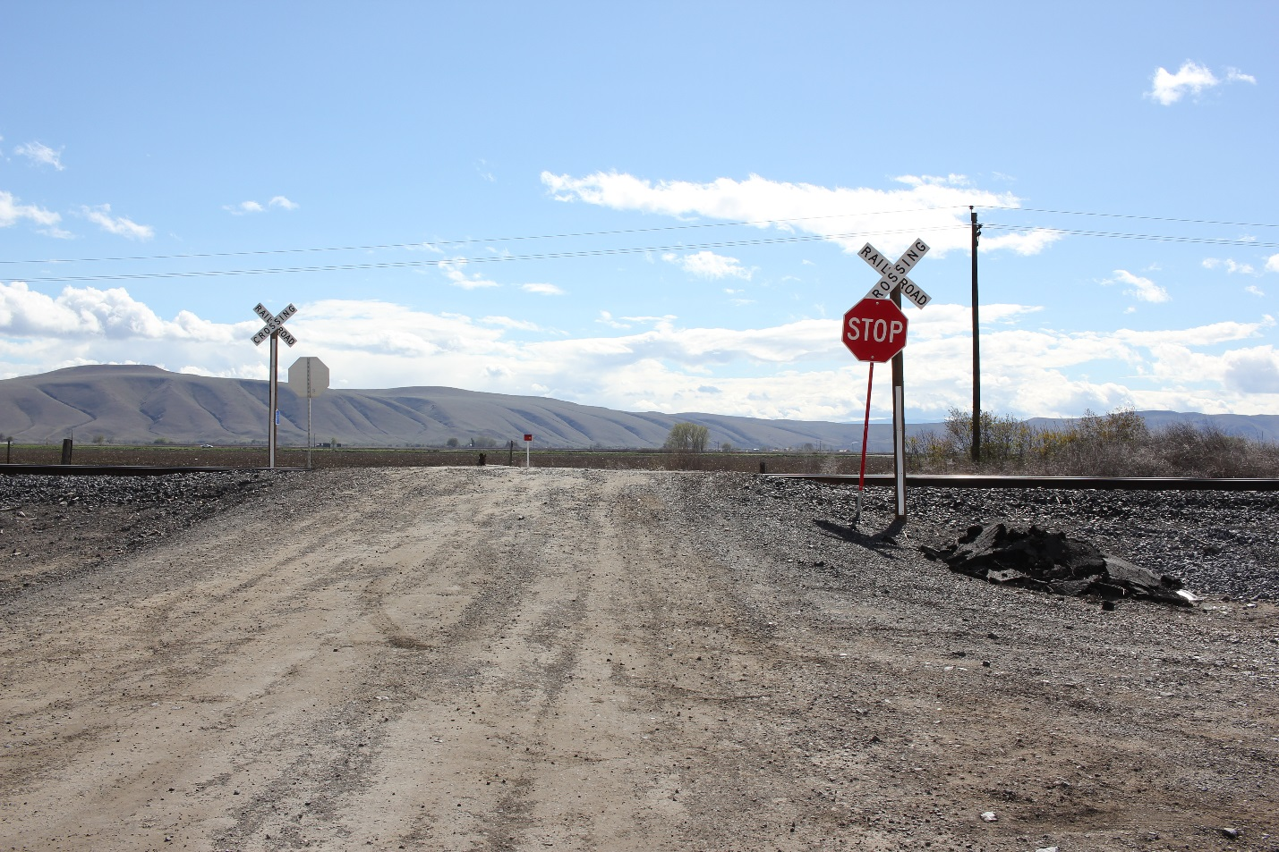
- The Barnhart Road and North Stevens Road Crossings are not Especially Hazardous. The factors enumerated in Skagit County are not present here at either crossing. First, Exhibit No. KM-3 shows unimpeded visibility at the North Stevens Road crossing in both directions. The photo below, taken from BNSF’s post-hearing brief, depicts very minimal vegetation along one side of the tracks:

- Judge Pearson observed during the April 27, 2015, site visit that the North Stevens Road crossing has better visibility than either of its alternate crossings.

- Similarly, Exhibit No. KM-2 shows unimpeded visibility at the Barnhart Road crossing in both directions. The photo below, taken from BNSF’s post-hearing brief, also depicts only a few trees along one side of the tracks:

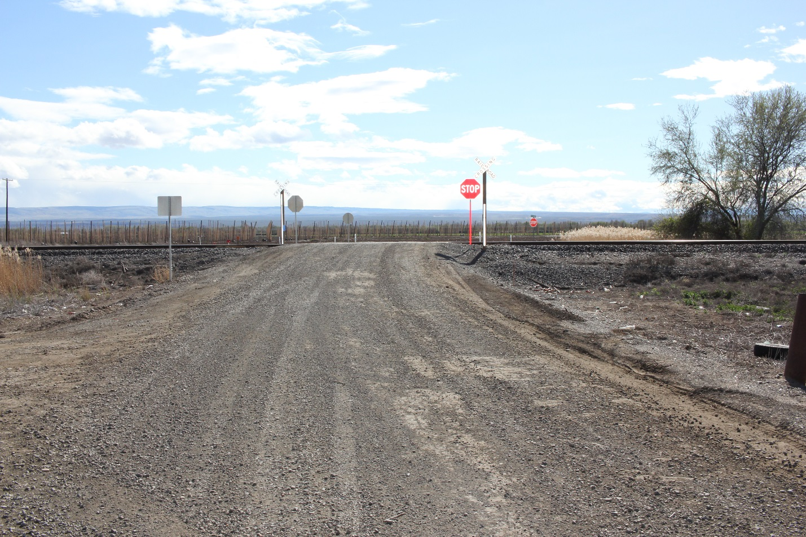
Judge Pearson observed during the April 27, 2015, site visit that the Barnhart Road crossing has better visibility than either of its alternate crossings.

- Second, the roadway crosses the tracks at a nearly 90 degree angle at both crossings. Third, neither crossing has limited holding capacity. Finally, only one set of mainline tracks is present at both crossings, and no sideline tracks are present. Accordingly, we find that neither crossing is especially hazardous.

- The Barnhart Road and North Stevens Road Crossings are also not “Uniquely Dangerous.” In its post-hearing brief, BNSF largely ignores those factors the Commission considers “especially hazardous,” arguing instead that other factors make both crossings “uniquely dangerous.” The Commission has not previously recognized the concept of “uniquely dangerous” or used most of the factors the Company proposes to determine whether a crossing should be closed. We decline to do so now. Even if we considered the Company’s factors, however, we would not reach a different conclusion.

- BNSF argues the crossings are “uniquely dangerous” because, inter alia, they are unpaved, frequently used by heavy farm equipment, and controlled by passive warning devices. While the north side of the Barnhart crossing and both sides of the North Stevens crossing are unpaved, this feature does not qualify either crossing as “uniquely dangerous,” as BNSF claims; numerous unpaved public crossings presently exist throughout Washington.

- Similarly, neither crossing is “uniquely dangerous” due to frequent use by heavy farm equipment. There are many crossings that are utilized by a high volume of farm equipment, particularly in agricultural areas throughout Eastern Washington.

- Moreover, if heavy farm equipment poses a risk at the North Stevens and Barnhart crossings, it poses the same risk at each of the alternate crossings. The record clearly demonstrates that regardless of whether the crossings remain open, farm equipment will continue to cross the tracks with the same frequency.

- Finally, the fact that both crossings have passive safety controls does not make them “uniquely dangerous.” Of the more than 2,200 at-grade crossings in Washington, 54 percent are controlled by passive warning devices. The crossings at North Stevens and Barnhart Roads are hardly unique in this respect. However, to address BNSF’s concerns about the lack of active warning devices, the Company may wish to assemble a diagnostic team to determine whether additional safety controls would be appropriate at either crossing.
- Because BNSF has not met its burden of proving that either crossing is especially hazardous, we need not undertake the analysis set forth in BNSF Railway Company v. Snohomish County to determine whether the public need is “so great” that the crossings must remain open. Rather, the appropriate standard here is whether the inherent danger of the crossings, balanced with public convenience and necessity, warrants closure of either crossing. A review of Commission decisions that apply this standard reveals that our jurisprudence is relatively undeveloped in this area.

- In Burlington Northern and Santa Fe Railway Company v. City of Sprague, the administrative law judge denied petitions for closure of two at-grade crossings because the petitioner failed to show that the crossings were particularly dangerous, that there were adequate alternative routes, or that closing either crossing would serve public convenience and necessity. Using Sprague as a guidepost, our analysis will consist of a comprehensive examination of both public safety – including consideration of the potential safety impact that closing the crossings would have on the surrounding community – and public convenience and necessity, which necessarily includes an inquiry into the adequacy of alternate crossings.

- Safety Impact of Crossing Closures on the Surrounding Community. Both Yakima County and Yakama Nation argue persuasively that closing either crossing would decrease safety in the surrounding community by introducing slow-moving farm equipment onto SR-22. For example, Mr. Curfman testified that the 70 trips his company makes across the North Stevens crossing each week between his two parcels would require an additional ten miles of travel; his 40-foot semi-trucks cannot make the turns required to navigate county roads. If the North Stevens crossing is closed, each of those semi-trucks, in addition to tractors that travel at a maximum speed of 18 miles per hour, would enter SR-22 into traffic without the benefit of a stop light, and would not reach safe highway traveling speed before arriving at an alternate crossing. In addition, SR-22 contains no acceleration lanes to accommodate the ingress and acceleration of semi-trucks or heavy farm equipment. Each of Yakima County’s witnesses echoed Mr. Curfman’s concerns.

- WSDOT expressed the same concerns in a March 12, 2015, letter to Mr. McHenry:

“If the N. Stevens Road and Barnhart Road crossings are closed, there are no alternate routes on the local system to accommodate farm vehicle traffic. In the absence of alternative routes, WSDOT expects an increase in the number and trip duration of farm vehicles on SR-22 … SR-22 has a speed limit of 60 miles per hour. Introducing slower farm vehicles with the high speed of highway traffic of SR-22 will create operational concerns and would likely increase the risk of collisions.”

- BNSF, however, failed to undertake any meaningful analysis of the public safety impact that closing either crossing would have on the surrounding community. On cross examination, Mr. Norris admitted that he performed no analysis of the increased risk of collisions along SR-22 caused by diverting passenger vehicles and farm equipment. Mr. Peterson similarly testified that he did not consider the potential adverse impacts of closing the crossings, nor was he asked to. As Yakima County correctly noted in its post-hearing brief, “unless and until these [safety] impacts can be quantified and weighed against the purported safety benefits of closing these crossings, the net safety impact of closing the crossings cannot be determined.”

- Although BNSF claims that the risk of collisions at both crossings is too great to allow either crossing to remain open, the Company’s expert witness failed to properly calculate the probability of a vehicle-train collision. Mr. Norris used the US Department of Transportation (USDOT) Accident Prediction Model for the North Stevens Road and Barnhart Road crossings, which requires producing, and then combining, three independent calculations. Mr. Norris testified that he completed only the first calculation, identified by USDOT as the basic formula, and neither completed the two subsequent calculations nor combined all three to produce an accurate result. Accordingly, BNSF failed to meet its burden to prove that the inherent danger of either crossing – which logically includes the risk of collision at the crossings – outweighs the public safety risks that will result if the crossings are closed.

- Public Convenience and Necessity. In its post-hearing brief, BNSF argues unpersuasively that closing both crossings would create a “minimal inconvenience” for the parties who presently use them. The testimony established that the inconvenience created by closing either crossing would be substantial.

- For example, S & P Farms owns and farms two 80-acre parcels that are bisected by the BNSF main line near the North Stevens crossing. S &P Farms uses the crossing to move large farm equipment between the two parcels, which eliminates the need to use SR-22. If the North Stevens crossing were closed, harvesting corn would require a “caravan of large, slow moving farm equipment (combine, grain cart, tractor with stalk beater, and semi-trucks) to travel more than a mile on SR-22 each time we need to cross the BNSF line.”

- T & K Farms also farms parcels of land on both sides of the BNSF mainline; the North Stevens crossing allows semi-trucks and trailers to move between the two parcels, similarly eliminating the need to use SR-22. Mr. Curfman testified that much of the company’s equipment travels at speeds below 25 mph, which would increase travel time between the two parcels from less than five minutes to more than 30 minutes. According to Mr. Curfman, this would increase labor and mechanical expenses for T & K, block traffic across SR-22 on narrow portions of the highway, and present a safety hazard to company equipment, employees, and other drivers.

- Mr. Zecchino testified that Zecchino Farms currently moves farm equipment between its two parcels of farming land, which are bisected by the BNSF mainline, by using the crossing at Barnhart Road. If the Barnhart crossing is closed, Zecchino farms would be required to transport its farm equipment two miles along SR-22 to the Satus Longhouse Road crossing each time it moved equipment or other vehicles between the two parcels.

- The record demonstrates that closure of either crossing would not just create a minor inconvenience, such as having to drive a few extra minutes to commute to and from work, or access a business. Each crossing is integral to daily farming activities, and provides the safest means to perform the work, both for farmers and for the traveling public.

- In addition to the farmers and suppliers who use the crossings in the course of conducting business, members of the Yakama Nation also use the Barnhart Road crossing to access the Satus Longhouse. Barnhart Road near the crossing predates the railroad tracks as a trail used by members of the Yakama Nation. The testimony in the record established that the Barnhart Road crossing is part of a traditional route the Satus Longhouse community uses to access the longhouse and the tribal cemetery. Yakama Nation witness Johnson Meninick explained that the Barnhart Road crossing is culturally significant to tribal members because the road was used by tribal elders, and “within our belief we have to follow the pattern that our elders have used, so we’ve always followed that pattern [across the Barnhart Road crossing] because it is our belief.”

- In its post-hearing brief, BNSF notes that funeral processions have “at times used alternative routes, such as over the Indian Church Road crossing.” While it is true that the testimony established that some funeral processions use a route along Indian Church Road, the testimony also established that the procession route is determined by the path of the decedent’s ancestors. This is not merely a matter of rerouting, as BNSF suggests.

- Both Yakima County and the Yakama Nation have demonstrated that there is a significant public need for both crossings, and that closing either crossing would negatively impact public safety. Moreover, closing the Barnhart Road crossing would effectively destroy the Yakama Nation’s long-standing cultural tradition.

- Adequacy of Alternate Crossings. We also find unconvincing BNSF’s argument that each of the alternate crossings is safer than the North Stevens or Barnhart crossings. In its post-hearing brief, the Company argues that the testimony “clearly established” that the Meyers and South Track Road crossings are both “substantially safer” than the North Stevens Road crossing. The testimony offered by BNSF witnesses, however, established only that both crossings are controlled by active warning devices, and that both roads are paved.

- In contrast, the evidence offered by Yakima County and the Yakama Nation established that factors other than warning devices make both alternate crossings more dangerous than the crossing at North Stevens Road. First, as Yakima County notes in its post-hearing brief, Mr. McHenry’s testimony and its accompanying exhibits demonstrate that the South Track Road crossing occurs at an oblique angle in the middle of an “S” curve, which impairs visibility in both directions. Moreover, testimony established that South Track Road is narrow, and is known for high speed traffic. Several witnesses testified that they avoid using South Track Road with farm equipment for those reasons.

- Second, the crossing at Meyers Road crosses the tracks at an oblique angle, and crosses two sets of tracks rather than one. This is problematic because a train stopped on one set of tracks may obscure visibility of the approach of a second train on the other set of tracks.

- BNSF also argues that the testimony “clearly established that the Indian Church Road crossing was substantially safer” and “the Satus Longhouse Road crossing was marginally safer” than the Barnhart Road crossing. Again, the testimony offered by BNSF witnesses established only that the Indian Church Road crossing is controlled by active warning devices, and that both crossings are located on paved roads.

- The Satus Longhouse Road crossing is controlled by passive safety devices (crossbuck and stop signs) and pavement markings. Exhibit No. KM-4 clearly shows that visibility is impeded on the northern approach to the west by trees and brush, which can be removed to improve visibility, and at closer distance by an abandoned building, which cannot be removed. The evidence demonstrates that visibility is more compromised at the Satus Longhouse Road crossing than it is at the Barnhart Road crossing.

- The evidence also showed that the Indian Church Road crossing is not a viable alternate crossing for many types of vehicles, including farm equipment and semi-trucks, because of the sharp, narrow turn required to access Indian Church Road to the south. The photos below – taken from both an aerial and street view, respectively − depict the nearly 135-degree right turn that vehicles must negotiate to travel on Indian Church Road back toward the Barnhart Road crossing:

Indian Church Road Crossing, Aerial View

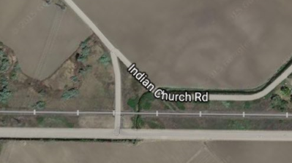

Indian Church Road Crossing, Street View

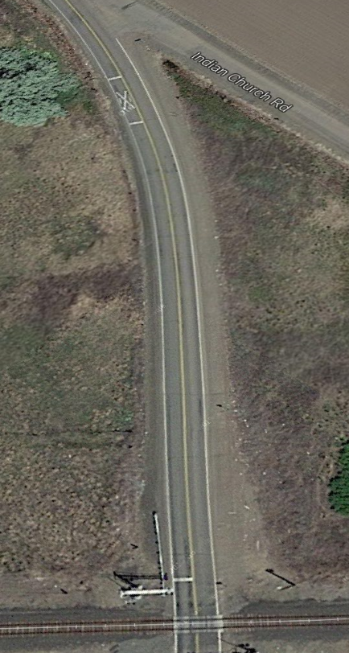

The evidence also shows that the northern approach to the crossing at Indian Church Road negotiates a curve that degrades visibility of the tracks, particularly to the west.

- Accordingly, the more viable alternate crossing to Barnhart Road for large farm equipment and semi-trucks is Satus Longhouse Road, which is controlled by passive warning devices similar to those at Barnhart Road. Although BNSF attempts to characterize the Satus Longhouse Road crossing as “marginally safer than the Barnhart Road Crossing,” the evidence clearly established that, because of degraded visibility at the Satus Longhouse crossing, the inverse is true.

- Decision. On balance, the evidence in the record weighs heavily in favor of keeping both the North Stevens Road and Barnhart Road crossings open. Yakima County presented extensive testimony regarding the use of both crossings in the course of day-to-day business for local farmers, several of whom farm on noncontiguous parcels of land bisected by the BNSF mainline track. The evidence demonstrated a public need for the crossings, as well as a much more convenient and efficient way for farmers to access their land.

- The Yakama Nation presented testimony about the tribal need for the Barnhart crossing, which is part of a culturally significant and traditional route that the Satus Longhouse community uses to access the longhouse and the cemetery. This is also a real and demonstrated public need for the Barnhart crossing to remain open. Accordingly, we find that BNSF failed to prove that the inherent danger of either crossing outweighs the demonstrated public need for it to remain open, and we deny both petitions for closure.

FINDINGS AND CONCLUSIONS

- (1) The Commission is an agency of the State of Washington vested by statute with the authority to regulate the placement and conditions of operation of crossings at grade of railroad tracks with public roadways within the State of Washington.

- (2) The Commission has jurisdiction over the subject matter of and the parties to this proceeding.

- (3) BNSF petitioned the Commission on March 10, 2014, for authority to close the highway-railway crossings at North Stevens Road and Barnhart Road in Yakima County, Washington.

- (4) The North Stevens Road and Barnhart Road at-grade crossings are located in a primarily agricultural area, surrounded by open farm fields. To the south, State Route 22 runs parallel to the BNSF main line.

- (5) Both crossings are used primarily by heavy farm equipment and other commercial vehicles, many of which avoid travel on State Route 22 entirely by using the crossings to access noncontiguous parcels of farm land.

- (6) Both crossings have excellent visibility at the point of crossing and superior visibility on either approach, as compared to adjacent crossings. Both crossings cross one set of tracks at a nearly 90 degree angle, and neither has limited holding capacity.

- (7) BNSF did not meet its burden to prove, by a preponderance of the evidence, that either the North Stevens Road or Barnhart Road crossings are especially hazardous.

- (8) The North Stevens Road at-grade crossing is within 1.4 miles of a crossing to the north (Meyers Road) and approximately one mile of a crossing to the south (South Track Road). Neither of those crossings provide the primary users of the North Stevens Road at-grade crossing −heavy, slow-moving farm equipment – more convenient or safer access across the tracks.

- (9) The Barnhart Road at-grade crossing is within 1.4 miles of a crossing to the north (Indian Church Road). To access Indian Church road to the west and travel back towards Barnhart road, vehicles must negotiate a nearly 135-degree angle turn on a narrow road. For practical purposes, the Indian Church Road at-grade crossing is not a viable alternative crossing for the primary users of the Barnhart Road at-grade crossing − heavy, slow-moving farm equipment.

- (10) The Barnhart Road at-grade crossing is within approximately two miles of a crossing to the south, Satus Longhouse Road. The Satus Longhouse Road at-grade crossing does not provide the primary users of the Barnhart Road at-grade crossing − heavy, slow-moving farm equipment – more convenient or safer access across the tracks.

- (11) Members of the Yakama Nation use the Barnhart Road crossing to access the Satus Longhouse and as a traditional funeral procession route, and closing the Barnhart Road crossing would effectively destroy a tribal tradition. The Yakama Nation’s use of the Barnhart Road crossing is a public necessity.

- (12) BNSF failed to prove, by a preponderance of the evidence, that the inherent risk associated with at-grade crossings outweighs the public convenience and necessity as it relates to either crossing.

- (13) The public convenience and necessity require that the North Stevens Road and Barnhart Road crossings remain open. The Commission should deny BNSF’s petitions to close the North Stevens Road crossing and the Barnhart Road crossing.

ORDER

THE COMMISSION ORDERS:

- (1) BNSF Railway Company’s petition to close the Barnhart Road at-grade highway rail crossing is DENIED.

- (2) BNSF Railway Company’s petition to close the North Stevens Road at-grade highway rail crossing is DENIED.

Dated at Olympia, Washington, and effective August 18, 2015.

WASHINGTON UTILITIES AND TRANSPORTATION COMMISSION

RAYNE PEARSON
Administrative Law Judge

NOTICE TO THE PARTIES

This is an initial order. The action proposed in this initial order is not yet effective. If you disagree with this initial order and want the Commission to consider your comments, you must take specific action within the time limits outlined below. If you agree with this initial order, and you would like the order to become final before the time limits expire, you may send a letter to the Commission, waiving your right to petition for administrative review.

WAC 480-07-825(2) provides that any party to this proceeding has 20 days after the entry of this initial order to file a petition for administrative review (Petition). Section (3) of the rule identifies what you must include in any Petition as well as other requirements for a Petition. WAC 480-07-825(4) states that any party may file an answer (Answer) to a Petition within 10 days after service of the petition.

WAC 480-07-830 provides that before the Commission enters a final order any party may file a petition to reopen a contested proceeding to permit receipt of evidence essential to a decision, but unavailable and not reasonably discoverable at the time of hearing, or for other good and sufficient cause. The Commission will not accept answers to a petition to reopen unless the Commission requests answers by written notice.

RCW 80.01.060(3), as amended in the 2006 legislative session, provides that an initial order will become final without further Commission action if no party seeks administrative review of the initial order and if the Commission fails to exercise administrative review on its own motion.

You must serve on each party of record one copy of any Petition or Answer filed with the Commission, including proof of service as required by WAC 480-07-150(8) and (9). To file a Petition or Answer with the Commission, you must file an original and three copies of your petition or answer by mail delivery to:

Attn: Steven V. King, Executive Director and Secretary
Washington Utilities and Transportation Commission
P.O. Box 47250
Olympia, Washington 98504-7250

In formal proceedings, such as this, the Commission’s regulatory staff often participates like any other party, while the Commissioners make the decision. Rather than participating as a party to the proceeding, Staff acted as policy advisors to Judge Pearson.
In compliance with Judge Pearson’s requests at hearing, two additional exhibits were submitted after the close of the evidentiary hearing. On May 4, 2015, BNSF submitted two documents. The first, which was marked as Exhibit GN-15, was a Washington State Department of Transportation Standard Collision History Detail Report referenced in footnote 7 of Gary Norris’s pre-filed testimony. The second, which was marked as Exhibit GN-16, was the Basic Accident Prediction Formula and the calculations supporting the predicted accident rates referenced on page 8 of Mr. Norris’s pre-filed testimony.
Norris, Exh. No. GN-5.
Norris, Exh. No. GN-6.
Norris, Exh. No. GN-4.
Id.
Norris, TR 300:10-11; Norris, Exh. GN-11T at 3:21-24.
Petitioner’s Post-Hearing Brief, at 4:8-9.
Id., at 4:6.
See McHenry, Exh. No. KM-10.
Respondent Yakima County’s Post-Hearing Brief, at 26-28.
BNSF Railway Company v. Snohomish County, Docket TR-090121, Order 03 ¶ 42 (October 21, 2009).
The terms “especially hazardous” (see BNSF v. City of Sprague, Docket TR-010684, ¶ 53), “particularly dangerous” (see BNSF v. Skagit County, Docket TR-940282, pg. 4), and “exceptionally hazardous” (see BNSF v. City of Mount Vernon, Docket TR-070696, Order 06 ¶ 60 and ¶ 71) have been used by the Commission interchangeably. For ease of reference, we use “especially hazardous” in our analysis here.
Department of Transportation v. Snohomish County, 35 Wn. 2d 247, 254 (1949) (hereinafter, Snohomish).
Id.
Burlington Northern RR Co. v. Skagit County, Docket TR-940282, Order 01 at 4 (December 13, 1996).
BNSF Railway Company v. Snohomish County, Docket TR-090121, Order 03 ¶ 49 (October 21, 2009). See also BNSF v. City of Ferndale, Docket TR-940330, Final Order (March 31, 1995); BNSF v. Skagit County, Docket TR-940282, Final Order (December 13, 1996); and Union Pacific Railroad v. Spokane County, Docket TR-950177, Final Order (July 3, 1996).
Burlington Northern and Santa Fe Railway Company v. City of Sprague, Docket TR-010684, Third Supplemental Order at ¶ 40 (October 21, 2002).
BNSF relies on the Commission’s analysis in Burlington Northern Railroad Company v. City of Ferndale to support its theory that the inherent danger of at-grade crossings is sufficient to warrant closure absent a strong showing of public necessity. But the facts in Ferndale are distinguishable from the facts here. We began our analysis in Ferndale with the premise that at-grade crossings are inherently dangerous, but went on to find that the crossing at issue was “especially hazardous” for three reasons: 1) the addition of siding increased use as a passing track, 2) new switching activity would occur over the crossing, and 3) two new passenger trains traveling at a rate of 79 mph were being added to the tracks. See Burlington Northern Railroad Company v. City of Ferndale, Docket TR-940330, Initial Order at 3-4 (November 18, 1994).
See the Washington Utilities and Transportation Commission Inventory of Public Crossings, available at http://www.utc.wa.gov/regulatedIndustries/transportation/rail/Pages/CrossingInventory.aspx (July 2015).
WSDOT sets forth specific criteria for signalization of at-grade crossings. According to WSDOT, “[a]ctive protection may be appropriate for those locations which have an exposure factor (trains per day times vehicle average daily traffic, or ADT) greater than 1,500 or are located on railroad main lines. However, a site specific evaluation of train and vehicle traffic volumes and speeds, rural or urban location, potential danger to a larger number of people, sight distance and accident history should be completed before making a decision.” (Washington State Department of Transportation Local Agency Guidelines, at Section 32.2 (June 2015)). Here, neither crossing meets the exposure factor threshold of 1,500. (Using the exposure factor formula of ADT multiplied by the number of trains per day, Barnhart Road has an exposure factor of 1,008. North Stevens Road has an exposure factor of 546.) The crossings, are, however, located on BNSF’s main line. Accordingly, it appears both crossings may benefit from WSDOT’s recommended “site specific evaluation,” commonly referred to as a diagnostic review.
Burlington Northern and Santa Fe Railway Company v. City of Sprague, Docket TR-010684, Third Supplemental Order ¶ 40 (October 21, 2002).
In Burlington Northern and Santa Fe Railway Company v. City of Sprague, the administrative law judge’s initial order was upheld by the Lincoln County Superior Court on appeal.
Burlington Northern and Santa Fe Railway Company v. City of Sprague, Docket TR-010684, ¶ 39.
Curfman, TR 99:14-20.
McHenry, Exh. No. KM-10.
Id., at 282:4-7.
Peterson, TR 202:11 – 203:10.
Respondent Yakima County’s Post-Hearing Brief, ¶ 64.
Norris, TR 303:20-25.
Petitioner’s Post-Hearing Brief, at 4:9-10.
Parrish, Exh. No. CP-1T, at 3:12-15.
Curfman, Exh. No. AC-1T, at 4:3-38; 5:23-29.
Zecchino, Exh. No. AZ-1T, at 2:25 – 3:3.
Meninick, TR 247:20-22.
Petitioner’s Post-Hearing Brief, at 20:23 – 21:1.
In its post-hearing brief, BNSF argues that the Commission’s consideration of the importance of the Yakama Nation’s traditional route over Barnhart Road is beyond the proper scope of the Commission’s analysis. BNSF relies on our decisions in BNSF Railway Company v. Snohomish County and BNSF Rail Co. v. Mt. Vernon, which conclude that the potential for economic damage to property falls outside the Commission’s purview. Conjectural economic damage to property, however, is in no way analogous to the Yakama Nation’s cultural traditions, which constitute a real and present transportation need that falls squarely within the scope of our analysis.
Petitioner’s Post-Hearing Brief, at 13:3-5.
McHenry, Exh. No. KM-1T, at 4:16-23.
Curfman, TR 103:17-20; Parrish, TR 109:24 – 110:1.
Petitioner’s Post-Hearing Brief, at 21:9-11.
Boob, TR 75:2-7; Curfman TR 93:21-94:7; Pinkham TR 233:2-10.

