BEFORE THE WASHINGTON UTILITIES AND TRANSPORTATION COMMISSION

SHUTTLE EXPRESS, INC.,  Petitioner and Complainant,  v.  SPEEDISHUTTLE WASHINGTON, LLC,  Respondent. | DOCKET NOS.  TC-143691  TC-160516  DECLARATION OF JACK ROEMER IN OPPOSITION TO MOTION OF SHUTTLE EXPRESS TO COMPEL RESPONSES TO DATA REQUESTS

- I, Jack Roemer hereby declare and state as follows:
- I am the Chief Financial Officer of SpeediShuttle Washington, LLC d/b/a SpeediShuttle Seattle (“SpeediShuttle”), and have been employed as CFO of SpeediShuttle, LLC, an affiliated entity, since 2009. In that capacity, I was intimately involved from the start in planning and launching our King County operation and testified previously at the brief adjudicative proceeding in this matter on January 12, 2015. I have reviewed Shuttle Express’ Motion to Compel Data Responses and particularly the Declaration of Wesley Marks in Support of in Docket Nos. TC-143691 and TC-160516 and submit the following Declaration in opposition to Shuttle Express’ Motion to Compel.
- SpeediShuttle may be in the same business as Shuttle Express but it never has and never will offer the same service. As the Commission is well aware, SpeediShuttle, LLC has also been operating for 17 years in the State of Hawaii under the Hawaii Public Utilities Commission’s regulations and has developed a unique service style that is reflective of SpeediShuttle®, not Shuttle Express.
- While it is true that SpeediShuttle uses some of the same data systems and has logically been in some of the same trade groups and used the same vendors, that in no way means: a) that we are a “copycat” or clone of Shuttle Express or; b) that we interact with vendors, operate software or participate in trade association groups in the same fashion as Shuttle Express. The relative ease or lack thereof in the ability of SpeediShuttle to generate requested data is also not something about which Shuttle Express could reasonably opine. It is also not true that we propounded data requests “asking for much of the same data they objected to as irrelevant and burdensome.” Much of the data requests propounded by Speedishuttle to Shuttle Express were designed to generate data that would reflect that Shuttle Express does not offer door-to-door service in a substantial portion of the market which in and of itself means SpeediShuttle could not be said to be “directly competing” with Shuttle Express or that Shuttle Express is adequately servicing the entire market at least in that facet of auto transportation operations.
- Shuttle Express’ knowledge about the type and kind of data SpeediShuttle enters into the Hudson system is entirely speculative and no parallels of functionality or facility of those data can possibly be drawn since it is proprietary and individually designed and operated.
- Mr. Marks’ Declaration also purports to offer “screenshots” of a door-to-door “trip” data from the Hudson Group data upon which he subsequently extrapolates. It is important to distinguish between a “reservation” and a “trip” in the context of shared ride services. A reservation is a booking for one or more guests for shared ride transportation. A trip is one or more reservations assigned to the same vehicle and driver and going in the same general direction. Mr. Marks’ data appear to be for a single reservation and it is impossible to tell whether it is for routed service, door-to-door service or charter service. The screenshots provide no information regarding the number of passengers, number of stops or other such overbroad items requested by Shuttle Express. With respect to the next “screenshot” Mr. Marks provides in his Declaration, this is a screenshot but of a different tab in the same reservation and is truncated.
- It is also important to understand the inherent limitations of the date and time stamps in the Hudson system. Mr. Marks would know that the data is frequently not correct and cannot be relied upon. This is a screen shot of an actual on demand reservation on the same screen as presented by Mr. Marks:
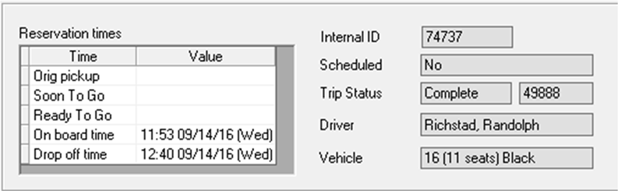
Note that we do not track “Ready to Go” because of the unreliability described below. On the lower left it shows an onboard time of 11:53:09. The second screen shot is, again identical to that provided by Mr. Marks:
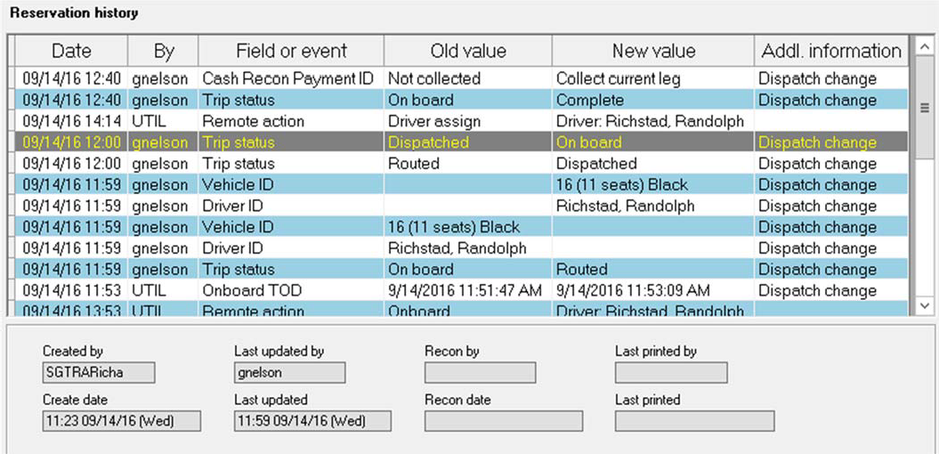 In the lower left, Hudson shows the reservation was booked at 11:23. This would indicate the wait time for the guest was 30 minutes. Note, however that the details above that (highlighted) shows an onboard time of 12:00, 7 minutes LATER. We would deem this to be a severe delay. But also note that the second screen shot above is truncated by the height of the window in Hudson. Scrolling down we are able to see the truth, despite the time stamps in Hudson:
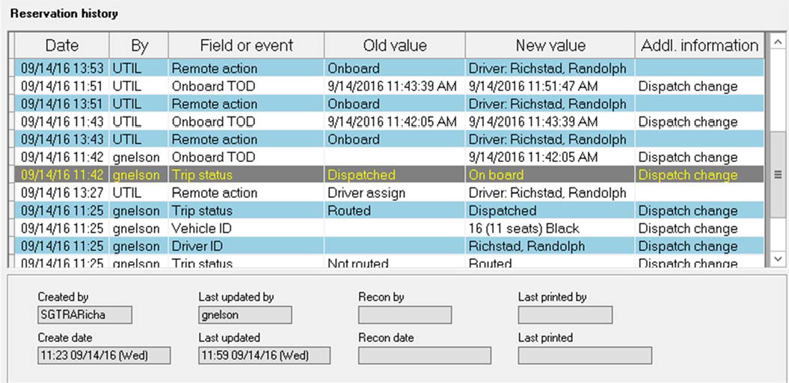
Now we see more information that helps us understand why the Hudson data is wrong. The highlighted line shows our dispatcher marked the guest on board at 11:42 – 19 minutes after he booked. What happens after that is an error that is created by Hudson and is why the request by SE is useless. You will note that two lines above the highlight is a line with a time stamp of 13:43 by “UTIL” then the onboard time is cleared. This is caused because the driver (Richstad, Randolph) paged something to dispatch and Hudson resets the reservation status incorrectly. This is a known issue that we cannot control. What it means is that the times in Hudson are not reliable. This occurs multiple times each day. We could create a screen shot like this for each of the 75,000 reservations we have to date. The process will be cumbersome, time-consuming and ultimately provide inconsistent data. Allowing one minute per shot to open the reservation, switch to the correct tab and take the screen shot would be 1,333 man hours. To do the same with the second tab would add another 600-700 man hours to the above. To provide the full history without truncation would more than double that we estimate.. Moreover, trip information (which Shuttle Express has requested but which they did not demonstrate in their Motion to Compel) in our system is maintained for only 60 days after which it is automatically purged from the system.
- As for Mr. Marks’ reference to the facility and ease to run reports on numerous parameters, their system again must be very different from ours. The kind of reports that Mr. Marks alludes to at ¶5 of his Declaration can only be created by someone with SQL expertise. These types of reports are also complex and time consuming to create. Custom reports are also very costly in our experience to tailor and adapt.
- Despite Mr. Marks’ minimization of the alleged “statistical data” they ask for in their data requests, Shuttle Express is not just asking for statistical data. They are asking for details of every single reservation since we began regulated operations which we calculate to be approximately 75,000 reservations and of/for every single trip actually performed which we believe to be 30,000 or more in the requested time interval. Such a request of retrieval is hardly “easy” or performed “routinely in the ordinary course of business.” Shuttle Express surely knows the scope of what they are asking and the burdens that would impose. Moreover, as just noted, many of the reports and data they seek are not maintained in the ordinary course of business whatsoever and would have to be created specially to be receptive to this request which process I am informed is not required by the Commission’s or other court’s discovery rules.
- Mr. Marks further next asserts SpeediShuttle is now the “Seattle airport Shuttle member of Go Group.” Actually, SpeediShuttle does not have any formal affiliation with the Go Group, and has no written agreement with Go Group beyond the Ticket Agent Agreement on file and approved by the WUTC. My understanding is that Shuttle Express, its individual owners and/or affiliates are an owner of the Go Group, while SpeediShuttle has no equity position nor formal membership in the Go Group.
- With regard to Mr. Marks’ assertion that “SpeediShuttle’s booking website was created by, and is maintained and hosted by, the Hudson Group,” that is false. Our website was created and is maintained by our own SpeediShuttle internal staff, not the Hudson Group. His observation that “he can easily tell” the source of the website might be one that he can easily make, but in this case, that observation is again wrong. Indeed, Mr. Marks cites a copyright reference in support of this theorizing. The page he refers to is actually a frame on one web page that contains the “Online Reservation System” but that is only the actual portal. While Hudson does own that specific technology, the graphics, descriptions and translations that follow in substantive content, and all other aspects of the websites, are SpeediShuttle’s.
- Mr. Marks’ characterizations and speculations continue at ¶7 of his Declaration where he says the “Hudson Group has created multiple iterations of the SpeediShuttle website and the links on SpeediShuttle website go to the Hudson Group webpages.” We have no idea what the latter comment means. SpeediShuttle does have different “booking engines” or portals for different languages but those are linked to our website, not Hudson’s. So in other words, the characterization that the Hudson Group captures for SpeediShuttle’s bookings and the prognostication about availability in statistical or summary form is inaccurate.
- Again, SpeediShuttle has booking engines or portals for different languages and also has its entire website available in several languages. . At the top of our main website page there is a flag.

Clicking the flag will reveal Japanese, Chinese and Korean flags. Selecting any of those will take you to the entire site of that language. These are the complete websites in each language, not just booking portals. There is also a bar near the top of the page that allows the user to quickly go to the foreign language booking engine. The Hudson Group provides SpeediShuttle with multiple sites for actually booking the reservation. These are integrated into the SpeediShuttle system through “frames.” So, for example, if you click on “Book A Ride,” above, a window on the website opens to allow you to actually book a reservation. The actual address of that site in the frame (the booking engine) is https://speedishuttleseattle.hudsonltd.net/res.
For Chinese, it is http://speedishuttleseattle3.hudsonltd.net/res.
For Japanese it is http://speedishuttleseattle4.hudsonltd.net/res.
For Korean it is http://speedishuttleseattle5.hudsonltd.net/res. Each of these was created by Hudson for us but we in turn customized them by translating all of the information so that it appears in whatever language, added the graphics and we, not they, maintain them. Note again, that these are just a component of our website used when you actual click “book,” something akin to a shopping cart or a Google map. They are not generally directly accessible to the normal user. The actual websites in each language contain much more travel information about Seattle, our services and our company and were created by and are maintained by us.
- Finally, Mr. Marks opines that “[t]he statistics are not burdensome to provide in my experience.” I am particularly puzzled how Mr. Marks would know this since Shuttle Express does not in any way support multiple language customers.
- Shuttle Express’ Motion to Compel also seems thoroughly predicated upon speculation about relationships underpinning the original application. No better example of this is the Go Group comments that Mr. Marks makes in ¶8 of his Declaration. Again, as noted above, I believe Shuttle Express, while no longer a member of the Go Group, has itself or through its owners, officers or affiliates some ownership or equity interest in the Go Group and obviously in that capacity has some ability to attempt to influence Go Group’s conduct and recordkeeping resources. Again, SpeediShuttle has no franchise agreement with Go Group or any financial interest in that company. As I understand the facts in Mr. Marks’ Declaration, Shuttle Express also unilaterally decided to terminate its contractual relationship with Go Group, whether or not that might have any impact of additional entrants in the Washington regulated marketplace. Plainly, if Shuttle Express has some existing or potential dispute with Go, this is not the proper forum for discovery related to that dispute.
- I have no knowledge about Mr. Marks’ conclusions as to Go Group’s overall financial arrangements with members including the reference to “receiv[ing] a percentage of all of its third party ticket bookings as well as retail credit card bookings of its members.” Once again, SpeediShuttle is not a “member” of the Go Group but simply deals with them as a wholesale customer who receives a discount, as shown in the Ticket Agent Agreement on file with and approved by the Commission. And directly contrary to Mr. Marks’ assertion, they do not get “a percentage” of our retail credit card bookings.
- Indeed, the entire theory about Go Group in this present action is apparently revealed at ¶9 of Mr. Marks’ Declaration in which he alleges because Go Group gets paid on a percentage basis “it would have been motivated to transition as much of the retail and wholesale (third party ticket agent) business as possible from Shuttle Express to its new client, SpeediShuttle.” As noted, if Shuttle Express has a dispute with the Go Group, this again, is not the proper forum for discovery related to that dispute.
- There is no question that the Go Group supported SpeediShuttle’s application as the hearing record reveals, but to what end is the information being sought about Go Group’s support of the application? Does SpeediShuttle have to provide documents to bolster a hypothetical premise that even, if proven, would appear not to be a basis for disqualifying an application? It appears that Shuttle Express is claiming that the prospect of financial benefit to the Go Group somehow led it to support SpeediShuttle’s application and that there must exist documents that reveal an improper or pecuniary purpose. No one disputes that the Go Group wanted an alternative provider for Shuttle Express once it unilaterally canceled its agreement with the Go Group. Does that fact suggest that the Go Group’s support of SpeediShuttle by letter (which the administrative law judge expressly gave little probative value or weight) Tr. 20 means that support was falsely or improperly premised?
- Finally, at ¶10 of Wesley Marks Declaration, Shuttle Express seeks to expand or defend its wide-ranging and voluminous data requests on the basis of precatory discussions amongst the Hudson Group, a former COO of Shuttle Express, John Rowley and the Go Group about “prodding” or otherwise inducing an application by SpeediShuttle. This, in apparent aid of their formative theory that somehow there might have been communications about the contemplated nature and scope of transportation to be proposed to the Commission by SpeediShuttle if a certificate were to be granted. Let me be clear, advice and recommendations regarding the law, rules, standards for evaluating and case decisions of the Commission in considering applications under the auto transportation statute was why we hired experienced counsel. Any information about what the Commission’s rules and practices were not the subject of reliance upon third parties other than counsel nor would any such prognostications, advice or recommendations be pertinent to the application record. Admittedly again, Shuttle Express seemingly now wants to use this forum for gathering information that appears to be based on theories that could serve as a basis for present or future civil actions against prior employee(s) and/or vendor or customer groups involving terminated agreements. I strongly believe that this is a misuse of discovery. Simply because discovery rules are broad on their face does not mean that Shuttle Express should be allowed to go on a fishing expedition to support its outrageous theories and in so doing, attempt to terminate SpeediShuttle’s emergence in the Washington marketplace. While that is undoubtedly its goal, the means it employs to achieve that result must be carefully and incrementally weighed from the outset, particularly as to its impact on the respondent, its customers, available resources, burdens and the purposes it seeks to fulfill.
- The foregoing statement is made under penalty of perjury under the laws of the State of Washington and is true and correct to the best of my knowledge and belief.

Signed at Salt Lake City, UT this 17th day of September, 2016.
___________________________________________
Mr. Jack Roemer
Chief Financial Officer
SpeediShuttle Washington, LLC

