https://www.seattletimes.com/business/carnival-cruise-lines-cancels-remaining-2020-seattle-alaska-voyages/

Carnival Cruise Lines cancels remaining 2020 Seattle-Alaska voyages
May 4, 2020 at 5:31 pm Updated May 6, 2020 at 11:14 pm
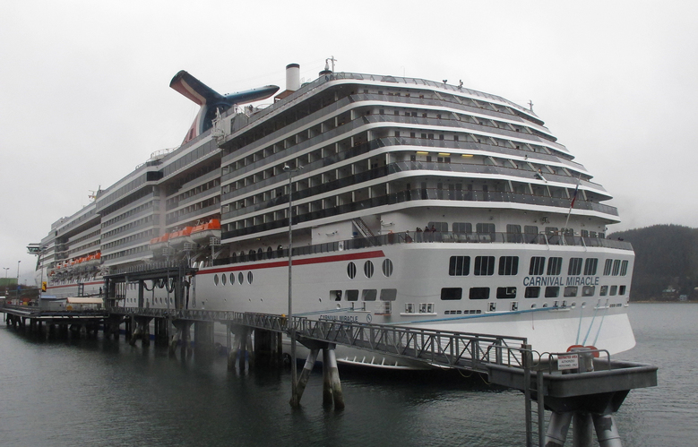The Carnival Miracle, which shares the design of the Carnival Spirit, docked in Juneau, Alaska in 2013. The Carnival Spirit was scheduled to... (Becky Bohrer / Associated Press, File) More
By
Katherine Khashimova Long
Seattle Times business reporter
Carnival Cruise Lines has canceled its remaining Alaska voyages, dealing another blow to Seattle’s coronavirus-battered cruise economy.
Between a no-sail order from the Centers for Disease Control and Prevention and a Canadian cruising moratorium, July 1 is the absolute earliest cruise ships could begin calling in Seattle again, according to the Port of Seattle.
The Carnival Spirit was scheduled to call in Seattle 11 times after that date, on its way to Alaska and Vancouver, British Columbia.
Each cruise vessel call supports $4.2 million in economic activity, according to the Port. Nearly 100 vessel calls have already been canceled to slow the spread of the coronavirus; 125 vessels are scheduled to call at Seattle in the latter half of the summer.
Cruising, which supports 5,500 regional jobs, has been one of the industries most hard-hit by measures to contain the spread of COVID-19, said Stephanie Jones Stebbins, the Port’s maritime director, in a Port Commission meeting last week. Beyond cruise lines and passengers, the shutdown affects provisioners and the local tourism industry, which had been anticipating nearly 1.3 million people to pass through Seattle on their way to or from a cruise.
“When it is safe to start up, we are confident this will be an important part of the economic recovery of our region,” Jones Stebbins said. “Port staff will be working with cruise industry and other travel partners to restart this business when it is safe to do so.”
ADVERTISING
Carnival’s shutdown extends beyond its Alaska routes. Other than eight vessels homeported in Florida, which will resume service Aug. 1, the company has suspended service on all routes departing from North American and Australian ports through Aug. 31.
“We are committed to supporting all public health efforts to manage the COVID-19 situation,” the Carnival statement read. “We are taking a measured approach, focusing our return to service on a select number of homeports where we have more significant operations that are easily accessible by car for the majority of our guests.”
In some instances, people infected on cruise ships have brought COVID-19 ashore and sparked new outbreaks of the disease, the CDC has said.
“People on a large ship, all together, at the same time, all the time — you couldn’t ask for a better incubator for infection,” Anthony Fauci, the nation’s top infectious-diseases expert, said in February.
Seattle-headquartered Holland America Line, which is owned by Carnival, has suspended sailings through June 30 and will “continue to evaluate our ability to operate successfully this summer,” said spokesperson Sally Andrews.
The four other cruise lines with Seattle itineraries — Celebrity Cruises, Norwegian Cruise Line, Royal Caribbean and Princess Cruises — did not respond to questions about whether they planned to continue sailing out of Seattle as scheduled when no-sail orders are lifted.
The Associated Press reported that the number of people visiting Alaska on cruise ships went from 480,000 in 1996 to almost 1.4 million last year, according to a report by state labor department economists Neal Fried and Karinne Wiebold. Mike Tibbles, with Cruise Lines International Association Alaska, said so far 419 voyages to Alaska, with a passenger capacity of 825,200, have been canceled.
Katherine Khashimova Long: 206-464-3229 or kalong@seattletimes.com; on Twitter: @_katya_long.

