June 30th, 2017

Mr. Steven King, Executive Secretary
Washington Utilities and Transportation Commission
1300 South Evergreen Park Drive SW
Olympia, WA 98504-7250

Re: FCC annual 481 filing
Docket No. UT-170011

Dear Mr. King:

Enclosed is a copy of FCC Form 481 and supporting documnets for 2017. Please contact me should you require any additional information.

Sincerely,

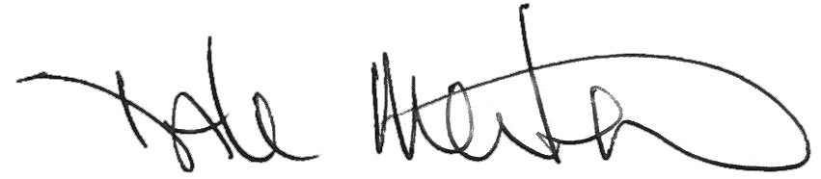

Dale Merten
Chief Operating Officer

