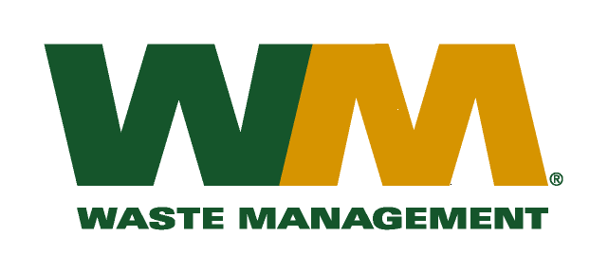

VIA EMAIL

June 24, 2015

Washington Utilities and Transportation Commission
Chandler Plaza Building
1300 S. Evergreen Park Drive SW
P.O. Box 47250
Olympia, WA. 98504-7250

Subject: Waste Management of Washington, Inc. d/b/a Waste Management – North Sound and Waste Management – Marysville (G-237) TG-151287
This letter is to request the Commission remove the filing made in the above-entitled docket that was submitted last week. The filing is being withdrawn due to the possible government shutdown that may take place on July 1 if the Washington State Legislature has not approved the state operating and capital budgets for the 2015-2017 biennium. The company intends to resubmit the filing as soon as the budgets are approved by the legislature. We therefore respectfully ask the records center to return the all the filing documents.
Thank you for your consideration. If you have any questions or need additional information, please contact me at:
Address: 720 4th Avenue, Suite 400, Kirkland, WA 98033
Telephone / Fax # / e-mail: (425) 814-7840 / (425) 814-7866 / mweinstein@wm.com

Respectfully,

Michael A. Weinstein
Senior Pricing Manager, Pacific Northwest Market Area

cc: Polly McNeill

