July 11, 2014

Steven V. King, Executive Director and Secretary
Utilities and Transportation Commission
1300 S. Evergreen Park Dr. SW
P.O. Box 47250
Olympia, WA 98504-7250

RE: Washington Utilities and Transportation Commission v. New Century Telecom, Inc.

Commission Staff’s Response to Application for Mitigation of Penalties UT-140902

Dear Mr. King:

On June 2, 2014, the Utilities and Transportation Commission issued a $1,000 Penalty Assessment in Docket UT-140902 against New Century Telecom, Inc. for 10 violations of Washington Administrative Code (WAC) 480-120-382, which requires telecommunications companies to furnish annual reports to the commission no later than May 1 each year.¹

On June 23, 2014, New Century Telecom, Inc. wrote the commission requesting mitigation of penalties (Mitigation Request).² In its Mitigation Request, New Century Telecom, Inc. does not dispute that the violation occurred. The company states, “Our records indicate that we did not file the 2013 annual report due to not having any business in the state of Washington since 2012. Also in my conversation with Virgil Santos, our license had been revoked and we need not to file the 2012 report.”

It is the company’s responsibility to ensure that the regulatory fee is paid and the annual report is filed by the May 1 deadline. On February 28, 2014, Annual Report packets were mailed to all regulated telecommunication companies. The instructions for annual report completion page of
the annual report informed the regulated company that it must complete the annual report form, pay the regulatory fees, and return the materials by May 1, 2014, to avoid enforcement action.

As of July 8, 2014, New Century Telecom, Inc. has not filed its 2013 annual report or paid any subsequent regulatory fees due. The company filed a petition on May 20, 2013 to be classified as a competitive telecommunication company under Docket UT-130917. Registration was

UTC Annual Reports
July 11, 2014
Page 2

effective as of June 19, 2013. Previously the company’s registration was revoked as of September 9, 2004 for failure to file the 2003 annual report and pay subsequent regulatory fees. New Century Telecom filed a Notice of Cessation on June 23, 2014 under Docket UT-141317.

Staff supports the company’s request for mitigation as the company has not had regulated telecommunication business within Washington and has requested to voluntarily cancel its registration. Staff recommends a reduced total penalty assessment of $200.

If you have any questions regarding this recommendation, please contact Amy Andrews, Regulatory Analyst, at (360) 664-1157, or aandrews@utc.wa.gov.

Sincerely,

Sondra Walsh, Director
Administrative Services

ATTACHMENT A
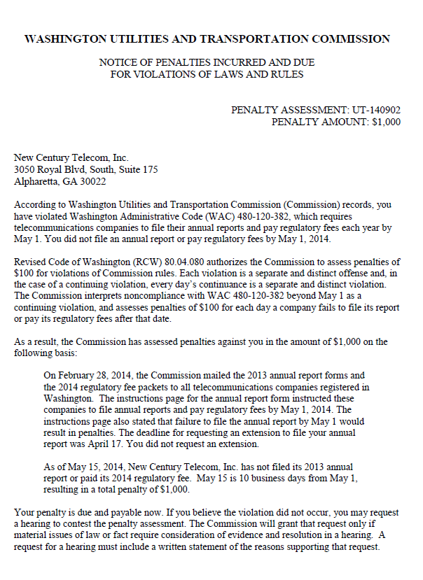

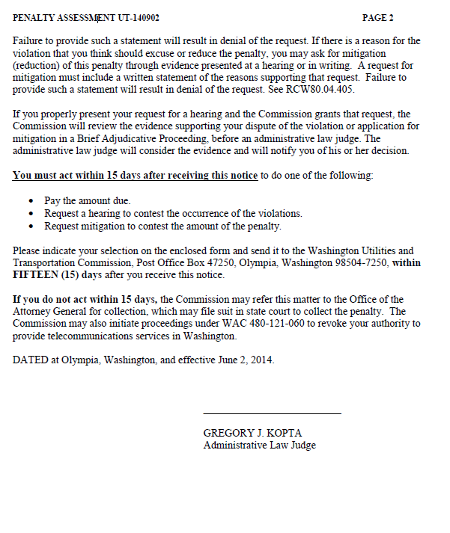

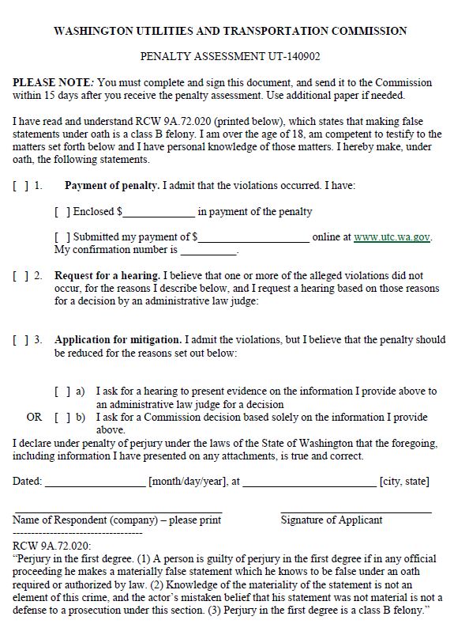

ATTACHMENT B
