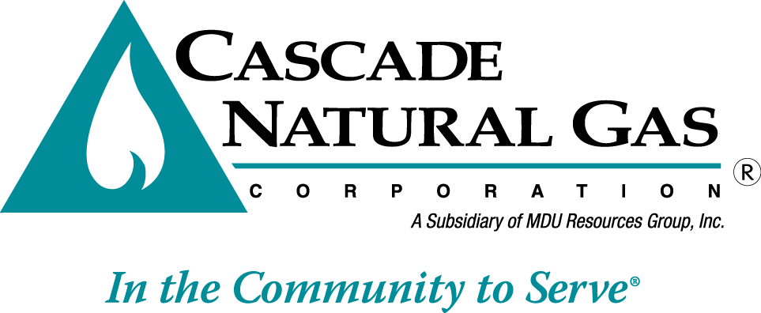
8113 W. GRANDRIDGE BLVD., KENNEWICK, WASHINGTON 99336-7166
TELEPHONE 509-734-4500 FACSIMILE 509-737-9803
www.cngc.com

April 22, 2016

Mr. Steven V. King
Executive Director and Secretary
Washington Utilities & Transportation Commission
Post Office Box 47250
Olympia, Washington 98504-7250

Re: 2015 Affiliated Interest Report

Dear Mr. King:

Pursuant to WAC 480-90-264, submitted herewith is Cascade Natural Gas’ Affiliated Interest report for the 12-month period ending December 31, 2015.

If there are any questions regarding this report, please contact me at (509) 734-4593.

Sincerely,

Michael Parvinen
Director, Regulatory Affairs

Attachment

